

SOFTWARE REQUIREMENT SPECIFICATION
Gym Center Management System
GCMS

– Hanoi, May 2026 –
Table of Contents
I. Record of Changes 8
II. Software Requirement Specification 9
1. Overall Requirements 9
1.1 Context Diagram 9
1.2 Main Business Processes 9
1.2.1 Manage Account 9
1.2.2 View Dashboard 10
1.2.3 Membership & Payment 11
1.2.4 Member & Staff Management 11
1.2.5 Personal Trainer Management 11
1.2.5.1 PT Service Registration & Schedule Generation 12
1.2.5.2 Reschedule Request Flow 13
1.2.5.3 Cancelled Session & Make-up Request Flow 14
1.2.5.4 Staff/Admin Schedule Operations 15
1.2.7 Equipment Management 17
1.2.8 Manage Blog & Policies 18
1.3 User Requirements 18
1.3.1 Actors 18
1.3.2 Use Cases (UC) 19
1.3.2 Use Case Diagrams 22
1.4 System Functionalities 24
1.4.1 Screens Flow 24
1.4.2 Screen Authorization 25
1.4.3 Non-UI Functions 28
1.5 Entity Relationship Diagram 29
2. Use Case Specifications 31
2.1 Authentication 31
2.1.1 Login User 31
2.2 User Management 33
2.2.1 Manage User Profile 33
2.2.2 Change Password 34
2.2.3 Manage Account 36
2.3 Member Management 38
2.3.1 Register Membership 38
2.3.2 Manage Members 40
2.3.2.1 Add Member 40
2.3.2.2 Search & View Member List 42
2.3.2.3 Update Member Status & Notification 43
2.3.2.4 Delete Member 44
2.3.3 View Member Portal 44
2.4 Membership Management 45
2.4.1 Manage Package 45
2.4.1.1 Create Package 45
2.4.1.2 View Package List 45
2.4.1.3 Update Package Details 46
2.4.1.4 Deactivate/Disable Package 46
2.4.2 Register Package 47
2.4.3 Renew & Transfer Package 47
2.4.3.1 Renew Package 47
2.4.3.2 Transfer Package 48
2.5. Payment Management 49
2.5.1 Record Payment 49
2.5.2 View Personal/ System Payment History 49
2.6. Attendance Management 50
2.6.1 Manage Staff & PT Check-ins 50
2.6.2 View Staff & PT Work History 51
2.6.2.1 Staff & Personal Trainer Screen 51
2.6.2.2 Admin Screen 52
2.7. Personal Trainer Management 53
2.7.1 Create Personal Trainer 53
2.7.2 View Personal Trainer List 54
2.7.3 Manage PT Registrations 55
2.7.3.1 Register PT Service 56
2.7.3.2 Approve PT Registration 57
2.7.3.3 View PT Registration History 58
2.7.3.4 Remove Cancelled PT Registration History 58
2.7.4 Manage Personal Trainers 59
2.7.4.1 Update Personal Trainer Profile 59
2.7.4.2 Personal Trainer Self-Edit Profile 60
2.7.4.3 Configure PT Service Price 61
2.7.4.4 Deactivate Personal Trainer Account 62
2.7.5 Manage PT Schedules 63
2.7.5.1 Generate PT Schedule Automatically 63
2.7.5.2 Create Reschedule Request 65
2.7.5.3 Respond Reschedule Request 66
2.7.5.4 Request Staff Support 67
2.7.5.5 Assign Substitute PT 68
2.7.5.6 Update Training Session Status 69
2.7.5.7 Mass Cancel PT Sessions 71
2.7.5.8 Create Make-up Request For Cancelled Session 72
2.7.5.9 Process Make-up Request 74
2.7.6 View PT Work Dashboard 75
2.7.7 Manage PT Package Types 76
2.7.7.1 View list PT Package 76
2.7.7.2 View PT package detail 77
2.7.7.3 Create PT package 77
2.7.7.4 Update PT package information 78
2.7.7.5 Delete PT package 79
2.8. Equipment Management 80
2.8.1 Manage Equipment 80
2.8.1.1 View/Search Equipment 80
2.8.1.2 Add Equipment 80
2.8.1.3 Edit Equipment 82
2.8.1.4 Delete Equipment 83
2.8.2 Manage Equipment Issues 84
2.8.2.1 View/Search Equipment Issues 84
2.8.2.2 Report Equipment Issue 85
2.8.2.3 Update Equipment Issue 86
2.8.2.4 View Equipment Issue Detail 86
2.8.3 View Equipment Reports 87
2.8.4 Manage Maintenance Schedules 87
2.8.4.1 View Maintenance Schedules 87
2.8.4.2 View Maintenance Schedule Detail 88
2.8.4.3 Create Maintenance Schedule 89
2.8.4.4 Update Maintenance Schedule 90
2.8.4.5 Cancel Maintenance Schedule 93
2.9. Dashboard & Reporting 94
2.9.1 View Dashboard 94
2.9.2 View Membership Growth Report 95
2.9.3 View Financial & Revenue Reports 96
2.10. Notification 96
2.10.1 Manage Notifications 96
2.10.2 View Member Notifications 98
2.11. Support 98
2.11.1 Chat Bot 98
2.12. Content Management 99
2.12.1 Manage Blog & Policies 99
2.12.1.1 Create Blog & Policy 99
2.12.1.2 View Blog & Policy 100
2.12.1.3 Update Blog & Policy 101
2.12.1.4 Delete Blog & Policy 101
3. Functional Requirements 103
3.1 Authentication 103
3.1.1 Login Screen 103
3.2 User Management 105
3.2.1 Profile Screen 105
3.2.2 Change Password Screen 107
3.2.3 Manage Account Screen 109
3.3 Member Management 111
3.3.1 Registration Screen 111
3.3.2 Manage Members Screen 113
3.3.3 View Member Portal Screen 115
3.4 Membership Management 116
3.4.1 Package List Screen 116
3.4.2 Package Registration Screen 117
3.4.3 Package Renewal & Transfer Screen 118
3.5. Payment Management 119
3.5.1 Record Payment Screen 119
3.5.2 Payment History Screen 120
3.6. Attendance Management 121
3.6.1 Manage Staff & PT Check-ins Screen 121
3.6.2 View Staff & PT Work History 122
3.6.2.1 Staff & Personal Trainer Screen 122
3.6.2.2 Admin Screen 124
3.7. Personal Trainer Management 125
3.7.1 Create Personal Trainer 125
3.7.1.1 Add Personal Trainer 125
3.7.1.2 PT Account Creation Result Screen 127
3.7.2 View Personal Trainer List Screen 128
3.7.3 Manage PT Registrations 130
3.7.3.1 PT Service Registration Screen 130
3.7.3.2 Manage PT Registration Requests 131
3.7.3.3 PT Service Registration Result Screen Description 133
3.7.4 Manage Personal Trainers 134
3.7.4.1 Personal Trainer Detail Screen 134
3.7.4.2 Edit PT Profile Form Screen 135
3.7.4.3 Manage PT Service Price Screen 137
3.7.4.4 Personal Trainer Self-Edit Profile Screen 139
3.7.5 Manage PT Schedules 140
3.7.5.1 Pending PT Registrations Screen 141
3.7.5.2 Generate PT Schedule Screen 142
3.7.5.3 Member/PT Weekly Schedule Screen 144
3.7.5.4 Reschedule / Make-up Request Form 146
3.7.5.5 Request Detail / Response Modal 148
3.7.5.6 Staff/Admin Schedule Support Screen 151
3.7.5.7 Assign Substitute PT Modal 153
3.7.5.8 Update Training Session Status Screen 154
3.7.5.9 Mass Cancel PT Sessions Screen / Modal 156
3.7.6 View PT Work Dashboard 157
3.7.6.1 View Personal Trainer Schedule & Work History 157
3.7.6.2 PT's Assigned Members Screen 159
3.7.7 Manage PT Package Types 160
3.7.7.1 View list PT Package Screen 161
3.7.7.2 PT Package Detail Modal 162
3.7.7.3 Create PT Package Screen 163
3.7.7.4 Edit PT Package Screen 165
3.7.7.5 Delete PT Package Confirmation Modal 166
3.8. Equipment Management 167
3.8.1 Manage Equipment 167
3.8.1.1 Equipment List Screen 167
3.8.2 Manage Equipment Issues 169
3.8.2.1 Equipment Issue Report Screen 169
3.8.3 View Equipment Reports 171
3.8.3.1 Equipment Report Screen 171
3.8.4 Manage Maintenance Schedules 173
3.8.4.1 Manage Equipment Screen 173
3.9. Dashboard & Reporting 175
3.9.1 View Dashboard Screen 175
3.9.2 View Membership Growth Report Screen 177
3.9.3 Package Registration Screen 177
3.10. Notification 178
3.10.1 Manage Notifications Screen 178
3.10.2 View Member Notifications Screen 180
3.11. Support 181
3.11.1 Chat Bot 181
3.12 Blog & Policies 183
3.12.1 Content & Policies Management Screen 183
4. Non-Functional Requirements 184
4.1 External Interfaces 184
4.1.1 User Interface 184
4.1.2 Hardware Interface 184
4.1.3 Software Interface 184
4.2 Quality Attributes 184
4.2.1 Usability 184
4.2.2 Performance 185
4.2.3 Security 185
4.2.4 Reliability 185
4.2.5 Maintainability 185
4.2.6 Scalability 185
5. Requirement Appendix 186
5.1 Business Rules 186
5.2 System Messages 189
5.3 Assumptions and Dependencies 195
5.4 Other Requirements 195
5.4.1 Audit Logs 195
5.4.2 Backup and Recovery 195
5.4.3 Localization 195
5.4.4 Compliance 196
5.5 Glossary and Acronyms Table 196

I. Record of Changes
Date | A/M/D | In charge | Change Description
22/05/2026 | A | DuongND | Initial Document Creation
23/05/2026 | A | ThangNH | Entity Relationship Diagram, Entities Description, Use cases Description for Package Management & Payment Management
26/05/2026 | M | ThangNH | Formatting Document
31/05/2026 | M | PhuND | Updated Personal Trainer application and account creation workflow, including application result lookup, uploaded certificate handling, default PT account credentials, and first-login password change requirement.
01/06/2026 | M | PhuND | Updated PT service registration workflow: new PT service registrations are created with Pending status before Staff/Admin processes payment and arranges training sessions.
02/06/2026 | M | PhuND | Updated the Personal Trainer workflow based on review feedback. Removed the online “Apply for Personal Trainer” process and “PT Application Result Lookup” because PT recruitment, CV submission, interview, professional evaluation, and approval are handled outside the system. Replaced it with “Add Personal Trainer / Create PT Account”, where Staff/Admin creates a PT profile and system account after offline approval. Updated related PT management scope, access rights, business rules, and iteration plan. Added rules that verified PT information is maintained by Staff/Admin, while PTs can only update limited public profile information. Updated PT service registration to start with Pending status before Staff/Admin processing.
06/06/2026 | M | PhuND | Updated Personal Trainer use case specifications based on review feedback. Revised management use cases into smaller CRUD/action-based use cases, reduced user-manual-style descriptions, and added business rules for computation, constraints, action enablement, soft delete, historical data consistency, and report consistency.
18/06/2026 | M | PhuND | Updated PT Schedule Management flows with fixed-slots allocation, weekly availability check, and session auto-generation logic for Iteration 2.
30/6/2026 | M | HoangDM | Revised the Manage Equipment, Manage Equipment Issues, View Equipment Reports, and Manage Maintenance Schedules use cases to align with the system’s business requirements.
07/07/2026 | M | PhuND | Update PT workflow
09/07/2026 | M | PhuND | Update last PT workflow
16/7/2026 | M | PhuND | Update new use case: Management PT Package Types
A - Added M - Modified D - Deleted

II. Software Requirement Specification

1. Overall Requirements

1.1 Context Diagram
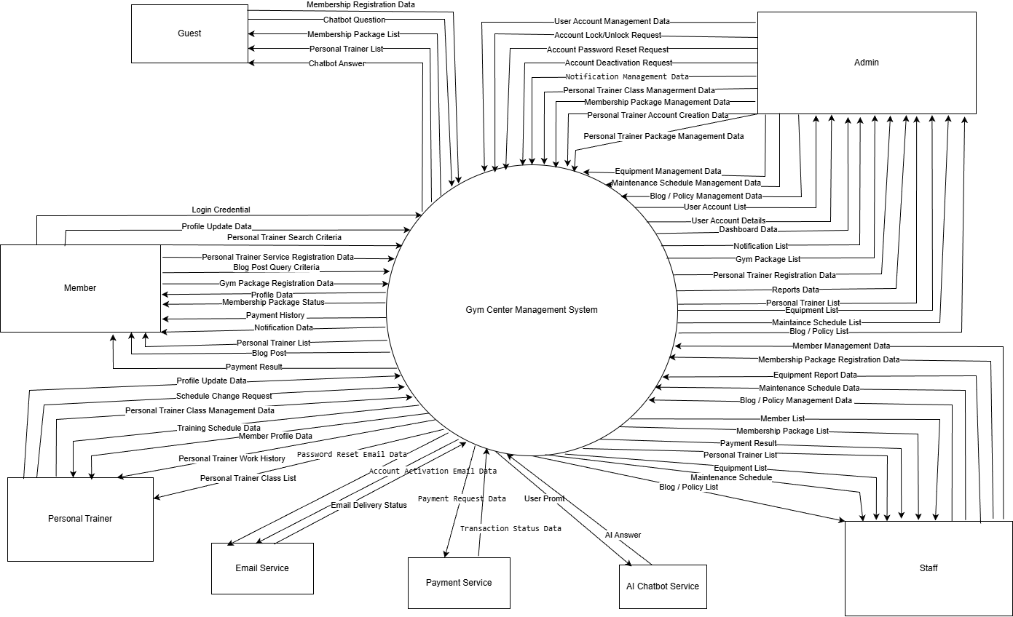

1.2 Main Business Processes

1.2.1 Manage Account
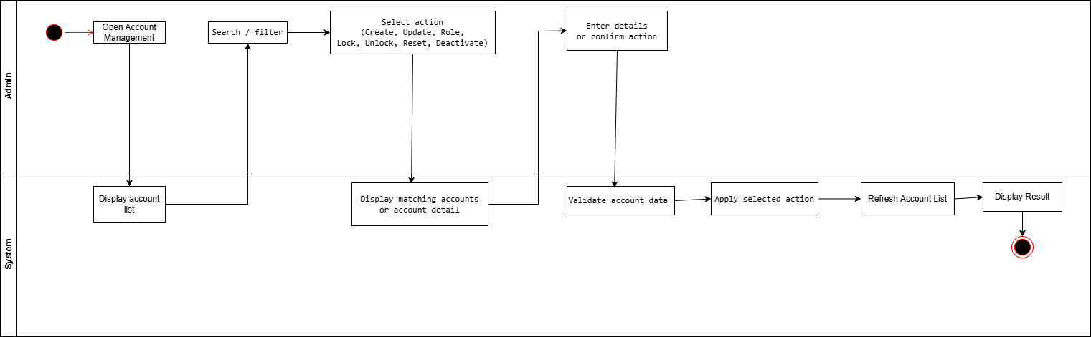

1.2.2 View Dashboard
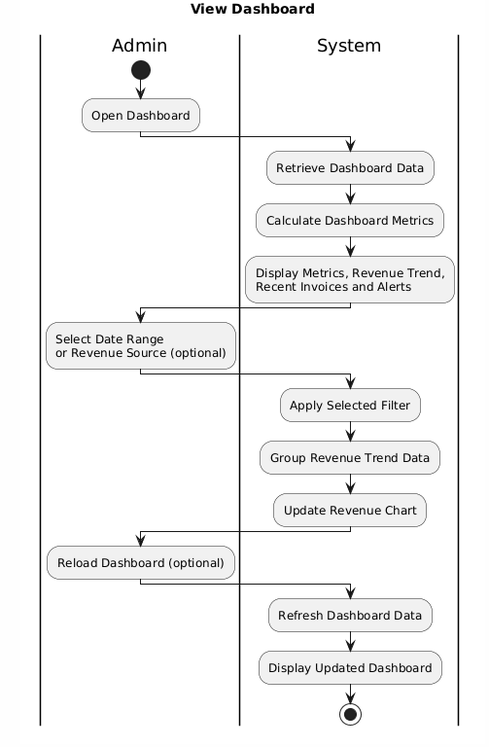

1.2.3 Membership & Payment
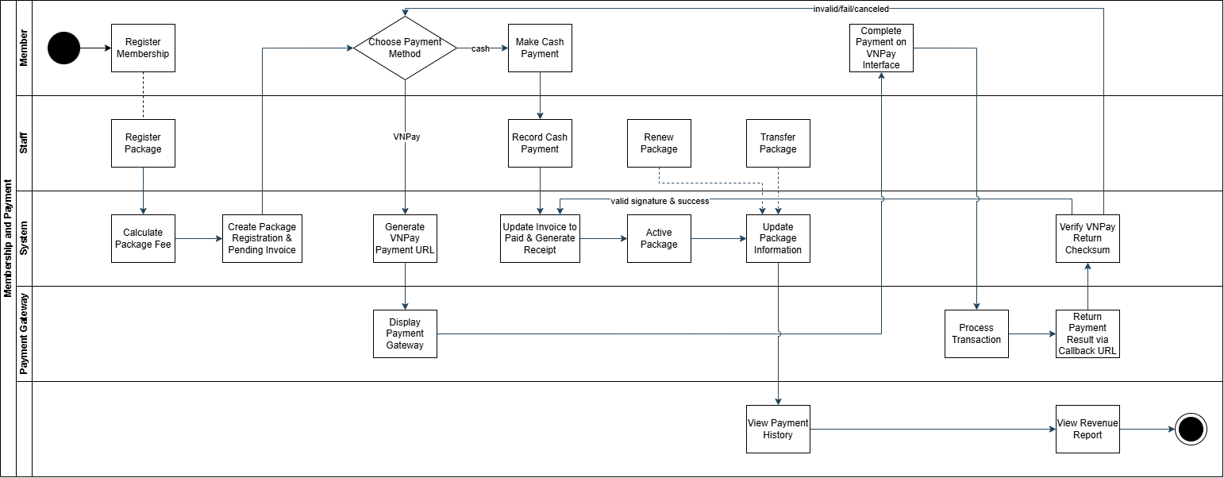
https://drive.google.com/file/d/1fmuwHR1jFeqExvDaBD1Y-KTUDXpadPuf/view?usp=sharing

1.2.4 Member & Staff Management
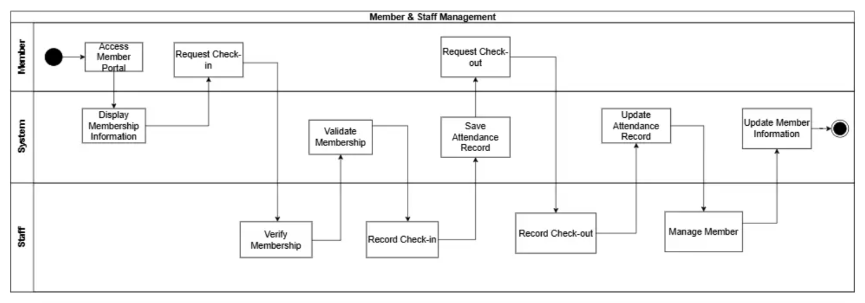
https://drive.google.com/file/d/1LbVxPrch0eEej0-HrXS-tYEraAOGZTcP/view?usp=sharing

1.2.5 Personal Trainer Management
Swimlane Diagram

1.2.5.1 PT Service Registration & Schedule Generation
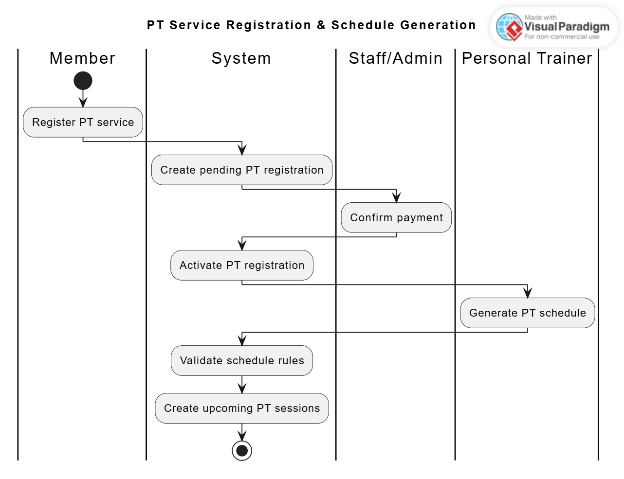 Figure 1.2.4.1: PT Service Registration & Schedule Generation
Step 1: Member gửi đơn đăng ký cho hệ thống(System)
Step 2: System tạo 1 đơn đăng ký với trạng thái đang chờ(Pending)
Step 3: Staff/Admin xác nhận thanh toán đơn đó
Step 4: Đơn chờ được chuyển sang trạng thái Active và được chuyển tiếp sang Huấn luyện viên cá nhân(PT) để sắp lịch
Step 5: Hệ thống check trùng lịch đối với Member và PT
Step 6: Hệ thống tạo lịch tự động
Step 7: Kết thúc quá trình đăng ký và xếp lịch tập

1.2.5.2 Reschedule Request Flow
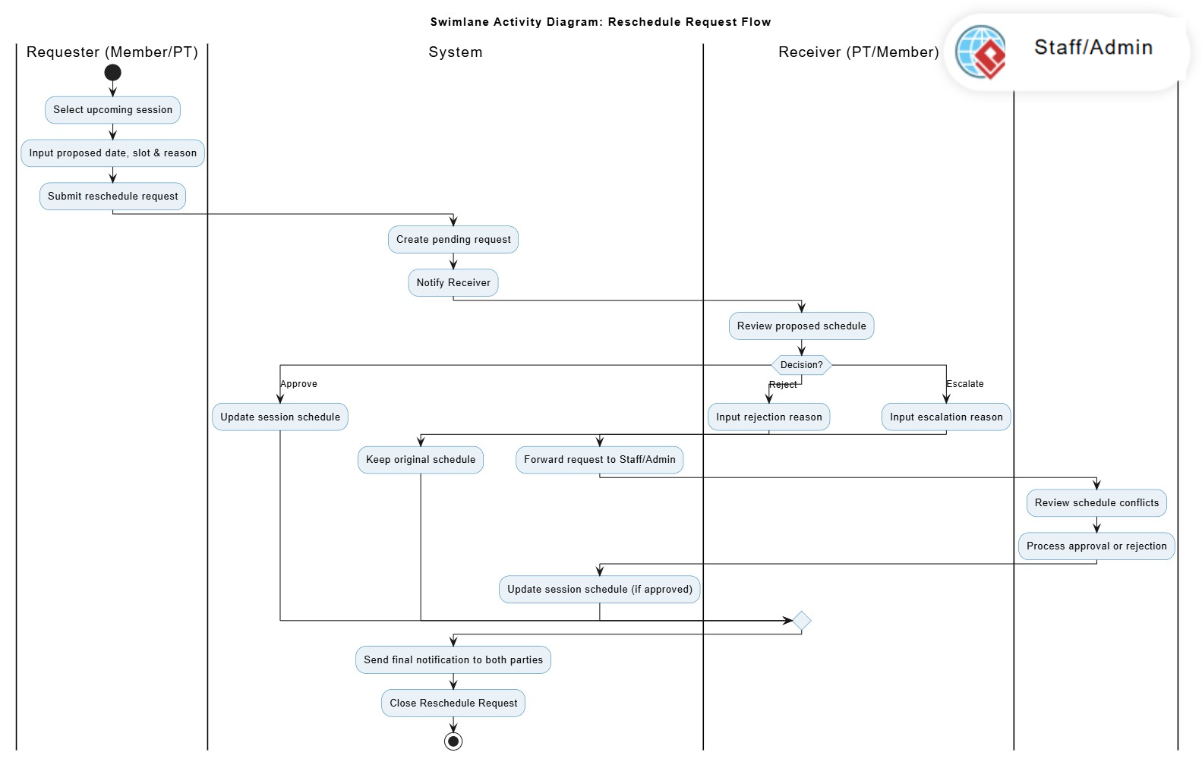Figure 1.2.4.2: Reschedule Request Flow
Step 1: Người gửi yêu cầu (Requester - Member/PT) chọn một ca tập sắp diễn ra và nộp thông tin đề xuất dời lịch.
Step 2: Hệ thống (System) khởi tạo yêu cầu dời lịch ở trạng thái chờ và gửi thông báo cho Người nhận (Receiver).
Step 3: Người nhận (Receiver - PT/Member) xem xét lịch trình được đề xuất.
Step 4: Trong trường hợp đồng ý (Approve), Hệ thống (System) cập nhật lịch trình mới cho buổi tập.
Step 5: Trong trường hợp từ chối (Reject), Người nhận (Receiver - PT/Member) nhập lý do từ chối và Hệ thống (System) bảo lưu lịch trình cũ.
Step 6: Trong trường hợp leo thang (Escalate), Người nhận (Receiver - PT/Member) nhập lý do hỗ trợ và Hệ thống (System) chuyển tiếp yêu cầu cho Quản trị viên / Nhân viên (Staff / Admin).
Step 7: Quản trị viên / Nhân viên (Staff / Admin) xem xét xung đột lịch trình và xử lý phê duyệt hoặc từ chối.
Step 8: Hệ thống (System) cập nhật lịch trình mới cho buổi tập (nếu được phê duyệt).
Step 9: Hệ thống (System) gửi thông báo kết quả cuối cùng cho cả hai bên và đóng yêu cầu dời lịch. Kết thúc quá trình dời lịch.

1.2.5.3 Cancelled Session & Make-up Request Flow
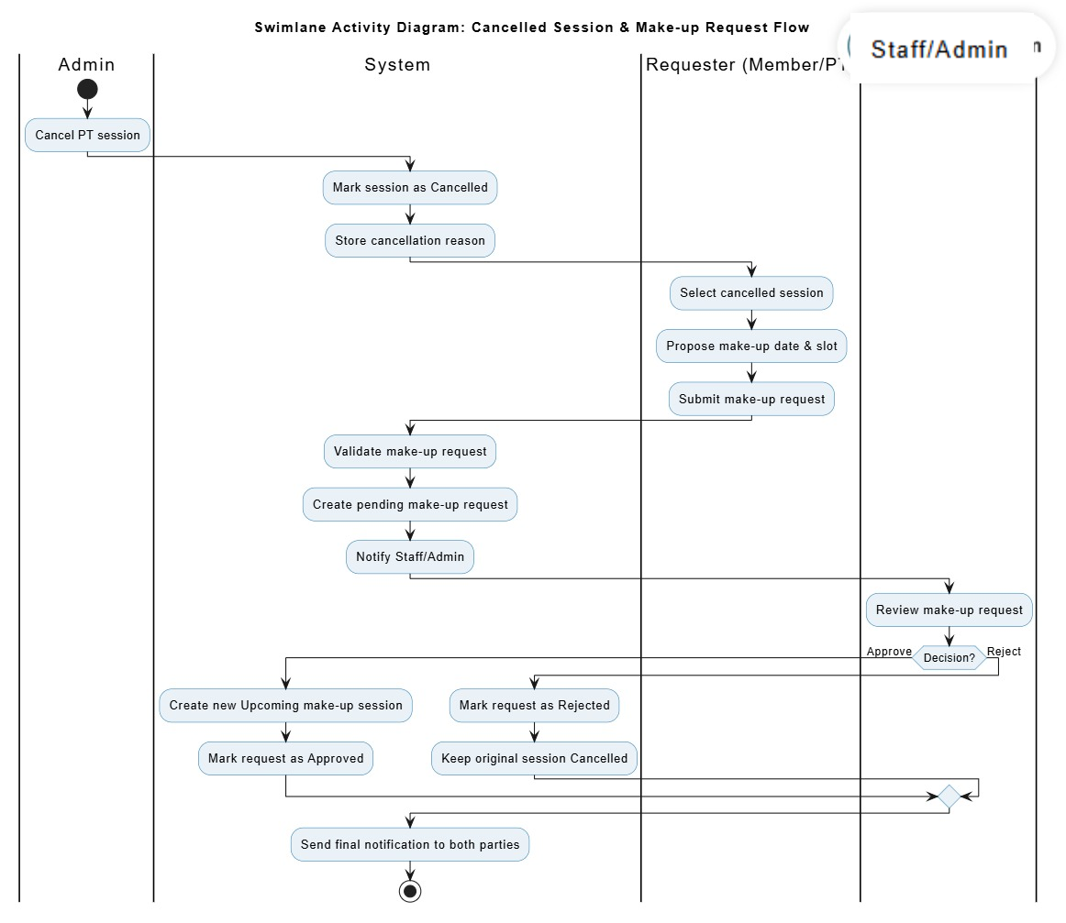Figure 1.2.4.3: Cancelled Session & Make-up Request Flow
Step 1: Quản trị viên (Admin) thực hiện hủy một buổi tập (PT session).
Step 2: Hệ thống (System) cập nhật trạng thái buổi tập thành đã hủy (Cancelled) và lưu trữ lý do hủy.
Step 3: Người gửi yêu cầu (Requester - Member/PT) chọn buổi tập đã hủy và nộp yêu cầu học bù kèm ngày giờ đề xuất.
Step 4: Hệ thống (System) xác thực yêu cầu và khởi tạo yêu cầu học bù ở trạng thái chờ (Pending).
Step 5: Hệ thống (System) gửi thông báo yêu cầu học bù cho Nhân viên / Quản trị viên (Staff/Admin).
Step 6: Nhân viên / Quản trị viên (Staff/Admin) xem xét yêu cầu học bù được đề xuất.
Step 7: Trong trường hợp đồng ý (Approve), Hệ thống (System) tạo một buổi tập bù mới ở trạng thái sắp diễn ra (Upcoming) và đánh dấu yêu cầu đã được duyệt.
Step 8: Trong trường hợp từ chối (Reject), Hệ thống (System) đánh dấu yêu cầu bị từ chối và bảo lưu buổi tập gốc ở trạng thái đã hủy (Cancelled).
Step 9: Hệ thống (System) gửi thông báo kết quả cuối cùng cho cả hai bên. Kết thúc quá trình học bù.

1.2.5.4 Staff/Admin Schedule Operations
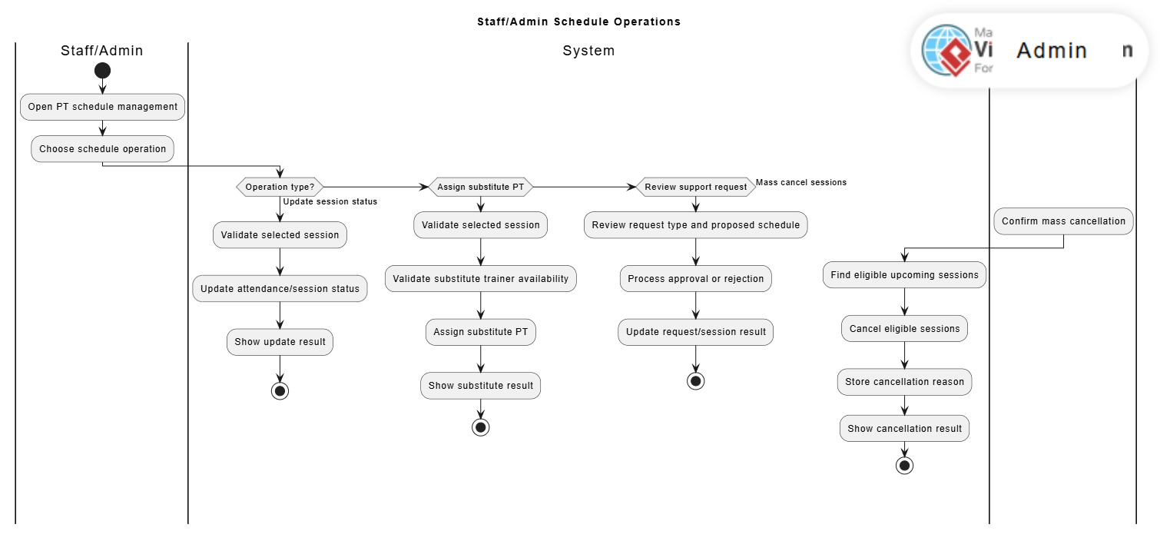Figure 1.2.5.4: Staff/Admin Schedule Operations
Step 1: Nhân viên / Quản trị viên (Staff/Admin) mở giao diện quản lý lịch tập PT (Open PT schedule management).
Step 2: Nhân viên / Quản trị viên (Staff/Admin) chọn một thao tác lịch trình (Choose schedule operation).
Step 3: Hệ thống (System) kiểm tra loại thao tác (Operation type) để rẽ nhánh xử lý.
Step 4: Trong trường hợp cập nhật trạng thái (Update session status), Hệ thống (System) xác thực ca tập được chọn (Validate selected session).
Step 5: Hệ thống (System) cập nhật kết quả điểm danh và trạng thái ca tập (Update attendance/session status).
Step 6: Hệ thống (System) hiển thị kết quả cập nhật (Show update result). Kết thúc quá trình cập nhật trạng thái ca tập.
Step 7: Trong trường hợp phân công PT dạy thay (Assign substitute PT), Hệ thống (System) xác thực ca tập được chọn (Validate selected session).
Step 8: Hệ thống (System) xác thực tính khả dụng của huấn luyện viên dạy thay (Validate substitute trainer availability).
Step 9: Hệ thống (System) phân công HLV dạy thay vào ca tập (Assign substitute PT).
Step 10: Hệ thống (System) hiển thị kết quả phân công (Show substitute result). Kết thúc quá trình phân công PT dạy thay.
Step 11: Trong trường hợp xem xét yêu cầu hỗ trợ (Review support request), Hệ thống (System) xem xét loại yêu cầu và lịch trình được đề xuất (Review request type and proposed schedule).
Step 12: Hệ thống (System) xử lý việc phê duyệt hoặc từ chối (Process approval or rejection). Step 13: Hệ thống (System) cập nhật kết quả yêu cầu và ca tập (Update request/session result). Kết thúc quá trình xem xét yêu cầu hỗ trợ.
Step 14: Trong trường hợp hủy lịch hàng loạt (Mass cancel sessions), Quản trị viên (Admin) xác nhận thao tác hủy hàng loạt (Confirm mass cancellation).
Step 15: Hệ thống (System) tìm kiếm các ca tập sắp diễn ra hợp lệ (Find eligible upcoming sessions).
Step 16: Hệ thống (System) hủy các ca tập hợp lệ đó (Cancel eligible sessions).
Step 17: Hệ thống (System) lưu trữ lý do hủy lịch (Store cancellation reason).
Step 18: Hệ thống (System) hiển thị kết quả hủy lịch (Show cancellation result). Kết thúc quá trình hủy lịch hàng loạt.

1.2.7 Equipment Management
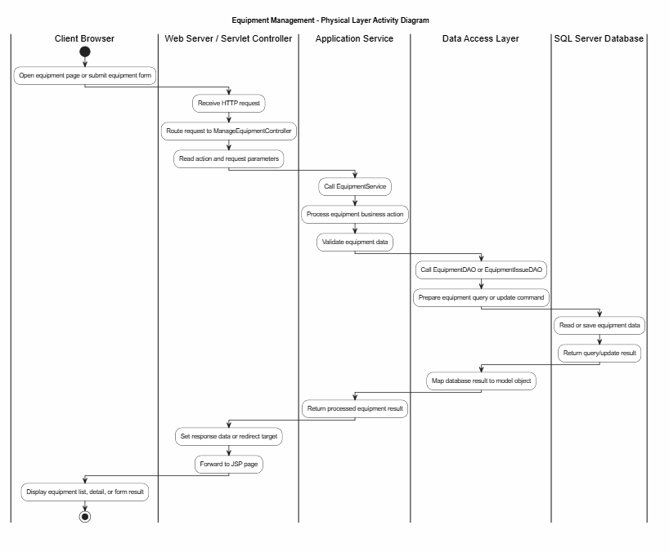

1.2.8 Manage Blog & Policies
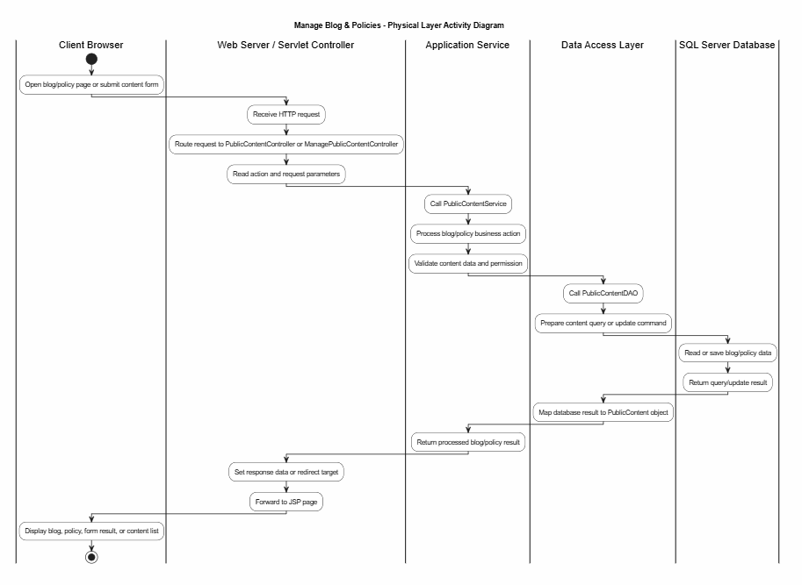

1.3 User Requirements

1.3.1 Actors

# | Actor | Description
1 | Admin | System administrators with full access to configure membership packages, create and manage Personal Trainer profiles and accounts after offline recruitment approval, publish system announcements, and extract financial/operational statistical reports.
2 | Staff | Operational employees responsible for checking member status, registering/renewing packages, logging cash payments, handling equipment reports, and managing Personal Trainer training schedules when necessary.
3 | Member | Registered customers who log into the system to manage their profiles, track package status, view PT information, and register for personal trainer service plans.
4 | Personal Trainer | Certified trainers who access the system to view assigned schedules, view work history, and update limited public profile information such as avatar, display name, and bio.
5 | Guest | Unauthenticated users who browse gym information, membership packages, and public Personal Trainer profiles, or submit membership registrations.

1.3.2 Use Cases (UC)
ID | Use Case | Actors | Feature | Use Case Description
UC-01 | Login User | Admin, Staff, Member, Personal Trainer | Authentication | Authenticates credentials, checks account status, handles logout, and redirects to role dashboards.
UC-02 | Register Membership | Guest | Member Management | Allows visitors to register a membership account and automatically creates an active Member account.
UC-03 | Manage User Profile | Admin, Staff, Member, Personal Trainer | User Management | Enables authenticated users to view and update their personal profiles.
UC-04 | Change Password | Admin, Staff, Member, Personal Trainer | User Management | Allows authenticated users to securely update their account passwords.
UC-05 | Manage Accounts | Admin | User Management | Enables administrators to perform CRUD operations on user accounts and update roles/statuses.
UC-06 | View Dashboard | Admin | Dashboard & Reporting | Displays real-time daily operational metrics, revenue tracking, and system alerts.
UC-07 | Manage Notifications | Admin | Notification | Allows administrators to create, edit, and delete global system announcements and promotions.
UC-08 | Manage Members | Admin, Staff | Member Management | Enables staff to manage member profiles, filter records, and track registration cycles.
UC-09 | View Member Portal | Member | Member Management | Provides a dedicated dashboard for members to check package validity and billing history.
UC-10 | View Member Notifications | Member | Notification | Displays global management announcements and custom alerts directly to members.
UC-11 | Manage Staff & PT Check-ins | Admin | Attendance Management | Logs, tracks, and processes daily attendance and facility check-ins at the front desk.
UC-12 | View Staff & PT Work History | Admin, Personal Trainer, Staff | Attendance Management | Renders chronological logs of facility check-ins and check-outs for audit.
UC-13 | View Member Growth Reports | Admin | Dashboard & Reporting | Generates membership growth reports by month, quarter, and year for business analysis and decision-making.
UC-14 | Chat Bot | Guest, Member | Support | Allows guests and members to ask gym-related questions and receive automatic responses based on the FAQ database.
UC-15 | Manage Package | Admin | Membership Management | Allows administrators to create, update, price, and catalog gym membership plans.
UC-16 | Register Package | Staff | Membership Management | Facilitates the assignment and enrollment of a member into a specific gym plan.
UC-17 | Record Payment | Staff | Payment Management | Processes membership billing, calculates net fees, logs data, and prints invoices.
UC-18 | Renew & Transfer Package | Staff | Membership Management | Handles membership duration extensions or package ownership transfers between members.
UC-19 | View Payment History | Staff, Admin | Payment Management | Provides a searchable, filterable archive of past transactional receipts and invoices.
UC-20 | View Financial & Revenue Reports | Admin | Dashboard & Reporting | Displays real-time daily operational metrics, revenue tracking.
UC-21 | Add Personal Trainer | Staff, Admin | PT Management | Allows Staff/Admin to create a Personal Trainer profile and system account after the trainer has passed the offline recruitment process. Staff/Admin enters verified trainer information, uploads required files if needed, and the system generates a temporary password for the trainer’s first login.
UC-22 | View Personal Trainer List | Guest, Member | PT Management | Allows Guests and Members to view the directory of official active Personal Trainers. Guests can view public trainer information, while Members can view trainer details and select a PT service package for registration.
UC-23 | Manage PT Registrations | Member, Staff, Admin | PT Management | Allows Members to register for PT service packages, Staff/Admin to confirm payment and activate registrations, Staff/Admin to view PT registration history, and Admin to remove cancelled PT registration history when allowed.
UC-24 | Manage Personal Trainers | Staff, Admin, Personal Trainer | PT Management | Allows Staff/Admin to update official Personal Trainer profile information, Admin to configure PT service prices and deactivate trainer accounts, and Personal Trainers to update limited public profile information such as avatar, display name, and description.
UC-25 | Manage PT Schedules | Personal Trainer, Member, Staff, Admin | PT Management | Includes PT schedule generation, Member/PT reschedule requests for upcoming sessions, make-up requests for cancelled sessions, Staff/Admin support review, substitute PT assignment, training session status updates, Admin single-session cancellation, Admin mass cancellation, and schedule conflict validation.
UC-26 | View PT Work Dashboard | Personal Trainer | PT Management | Allows Personal Trainers to view their work dashboard, weekly teaching schedule, assigned members, training progress, cancelled sessions, substitute sessions, and work history in a read-only format.
UC-27 | Manage PT Package Types | Staff, Admin | PT Management | Allows Admin create, update, delete Personal Trainer package
UC-28 | Manage Equipment | Admin, Staff | Equipment Management | Enables the system to manage gym equipment information, including operating status, category, location, image,purchase date, and warranty details. Staff can monitor and update equipment records, while Admin can add new equipment and remove equipment from active use.
UC-29 | Manage Equipment Issues | Admin, Staff | Equipment Management | Enables users to record and manage issues related to gym equipment. Each issue is linked to a specific equipment item and includes issue type, description, optional image, reporter information, and processing status so the equipment condition can be reflected accurately.
UC-30 | View Equipment Reports | Admin | Equipment Management | Provides Admin with an overview of equipment condition and issue handling, including equipment counts by status,active equipment rate, issue counts by processing status, and detailed operating indicators for each equipment item.
UC-31 | Manage Maintenance Schedules | Admin, Staff | Equipment Management | Enables the system to plan and track equipment maintenance schedules. Admin manages maintenance plans, while Staff updates maintenance progress and completion results, helping connect maintenance work with related equipment and issues.
UC-32 | Manage Blog & Policies | Admin | Content Management | Allows Admin and Staff to create, update, publish, and manage gym policies and blog posts for members.

1.3.2 Use Case Diagrams
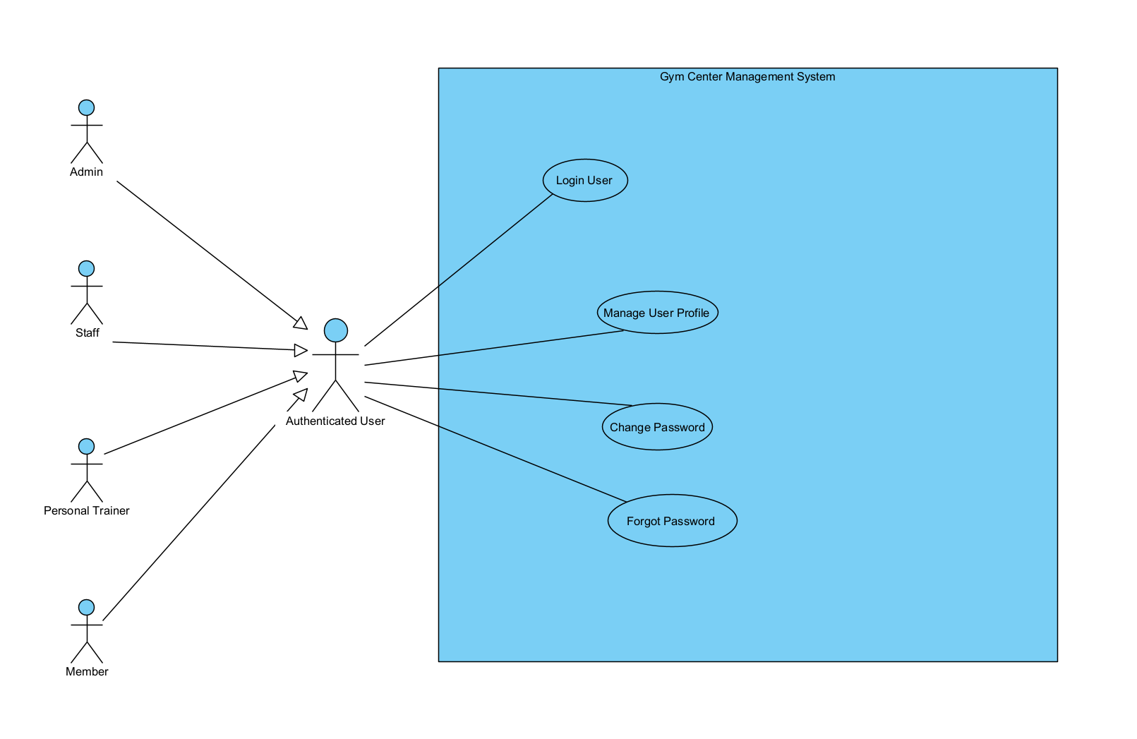
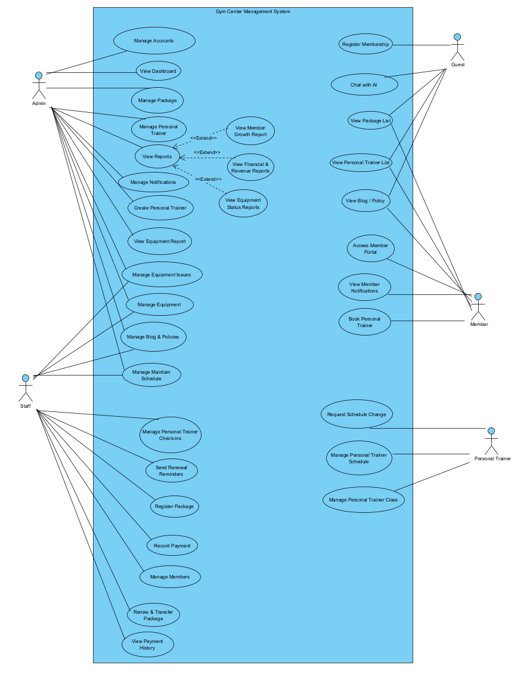

1.4 System Functionalities

1.4.1 Screens Flow
This section presents the screen flow of the Gym Center Management System. The purpose of the screen flow is to describe how users navigate between the main screens of the system when performing their tasks.
To improve readability, the screen flow is divided by user roles, including Guest, Member, Personal Trainer, Staff, and Admin. The overall screen flow shows the high-level navigation of the system, while the role-based and feature-based screen flows describe the main screens and transitions for each user 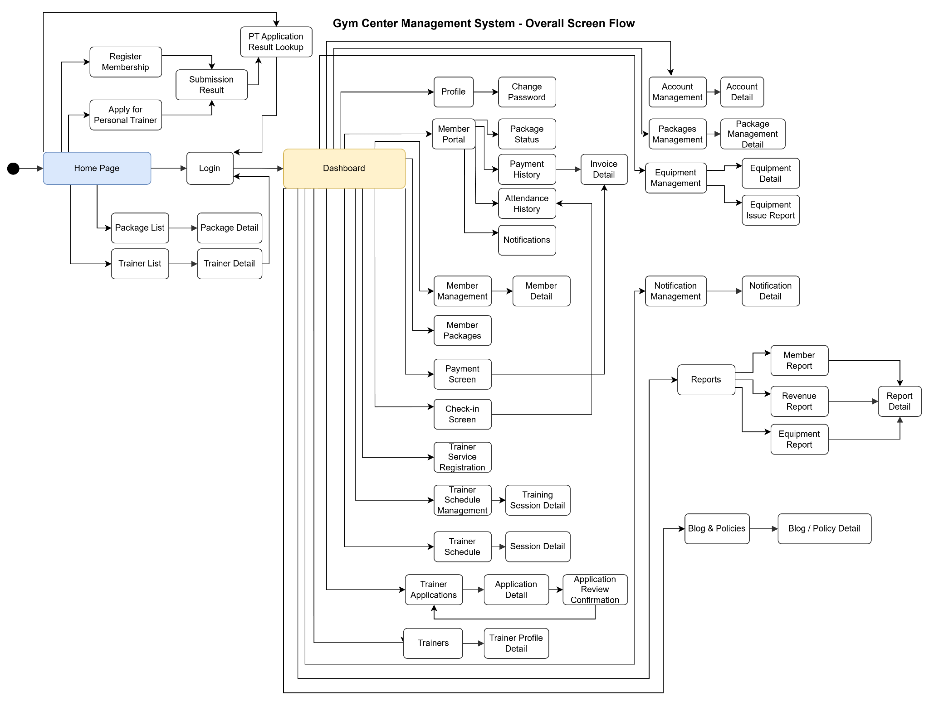
Figure 1.4.1.1 - Overall Screen Flow

1.4.2 Screen Authorization

Screen | Guest | Member | Personal Trainer | Staff | Admin
Home | X | X | X | X | X
Login | X | X | X | X | X
Register Membership | X
List PT Package |  |  |  | X | X
PT Package Create |  |  |  |  | X
PT Package Detail |  |  |  | X | X
PT Package Edit |  |  |  |  | X
Add Personal Trainer |  |  |  | X | X
PT Account Creation Result |  |  |  | X | X
Membership Package List | X | X
Package Detail | X | X
Public Personal Trainer List | X | X
Personal Trainer Detail Screen |  | X |  | X | X
User Profile |  | X | X | X | X
Change Password |  | X | X | X | X
Member Dashboard |  | X
Member Package Status |  | X
Member Payment History |  | X
Member Attendance History |  | X
Member Notifications |  | X
PT Service Registration Screen |  | X
PT Service Registration Result Screen |  | X
Personal Trainer Dashboard |  |  | X
PT Registration History(Staff-View only), Admin(View, sort delete) |  |  |  | X | X
PT Attendance Management |  |  |  | X | X
Generate PT Schedule Screen |  |  | X
Personal Trainer Management Screen |  |  |  | X | X
Member/PT Weekly Schedule Screen |  | X | X
Personal Trainer Self-Edit Profile Screen |  |  | X
Reschedule / Make-up Request Form |  | X | X
Staff/Admin Schedule Support Screen |  |  |  | X | X
Assign Substitute PT Modal |  |  |  | X | X
Mass Cancel PT Sessions Screen / Modal |  |  |  |  | X
Request Detail / Response Modal |  |  | X
Update Training Session Status Screen |  |  |  | X | X
Trainer Schedule and Work History Screen |  |  | X
Staff Dashboard |  |  |  | X
Member Management List |  |  |  | X | X
Member Detail |  |  |  | X | X
Member Package Management |  |  |  | X | X
Package Registration Screen |  |  |  | X | X
Package Renewal & Transfer Screen |  |  |  | X | X
Record Payment |  |  |  | X | X
Invoice Detail |  | X |  | X | X
Staff Payment History |  |  |  | X | X
Check-in Screen |  |  |  | X | X
Attendance History |  | X |  | X | X
Pending PT Registrations Screen |  |  | X
Equipment Management |  |  |  | X | X
Equipment Detail |  |  |  | X | X
Add Equipment |  |  |  |  | X
Equipment Status Update |  |  |  | X | X
Equipment Issue Report |  |  |  | X | X
Equipment Status Report |  |  |  |  | X
Admin Dashboard |  |  |  |  | X
Account Management |  |  |  |  | X
Account Detail |  |  |  |  | X
Package Management |  |  |  |  | X
Package Management Detail |  |  |  |  | X
Manage PT Service Price Screen |  |  |  |  | X
Notification Management |  |  |  |  | X
Notification Detail |  |  |  |  | X
Reports |  |  |  |  | X
Member Report |  |  |  |  | X
Revenue Report |  |  |  |  | X
Equipment Report |  |  |  |  | X
Report Detail |  |  |  |  | X
Blog & Policies |  | X |  | X | X

1.4.3 Non-UI Functions
This section describes system functions that are executed without direct user interaction through a screen, such as automatic jobs or background services.

# | Feature | System Function | Description
1 | Notification Management | Automatic Renewal Reminder Job | The system automatically detects membership packages that are near expiration and generates renewal reminder notifications for related members. The function checks package expiration dates based on the configured reminder threshold, creates reminder content, sends notifications through the supported channel, records the sending result, and prevents duplicate reminders for the same expiration period.

1.5 Entity Relationship Diagram
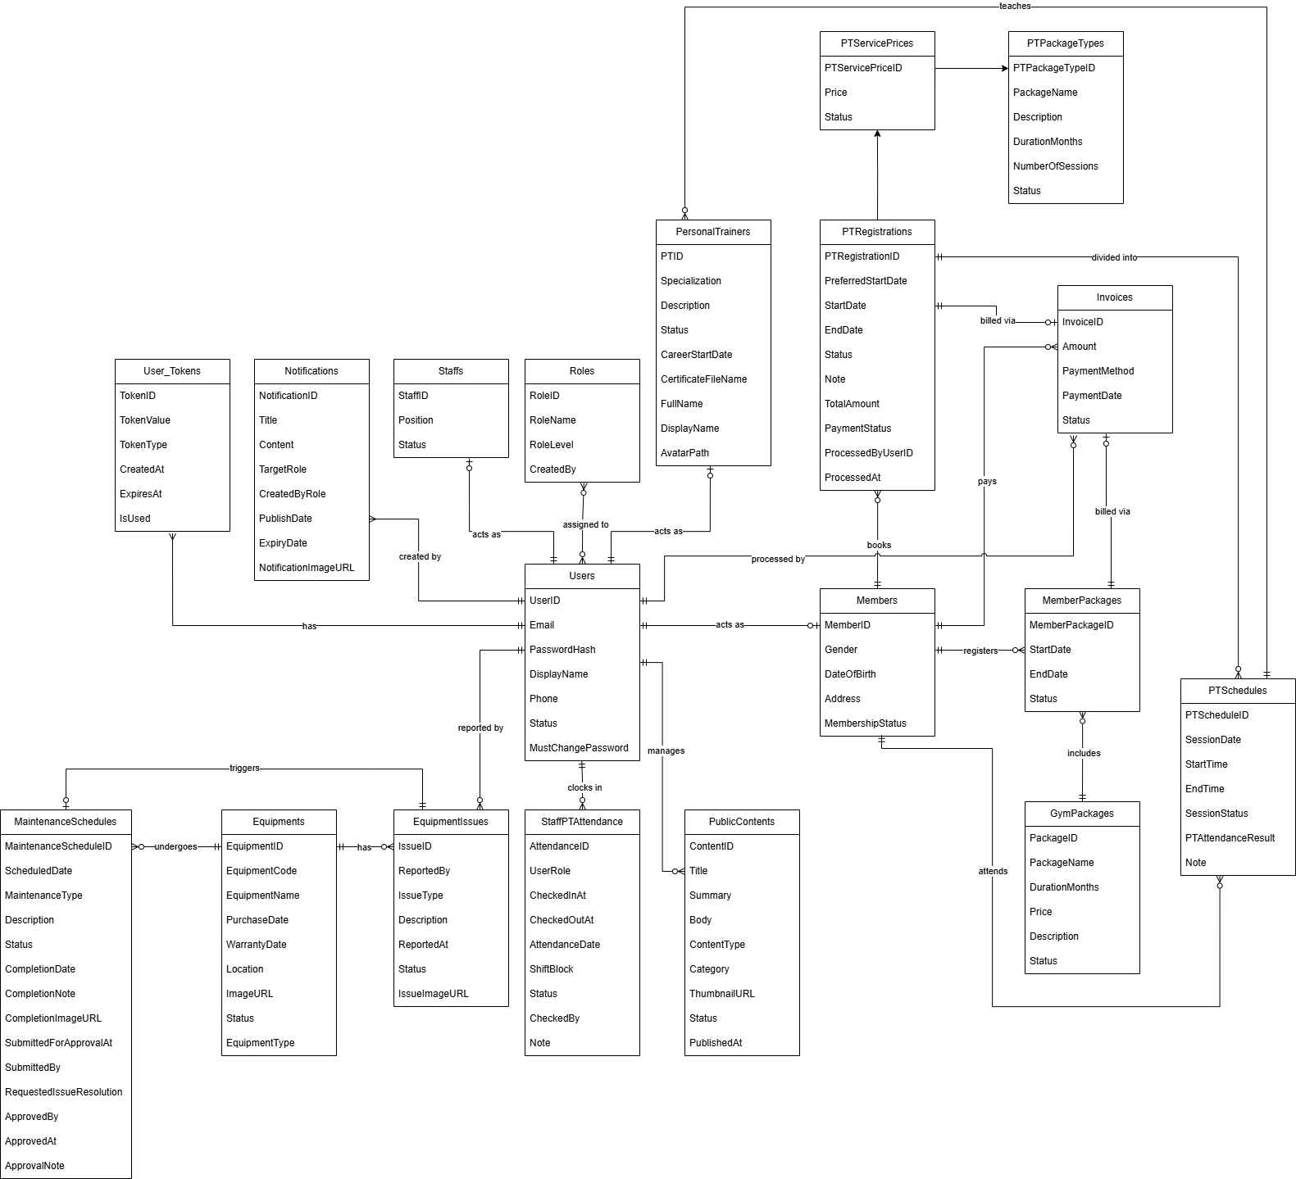
https://drive.google.com/file/d/1JFfyX2cnXeO8cDF7eUyRm2Pisg2IiMT6/view?usp=sharing
Entities Description
# | Entity | Description
1 | Users | Stores core account information, authentication credentials, account status.
2 | Roles | Stores system roles (Admin, Staff, Member, PT) for access control.
3 | Members | Stores specific profile information and current membership statuses for gym members, linking directly to the User entity.
4 | Staffs | Stores profile information, positions, and status for gym staff members.
5 | PersonalTrainers | Stores official Personal Trainer profiles, including specialization, experience, and linked user account.
6 | StaffPTAttendance | Records time tracking, check-ins, and shift blocks for staff and personal trainers.
7 | GymPackages | Catalogs the gym's available training plans (e.g., 1-month, 1-year), including duration and pricing configurations created by the Admin.
8 | MemberPackages | Records the active or expired membership plans purchased by specific members, tracking the exact start and end dates.
9 | Invoices | Records all cash transactions, invoices, and billing history for purchased membership packages and Personal Trainer service registrations.
10 | PTPackageTypes | Catalogs the available Personal Trainer service plans (number of sessions, duration).
11 | PTServicePrices | Defines specific pricing for PT package types based on the assigned Personal Trainer.
12 | PTRegistrations | Stores member registrations for Personal Trainer service plans, tracking remaining sessions and billing status.
13 | PTSchedules | Manages detailed Personal Trainer training sessions arranged by Staff/Admin, including session date, time, and attendance result.
14 | Equipments | Tracks physical gym assets, including their operational statuses (Available, Maintenance, Broken), purchase dates, and warranty periods.
15 | EquipmentIssues | Records and tracks reported problems, maintenance logs, and resolution statuses for gym equipment.
16 | MaintenanceSchedules | Tracks and schedules maintenance activities for gym equipment, often triggered by reported equipment issues.
17 | Notifications | Stores system-wide announcements, promotions, and news created by Administrators for gym members and staff.
18 | User_Tokens | Stores temporary tokens for system authentication tasks, such as password resets.

2. Use Case Specifications

2.1 Authentication

2.1.1 Login User
Primary Actors | Admin, Staff, Member, Personal Trainer | Secondary Actors
Description | This use case allows a registered user to access the Gym Center Management System by signing in with a registered email and password, or by being automatically authenticated through a valid Remember Me token. The system validates the credentials, checks the account status, creates an authenticated session, and redirects the user to the correct dashboard based on role. If the account is marked as requiring a password change, the system forces the user to complete the Change Password flow before accessing protected features. This use case also covers logout, where the system invalidates the current session and removes any stored Remember Me token.
Preconditions | The user has an existing account in the system and the account record is not deleted.  The login page is accessible.  For automatic login, the browser already stores a valid remember_me_token cookie.  For logout, the user is currently authenticated or still has a valid Remember Me token stored in the browser.
Postconditions | If login is successful, the system creates an authenticated session for the user.  If Remember Me is selected, the system stores a Remember Me token in both the database and browser cookie.  The user is redirected either to the role-based dashboard or to the Change Password page if password change is mandatory.  If logout is successful, the current session is invalidated and the Remember Me token is removed from both the browser and the system.
Normal Sequence/Flow | 1. The user requests access to the system through the Login page.  2. The system displays the login form with Email, Password, Remember Me option, Forgot Password link, and Register link.  3. The user enters email and password, optionally selects Remember Me, and submits the form.  4. The system validates that Email and Password are not empty.  5. The system authenticates the account by finding the user by email and comparing the stored password hash with the SHA-256 hash of the entered password.  6. The system checks the account status.  7. If the credentials are valid and the account is allowed to access the system, the system creates a new authenticated session and stores the logged-in user in session.  8. If the user selected Remember Me, the system generates a unique token, stores it in User_Tokens with a 7-day expiration.  9. If the account is marked MustChangePassword = true, the system redirects the user to the Change Password page.  10. Otherwise, the system redirects the user to the correct dashboard based on role: Admin, Staff, Member, or PT.
Alternative Sequences/Flows | A1. Existing authenticated session: If the user is already logged in and accesses /login, the system redirects the user to the corresponding dashboard.  A2. Automatic login by Remember Me: If no active session exists but a valid Remember Me token is found, the system authenticates the user automatically, creates a session, and continues with Step 9 or Step 10.  A3. Login without Remember Me: If the user does not select Remember Me, the system logs the user in normally without creating a persistent token.  A4. Mandatory password change: If the authenticated account has MustChangePassword = true, the system redirects the user to /change-password instead of the dashboard.  A5. Logout: When the authenticated user chooses Logout, the system deletes the Remember Me token from the database if it exists, clears the remember_me_token cookie from the browser, invalidates the current session, and redirects the user to the Login page.
Exception Flows | E1. Missing required fields: If Email or Password is blank, the system stops processing and shows an error message on the Login page.  E2. Invalid credentials: If the email does not exist or the password does not match, the system denies access and shows an invalid login error.  E3. Inactive account: If the account status is Inactive, the system denies access and informs the user that the account has not been activated.  E4. Locked account: If the account status is Locked, the system denies access and informs the user that the account is locked.  E5. Authentication or database error: If a system or database error occurs during authentication or token processing, the system stops the flow and shows a system error message.  E6. Invalid or expired Remember Me token: If a Remember Me token is missing, expired, already used, or not matched to a valid account, the system ignores automatic login and shows the normal Login page.
Business Rules | BR-CONS-01, BR-CONS-05

2.2 User Management

2.2.1 Manage User Profile
Primary Actors | Authenticated Users (Admin, Staff, Member). | Secondary Actors
Description | The authenticated user views and updates personal profile information. In the current implementation, editable profile fields are mainly supported for authenticated user.
Preconditions | The user has logged into the system successfully and the session is valid.
Postconditions | The profile information is updated successfully and stored in the system, or no change is saved if validation fails.
Normal Sequence/Flow | 1.The user selects the profile function.  2. The system retrieves the current user profile based on the logged-in account and role.  3. The system displays the profile information.  4. The user switches to edit mode.  5. The user updates the allowed profile fields.  6. The user submits the updated profile.  7. The system validates the submitted data.  8. The system saves the updated profile information.  9. The system reloads the profile page and displays a success message.
Alternative Sequences/Flows | None
Exception Flows | If required fields are missing, the system displays an error message and does not save the profile.  If the phone number is invalid or already exists in another account, the system rejects the update.  If the user attempts to change the email address, the system rejects the update.  If the date of birth is invalid or in the future, the system rejects the update.  If an uploaded file does not meet the required type or size constraints, the system rejects the upload and does not save the profile update.
Business Rule | BR-CONS-03, BR-CONS-21, BR-CONS-25

2.2.2 Change Password
Primary Actors | Authenticated Users (Admin, Staff, Member, Personal Trainer). | Secondary Actors
Description | The authenticated user changes their account password so that account security is maintained. The system also supports mandatory password change for accounts that are using a temporary password.
Preconditions | The user has logged into the system successfully and the session is valid.
Postconditions | The new password is stored successfully, MustChangePassword is cleared, remember-me tokens are revoked, other active sessions of the same account are invalidated, and the user is redirected to the appropriate dashboard.
Normal Sequence/Flow | 1.The user opens the Change Password page.  2. The system displays the password change form.  3. The user enters the current password, new password, and confirmation password.  4. The user submits the form.  5. The system validates the required fields and password rules.  6. The system verifies that the current password is correct.  7. The system verifies that the new password is different from the current password.  8. The system updates the password in the database.  9. The system clears the MustChangePassword flag.  10. The system revokes remember-me tokens and expires the remember-me cookie.  11. The system invalidates other active sessions of the same user.  12. The system redirects the user to the correct dashboard based on role .
Alternative Flows | None
Exception Flows | E1. Unauthenticated Access Error: If the user is not logged in, the system redirects the user to the Login page.  E2. Account Not Found or Inactive Error: If the current account no longer exists or is no longer in Active status, the system invalidates the session and redirects the user to the Login page.  E3. Missing Required Password Fields Error: If any password field is empty, the system displays an error message and does not continue the update.  E4. Invalid New Password Format Error: If the new password does not satisfy the password policy, the system displays an error message and does not update the password.  E5. Password Confirmation Mismatch Error: If the confirmation password does not match the new password, the system displays an error message and does not update the password.  E6. Incorrect Current Password Error: If the current password does not match the stored password, the system displays an error message and does not update the password.  E7. Reused Current Password Error: If the new password is the same as the current password, the system displays an error message and does not update the password.  E8. Password Update Persistence Error: If the system cannot save the new password because of a database or persistence failure, the system displays an error message and keeps the current password unchanged.
Business Rules | BR-CONS-01

2.2.3 Manage Account
Primary Actors | Admin | Secondary Actors
Description | The administrator manages user accounts by viewing the account list, searching and filtering accounts, creating new managed accounts, updating account details, changing supported roles, locking or unlocking accounts, resetting passwords, and deactivating accounts.
Preconditions | The administrator has logged into the system successfully and has permission to access account management.
Postconditions | The selected account is created, updated, locked, unlocked, reset, deactivated, or left unchanged if validation fails. For successful create and password reset operations, a temporary password is generated and the target account is marked to change password at the next login.
Normal Sequence/Flow | 1. The administrator opens the Account Management page.  2. The system displays the account list with search, filter, and pagination options.  3. The administrator selects an account management action.  4. If the administrator creates a new account, the administrator enters account information and submits the form.  5. If the administrator edits an existing account, the administrator updates account details and submits the form.  6. The system validates the submitted data.  7. The system saves the changes or performs the requested account action.  8. If the action is account creation or password reset, the system generates a temporary password.
Alternative Flows | A1. Search and Filter Flow: The administrator searches accounts by keyword and filters them by role, status, and page size.  A2. Lock or Unlock Account Flow: The administrator locks an active account or unlocks a locked account.  A3. Reset Password Flow: The administrator resets a user account password. The system generates a new temporary password and marks the account for mandatory password change.  A4. Deactivate Account Flow: The administrator deactivates an account instead of permanently deleting it.  A5. Role Reassignment Flow: The administrator changes the role of an eligible account between Staff and Member.
Exception Flows | E1. Unsupported Account Creation Role Error: If the administrator attempts to create an account with a role other than Staff or Member, the system rejects the request.  E2. Invalid Account Data Error: If required fields are missing, the email format is invalid, the phone number format is invalid, or the status is unsupported, the system rejects the request and does not save the account.  E3. Duplicate Email Error: If the email address is already used by another account, the system rejects the request.  E4. Duplicate Phone Number Error: If the phone number is already used by another account, the system rejects the request.  E5. Unsupported Role Transition Error: If the administrator attempts to assign or change a role outside the supported Staff and Member transition rules, the system rejects the request.  E6. Self-Role Change Error: If the administrator attempts to change the role of the currently logged-in account, the system rejects the request.  E7. Self-Status Change Error: If the administrator attempts to change the status of the currently logged-in account, the system rejects the request.  E8. Inactive-to-Locked Transition Error: If the target account is already Inactive and the administrator attempts to change it to Locked, the system rejects the request.  E9. Unlock Non-Locked Account Error: If the administrator attempts to unlock an account that is not currently Locked, the system rejects the request.  E10. PT Blocking Schedule Error: If the target account belongs to a PT and still has blocking teaching schedules, the system rejects lock or deactivation actions.  E11. Account Action Persistence Error: If the system cannot complete the requested create, update, lock, unlock, reset, or deactivation action because of a database or persistence failure, the system displays an error message and leaves the account unchanged.
Business Rules | BR-CONS-01, BR-CONS-02, BR-CONS-05, BR-ACT-08, BR-ACT-22, BR-CONS-23, BR-CONS-40

2.3 Member Management

2.3.1 Register Membership
Primary Actors | Guest | Secondary Actors
Description | This use case allows a guest to register a new membership account in the system. The system collects the registration information, validates the input data, checks the uniqueness of the email and phone number, creates a User account with the Member role and Inactive status, and creates a corresponding Member profile with initial Pending membership status. The system then generates a time-limited email verification token, sends an activation link to the registered email address, and activates the account only after successful verification.
Preconditions | The user does not have an active authenticated session.  The registration page is accessible.  The system is able to connect to the database.
Postconditions | If registration is successful, the system creates:  - a User account with role Member and status Inactive  - a Member profile with membership status Pending  - a VERIFICATION token with a 24-hour validity period  If email verification is successful:  - User.Status is updated to Active  - Member.MembershipStatus is updated to Active  - the verification token is marked as used  - the user is redirected to the Login page with a success message and pre-filled email
Normal Sequence/Flow | 1.The guest opens the registration page.  2. The system displays the registration form, including full name, email, phone number, password, confirm password, and optional profile information.  3. The guest enters the required information and submits the form.  4. The system validates required fields, input format, password confirmation, and other basic constraints.  5. The system checks that the email and phone number do not already exist in the system.  6. The system creates a new user account with role Member, status Inactive, and a hashed password.  7. The system creates the related member profile with initial status Pending.  8. The system generates a VERIFICATION token valid for 24 hours and stores it in the system.  9. The system sends an email verification link to the registered email address.  10. The system informs the guest that registration was successful and instructs them to check their email for account activation.  11. The user opens the email and clicks the verification link, or manually enters the token on the verification page.  12. The system validates the token and confirms that it is valid, unused, and not expired.  13. The system activates the user account and the member profile.  14. The system redirects the user to the Login page, displays a success message, and pre-populates the verified email address.
Alternative Sequences/Flows | A1. Registration without optional profile data: The guest may leave gender, date of birth, and address blank; the system still allows registration if all required data is valid.
Exception Flows | E1. Invalid input data: If required fields are missing, the email or phone format is invalid, the passwords do not match, the password does not meet the required format, or the date of birth is invalid, the system rejects the submission and returns the user to the registration form with an error message.  E2. Duplicate email or phone number: If the email or phone number already exists, the system stops the registration process and displays a duplication error message.  E3. Registration processing failure: If a system or database error occurs while creating the account, profile, or token, the transaction is rolled back and the system displays a registration failure message.  E4. Invalid verification token: If the token is missing, invalid, expired, or already used, the system rejects the activation request and displays a verification error message.
Business Rules | BR-CONS-02

2.3.2 Manage Members

2.3.2.1 Add Member
Primary Actors | Staff | Secondary Actors | Member
Description | This use case allows Staff to create a new Member account/profile in the Gym Management System
Preconditions | - The Staff is authenticated.  - The Staff has permission to manage members.  - The Add Member screen is available.
Postconditions | - A new Member record is created.  - The Member is assigned an initial valid status.  - The system stores creation information.
Normal Sequence/Flow | - Staff opens the Add Member screen.  - System displays the member creation form.  - Staff enters required member information.  - Staff submits the form.  - System validates all entered data.  - System checks whether the email or phone number already exists.  - System creates the Member record.  - System displays a success message.  - System redirects Staff to the member list or member detail page.
Alternative Sequences/Flows | A1: Invalid Phone Number (Error Condition)  * Line 5 Extensions: If the phone number does not follow the system requirements:  1. The system displays a validation error message indicating that the phone number must start with 0 and contain exactly 10 digits.  A2: Duplicate Account Information (Error Condition)  * Line 6 Extensions: If the entered email or phone number already exists in the system:  1. The system displays an error notification stating that the member cannot be added and requests the user to check the email or phone number.  A3: Invalid Email Format (Error Condition)  * Line 5 Extensions: If the email address lacks mandatory format symbols, such as missing an “@” symbol:  1. The system displays a validation error message informing the user to include an “@” in the email address.  A4: Missing Required Information (Error Condition)  * Line 5 Extensions: If any required member information is missing:  1. The system displays validation messages for the missing required fields.  2. The system keeps the entered valid information on the form.  3. The member account is not created.
Business Rules | BR-CONS-02, BR-CONS-40

2.3.2.2 Search & View Member List
Primary Actors | Staff | Secondary Actors | Member
Description | This use case allows Staff to search, filter, paginate, and view the list of gym members.
Preconditions | - The Staff is authenticated.  - The Staff has permission to access the member management screen.
Postconditions | - The system displays the member list matching the submitted search and filter criteria.
Normal Sequence/Flow | - Staff opens the Member Management screen.  - The system displays the member list with pagination.  - Staff enters a search keyword.  - Staff selects a membership package type filter.  - Staff submits the search/filter form.  - The system validates the submitted filter values.  - The system retrieves matching member records.  - The system displays the filtered member list.  - Staff selects View Profile for a member.  - The system opens the selected member’s portal profile.
Alternative Sequences/Flows | A1: Member Not Found (Error Condition)  * Line 7 Extensions: If no member record matches the search criteria:  1. The system displays a "Currently, no member data matches your search filters." message.
Business Rules | BR-CONS-03

2.3.2.3 Update Member Status & Notification
Primary Actors | Staff | Secondary Actors | Member
Description | This use case allows Staff to lock or unlock a member account and send a quick renewal reminder notification to a member.
Preconditions | - The Staff is authenticated.  - The Staff has permission to manage members.  - The selected member exists in the system.
Postconditions | - The selected member status is updated, or a notification is created for the selected member.
Normal Sequence/Flow | - Staff opens the Member Management screen.  - The system displays the member list and current member statuses.  - Staff selects Lock or Unlock for a member.  - The system displays a confirmation prompt.  - Staff confirms the action.  - The system validates the selected member and target status.  - The system updates the member status.  - The system redirects Staff back to the member list.  - Staff selects Send Reminder for a member.  - The system displays a confirmation prompt.  - Staff confirms the reminder action.  - The system creates a predefined renewal reminder notification for the member.  - The system redirects Staff back to the member list.
Alternative Sequences/Flows | A1: Cancel Status Update  * Line 4 Extensions: If Staff cancels the confirmation prompt:  1. The system does not update the member status.  2. The member list remains unchanged.  A2: Cancel Reminder Notification  * Line 10 Extensions: If Staff cancels the confirmation prompt:  1. The system does not create a notification.  2. The member list remains unchanged.
Business Rules | BR-CONS-03, BR-CONS-13

2.3.2.4 Delete Member
Primary Actors | Staff | Secondary Actors | Member
Description | This use case allows Staff to delete a member from the active member management list.
Preconditions | - The Staff is authenticated.  - The Staff has permission to manage members.  - The selected member exists.
Postconditions | - The selected member is deleted or removed from active member management.
Normal Sequence/Flow | - Staff opens the Member Management screen.  - The system displays the member list.  - Staff selects Delete for a member.  - The system displays a deletion confirmation prompt.  - Staff confirms the deletion.  - The system validates the selected member ID.  - The system deletes the selected member.  - The system redirects Staff back to the member list.
Alternative Sequences/Flows | A1: Cancel Deletion  * Line 4 Extensions: If Staff cancels the confirmation prompt:  1. The system does not delete the member.  2. The member list remains unchanged.
Business Rules | BR-CONS-03

2.3.3 View Member Portal
Primary Actors | Staff | Secondary Actors
Description | This use case allows a Member to view their own portal information. Staff and Admin may view a specific member portal only when a member ID is provided from the member management context.
Preconditions | - The user is authenticated.  - The Member account exists.  - For Staff/Admin access, a valid member ID is provided.
Postconditions | - The system displays the member profile and member service information.
Normal Sequence/Flow | - Member opens the Member Portal screen.  - The system verifies the authenticated user.  - The system identifies the current Member user ID.  - The system retrieves the member profile.  - The system retrieves the member services.  - The system displays the member portal.
Alternative Sequences/Flows | A1: Invalid Login Credentials (Error Condition)  * Line 1 Extensions: If authentication fails:  1. The system denies access and displays an authentication error message.
Business Rules | BR-CONS-03, R-CONS-07

2.4 Membership Management

2.4.1 Manage Package

2.4.1.1 Create Package
Primary Actors | Admin | Secondary Actors | None
Description | Create a new gym membership package plan.
Preconditions | Admin is logged in.
Postconditions | A new package is saved in the package catalog.
Normal Sequence/Flow | - Admin submits new package parameters (Name, Price, Duration).  - The system validates that package duration is positive, and price is non-negative.  - The system saves the package configuration in the database.
Alternative Sequences/Flows | A1: Validation Failure: 2a.If price/duration violates validation, system rejects changes.
Business Rules | BR-CONS-06

2.4.1.2 View Package List
Primary Actors | Admin | Secondary Actors | None
Description | Browse available package plans and details.
Preconditions | Gym packages exist in the database.
Postconditions | Package catalog is rendered. No state changes.
Normal Sequence/Flow | - User requests package list.  - The system retrieves and displays a list of active packages.
Alternative Sequences/Flows | None
Business Rules | None

2.4.1.3 Update Package Details
Primary Actors | Admin | Secondary Actors | None
Description | Update the name, pricing, duration, or description of a package.
Preconditions | Admin is logged in; Package plan exists.
Postconditions | Updated package details are saved. Existing active memberships and invoices are not retroactively modified.
Normal Sequence/Flow | - Admin submits updated package parameters (Name, Price, Duration).  - The system validates parameters.  - The system saves updates. Existing registered plans and paid invoices remain unaffected to ensure consistency.
Alternative Sequences/Flows | None
Business Rules | BR-CONS-06, BR-CONS-10

2.4.1.4 Deactivate/Disable Package
Primary Actors | Admin | Secondary Actors | None
Description | Disable a package plan from catalog (Soft Delete).
Preconditions | Admin is logged in.
Postconditions | Package status is updated to Inactive. Past registrations and reports remain intact.
Normal Sequence/Flow | - Admin requests to deactivate a package.  - System changes status of the package to Inactive in package catalog.  - Package is hidden from active registration menus, but old invoices and reports remain unchanged.
Alternative Sequences/Flows | None
Business Rules | None

2.4.2 Register Package
Primary Actors | Staff | Secondary Actors | Payment Gateway (VNPay)
Description | Register a membership plan for a member.
Preconditions | Staff is logged in; Member record exists in the system.
Postconditions | Package registration record is created with Pending Payment status.
Normal Sequence/Flow | - Staff selects Member and Gym Package.  - System validates package active status.  - The system calculates Package Start and Expiration Dates.  - The system creates a MemberPackage record in Pending Payment status and generates an invoice.  - The system redirects to Payment Gateway (VNPay).  - User completes the payment.  - Payment Gateway returns success.  - System updates invoice to Paid and activates the package.
Alternative Sequences/Flows | A1: Active Package Conflict: 3a. If the member already has an active package of the same type, the system concatenates the new duration by setting start date to the day after current package expiry.  E1: Payment Failed/Cancelled: If VNPay returns failure or user cancels, the system keeps the package as Pending Payment and notifies the user.  E2: Invalid VNPay Signature: If the callback signature is invalid, the system rejects the payment and logs a security warning.
Business Rules | BR-CONS-04, BR-COMP-12

2.4.3 Renew & Transfer Package

2.4.3.1 Renew Package
Primary Actors | Staff, Admin, Member | Secondary Actors | Payment Gateway (VNPay)
Description | Extend membership duration of a member's package.
Preconditions | Member exists; Gym Package is active or recently expired.
Postconditions | The expiration date of the package is extended after payment is recorded.
Normal Sequence/Flow | - Staff submits renewal request for a selected plan.  - The system calculates start date and expiration date.  - The system creates a pending invoice.  - The system redirects to Payment Gateway (VNPay).  - User completes the payment.  - Payment Gateway returns success.  - System updates invoice to Paid, updates expiration date and status.
Alternative Sequences/Flows | A1: Active Package Continuation: 2a. If the member already has an active package, the system concatenates the new duration by setting the start date to the day after the current package's expiration date.  E1: Gym Package Inactive: 2b. If the selected package is inactive or not found, the system aborts the request and rolls back the database transaction.  E2: Member Not Found: If the member does not exist, the system displays an error message and stops the process.  E3: Payment Failed/Cancelled: If the transaction fails on VNPay or the pending renewal invoice is cancelled, the system deletes the pending package record.  E4: Invalid VNPay Signature: If the callback signature is invalid, the system rejects the payment and logs a security warning.
Business Rules | BR-COMP-12, BR-CONS-10

2.4.3.2 Transfer Package
Primary Actors | Staff, Admin | Secondary Actors | Member
Description | Transfer the remaining active duration of a package from a transferor to a transferee.
Preconditions | Transferor has an active package with positive remaining duration.
Postconditions | Transferor's package is deactivated; transferee's package is activated with remaining duration.
Normal Sequence/Flow | - Staff submits a transfer request specifying Current Member and Target Member.  - The system verifies the transferor package is active and calculates remaining days.  - System deactivates the package for the Current Member and creates a new active package for the Target Member with the remaining duration.  - System records both parties in the audit log database.
Alternative Sequences/Flows | A1: Expired Package: 2a. If package is expired, the system blocks the transfer request.
Business Rules | BR-COMP-12, BR-CONS-18, BR-CONS-19

2.5. Payment Management

2.5.1 Record Payment
Primary Actors | Staff | Secondary Actors | None
Description | Process cash payment for a package or PT service booking, activating the service.
Preconditions | Staff is logged in; A pending unpaid invoice exists.
Postconditions | Invoice status is updated to Paid and the associated package/PT service is activated.
Normal Sequence/Flow | - Staff selects a pending invoice and submits cash payment confirmation.  - The system verifies payment completeness against the computed total.  - The system records payment transaction, sets invoice status to Paid, and automatically changes associated package/service status to Active.  - The system logs transaction audit details and prints invoice receipt.
Alternative Sequences/Flows | A1: Insufficient Cash Payment: System blocks payment confirmation and prompts for correct cash amount.
Business Rules | BR-CONS-04, BR-CONS-10

2.5.2 View Personal/ System Payment History
Primary Actors | Member (Personal), Staff & Admin (System-wide) | Secondary Actors | None
Description | Search and view details of past payment transactions.
Preconditions | User is logged in.
Postconditions | Transaction logs are displayed. No state changes.
Normal Sequence/Flow | - User submits search query or applies date range filter.  - System retrieves payment invoice records and renders list summaries.
Alternative Sequences/Flows | None
Business Rules | None

2.6. Attendance Management

2.6.1 Manage Staff & PT Check-ins
Primary Actors | Admin | Secondary Actors
Description | This use case allows Admin to manually record check-in and check-out attendance for Staff and Personal Trainers using system buttons.
Preconditions | - The Admin is authenticated.  - The Admin has permission to access the Staff/PT check-in screen.  - Active Staff and Personal Trainer accounts exist.
Postconditions | - The system creates, updates, cancels, or restores a Staff/PT attendance record.
Normal Sequence/Flow | - Admin opens the Staff & PT Check-in screen.  - The system displays shift, date, and keyword filters.  - Admin selects a shift.  - Admin selects a date.  - Admin optionally enters a keyword.  - Admin submits the filter request.  - The system validates the selected shift and date.  - The system displays active Staff/PT users and their attendance status.  - Admin selects Check In for a user.  - The system validates check-in eligibility.  - The system creates a check-in record.  - The system displays a success message.  - Admin selects Check Out for a checked-in user.  - The system validates check-out eligibility.  - The system records the check-out time.  - The system displays a success message.
Alternative Sequences/Flows | A1: Invalid Shift  * Line 7 Extensions: If the submitted shift is invalid:  1. The system defaults to the Morning shift.  2. The system displays the attendance list for the normalized shift.  A2: Check-in Not Current Date  * Line 10 Extensions: If Admin attempts check-in for a date other than the current date:  1. The system rejects the check-in.  2. The system displays a validation message.  A3: Check-in Outside Allowed Time Window  * Line 10 Extensions: If the current time is outside the selected shift’s attendance window:  1. The system rejects the check-in.  2. The system displays a message that check-in is not allowed for the shift at the current time.  A4: Check-in Outside Allowed Time Window  * Line 13 Extensions: If Admin selects Undo Check-out for a completed attendance record:  1. The system validates the attendance record.  2. The system removes the check-out time.  3. The system displays a success message.  A5: Cancel Attendance Record  * Line 13 Extensions: If Admin selects Cancel for an attendance record:  1. The system validates the attendance record.  2. The system marks the record as cancelled/deleted.  3. The system displays a success message.
Business Rules | BR-CONS-60, BR-CONS-61, BR-CONS-62

2.6.2 View Staff & PT Work History

2.6.2.1 Staff & Personal Trainer Screen
Primary Actors | Staff, Personal Trainer | Secondary Actors
Description | This use case allows Staff and Personal Trainers to view only their own attendance history.
Preconditions | - The Staff or Personal Trainer is authenticated.  - The user account is active.  - The Work History screen is available.
Postconditions | - The user views only their own attendance history.  - No attendance record is modified.
Normal Sequence/Flow | - Staff or Personal Trainer opens the Work History screen.  - The system verifies the authenticated user and role.  - The system restricts the query to the current user.  - The system displays available filters for shift and date range.  - The user selects a shift filter if needed.  - The user selects from-date and to-date filters if needed.  - The user submits the filter request.  - The system validates the filter values.  - The system retrieves attendance records belonging only to the current user.  - The system displays the attendance history list.
Alternative Sequences/Flows | A1: Invalid Date Range  * Line 8 Extensions: If the from-date is later than the to-date:  1. The system displays a validation error message.  2. The system does not retrieve attendance records.  A2: No Records Found  * Line 9 Extensions: If no records match the selected filters:  1. The system displays an empty history message.
Business Rules | BR-CONS-27

2.6.2.2 Admin Screen
Primary Actors | Admin | Secondary Actors
Description | This use case allows Admin to view attendance history for all Staff and Personal Trainers.
Preconditions | - The Admin is authenticated.  - The Admin has permission to view Staff/PT work history.
Postconditions | - The Admin views attendance history records matching selected filters.  - No attendance record is modified.
Normal Sequence/Flow | - Admin opens the Admin Work History screen.  - The system verifies Admin permission.  - The system displays role, shift, date range, and keyword filters.  - Admin selects a role filter if needed.  - Admin selects a shift filter if needed.  - Admin selects from-date and to-date filters if needed.  - Admin enters a name or email keyword if needed.  - Admin submits the filter request.  - The system validates all filter values.  - The system retrieves matching Staff/PT attendance history records.  - The system displays the attendance history list.
Alternative Sequences/Flows | A1: Invalid Date Range  * Line 9 Extensions: If the from-date is later than the to-date:  1. The system displays a validation error message.  2. The system does not retrieve attendance records.  A2: No Records Found  * Line 10 Extensions: If no records match the selected filters:  1. The system displays an empty history message.
Business Rules | BR-CONS-05

2.7. Personal Trainer Management

2.7.1 Create Personal Trainer
Primary Actors | Staff, Admin | Secondary Actors
Description | Allows authorized Staff or Administrators to create a new Personal Trainer profile and system account after the candidate has successfully passed the offline recruitment process.
Preconditions | - The Actor is authenticated and authorized to access the PT management module.  - The Personal Trainer has passed the offline recruitment evaluation.
Postconditions | - A new User entity with the 'PT' role is created with 'Active' status.  - A linked Personal Trainer profile is successfully persisted and visible in the PT directory.
Normal Sequence/Flow | - Staff/Admin: Requests the system to create a new Personal Trainer account.  - System: Prompts the Actor to provide the strictly verified professional details (Full Name, Phone Number, Specialization, Career Start Date, and Certificate), along with initial public profile data (Display Name, Biography, and Avatar).  - Staff/Admin: Provides the required verified information and uploads the relevant files.  - System: Validates the input data format, ensures the email and phone number are completely unique within the system, and verifies the Career Start Date constraint.  - System: Generates a secure temporary password and hashes it for the new account.  - System: Executes an atomic transaction to persist both the User account and the Personal Trainer profile entities into the database.  - System: Displays a success notification along with the generated temporary password for the initial login handover.
Alternative Sequences/Flows | E1. Duplicate Contact Information:  At Step 4 of the Normal Flow: If the System detects that the provided email or phone number already exists in the database, the System aborts the transaction, preserves the previously entered valid data, and displays a specific duplicate data error message.  E2. Invalid Career Experience:  At Step 4 of the Normal Flow: If the System detects that the calculated experience (based on the Career Start Date) is less than 1 year or exceeds 25 years, the System rejects the input and prompts the Actor to correct the timeline.  E3. File Upload Violation:  At Step 4 of the Normal Flow: If the uploaded Avatar or Certificate exceeds the size limit (e.g., 5MB) or is in an unsupported format, the System intercepts the request and displays a file validation error.
Business Rules | BR-ACT-08, BR-CONS-02, BR-CONS-40, BR-CONS-20, BR-ACT-22, BR-CONS-45

2.7.2 View Personal Trainer List
Primary Actors | Guest, Member | Secondary Actors
Description | Allows Guests and authenticated Members to browse and search the directory of official, active Personal Trainers. Authenticated Members are granted extended privileges to view detailed service package pricing.
Preconditions | - The system database contains at least one Personal Trainer record with an 'Active' working status.
Postconditions | - The Actor successfully views the permitted Personal Trainer information.  - The system state remains unchanged (Read-only operation).
Normal Sequence/Flow | - Guest/Member: Requests to view the Personal Trainer directory.  - System: Retrieves all Personal Trainer profiles that have an 'Active' status.  - System: Displays the directory containing basic public information (e.g., Avatar, Display Name, Experience Years, Specialization).  - Guest/Member: Provides specific search criteria (e.g., keyword, preferred specializations).  - System: Validates the search parameters and queries the database for matching 'Active' profiles.  - System: Displays the filtered list of Personal Trainers.
Alternative Sequences/Flows | A1. Extended Pricing View (Member Privilege):  At Step 3 or 6 of the Normal Flow: If the System detects that the Actor is an authenticated Member, the System additionally retrieves and displays the active service package prices associated with each Personal Trainer.  A2. Restricted Pricing View (Guest Restriction):  At Step 3 or 6 of the Normal Flow: If the System detects that the Actor is an unauthenticated Guest, the System hides the detailed pricing information and displays a prompt requesting the Actor to authenticate (login) to view service prices.  E1. No Matching Results:  At Step 5 of the Normal Flow: If the System finds no active Personal Trainers matching the provided search criteria, the System returns an empty dataset and displays a "No trainers found" informational message.
Business Rules | BR-CONS-28

2.7.3 Manage PT Registrations
Description: This management use case groups the main PT registration operations, including member registration, payment approval, registration history viewing, and removal of cancelled registration records.

2.7.3.1 Register PT Service
Primary Actors | Member | Secondary Actors
Description | This use case allows a Member to register for a Personal Trainer service package with a selected Personal Trainer. The registration is created as a request and waits for Staff/Admin payment confirmation before it becomes active.
Preconditions | - Member has logged in.  - Member has an active membership.  - Selected Personal Trainer is active.  - Selected PT service package is available.
Postconditions | - System records a new PT registration request.  - PT registration status is Pending.  - Payment status is Unpaid.  - Staff/Admin can process the registration later.
Normal Sequence/Flow | - Member requests PT service registration.  - System validates member eligibility.  - System validates selected PT service availability.  - System validates preferred start date.  - System checks duplicate active or pending PT registrations.  - System records the PT registration request.  - System generates an invoice and redirects Member to Payment Gateway (VNPay).  - Member completes the payment.  - Payment Gateway returns success.  - System updates registration and payment status to Active and Paid.
Alternative Sequences/Flows | E1. Invalid Preferred Start Date: System detects that the preferred start date is earlier than the registration date or later than one year after the registration date. System rejects the PT service registration request. System informs the Member about the invalid preferred start date.  E2. Duplicate Pending Registration For The Same PT Service: System detects that the Member already has a pending registration request for the same Personal Trainer service package. System rejects the duplicate PT service registration request. System informs the Member about the duplicate pending registration.  E3. Payment Failed/Cancelled: If VNPay returns a failure or the Member cancels, the system keeps the registration as Unpaid/Pending and notifies the Member.  E4. Invalid VNPay Signature: If the callback signature is invalid, the system rejects the payment and logs a security warning.
Business Rules | BR-CONS-03, BR-CONS-11, BR-ACT-16, BR-CONS-29

2.7.3.2 Approve PT Registration
Primary Actors | Staff, Admin | Secondary Actors | Member, Personal Trainer
Description | This use case allows Staff/Admin to approve a PT registration after payment confirmation.
Preconditions | - Staff/Admin has logged in.  - PT registration exists.  - PT registration status is Pending.  - Payment status is Unpaid.
Postconditions | - PT registration status becomes Active.  - Payment status becomes Paid.  - System records the processing information.  - Personal Trainer can generate the PT schedule later.
Normal Sequence/Flow | - Staff/Admin requests PT registration approval.  - System validates registration status.  - System validates payment status.  - System activates the PT registration.  - System records the approval result.  - System confirms successful approval.
Alternative Sequences/Flows | E1. Registration Is Not Pending  - System detects that the PT registration is not pending.  - System rejects the approval request.  - System keeps the PT registration unchanged.  E2. Payment Is Not Confirmed  - System detects that payment confirmation is not available.  - System rejects the approval request.  - System keeps the PT registration as unpaid.  E3. Selected Personal Trainer Is Inactive  - System detects that the selected Personal Trainer is inactive.  - System rejects the approval request.  - System keeps the PT registration unchanged.
Business Rules | BR-ACT-16, BR-CONS-29

2.7.3.3 View PT Registration History
Primary Actors | Staff, Admin | Secondary Actors
Description | This use case allows Staff/Admin to review PT registration records for operational tracking.
Preconditions | - Staff/Admin has logged in.  - Staff/Admin has permission to access PT registration records.
Postconditions | - System presents PT registration history.  - No registration data is modified.
Normal Sequence/Flow | - Staff/Admin requests PT registration history.  - System retrieves matching PT registration records.  - System presents PT registration history.  - Staff/Admin reviews PT registration information.
Alternative Sequences/Flows | A1. No Registration History Found  - System finds no PT registration history records.  - System presents an empty history result.  - Staff/Admin reviews the empty history result.
Business Rules | BR-CONS-04, BR-CONS-05, BR-CONS-29

2.7.3.4 Remove Cancelled PT Registration History
Primary Actors | Admin | Secondary Actors
Description | This use case allows an Admin to remove cancelled PT registration records from the normal history view.
Preconditions | - Admin has logged in.  - Cancelled PT registration record exists.  - Admin has permission to remove PT registration history records.
Postconditions | - System hides the cancelled registration from the normal history view.  - System preserves historical data for audit purposes.  - Staff cannot remove the registration record.
Normal Sequence/Flow | - Admin requests removal of a cancelled PT registration record.  - System validates Admin permission.  - System validates registration status.  - System removes the cancelled registration from the normal history view.  - System confirms successful removal.
Alternative Sequences/Flows | E1. Registration Is Not Cancelled  - System detects that the selected PT registration is not cancelled.  - System rejects the removal request.  - System keeps the PT registration history unchanged.  E2. User Is Not Admin  - System detects that the actor does not have Admin permission.  - System denies the removal request.  - System keeps the PT registration history unchanged.
Business Rules | BR-CONS-05

2.7.4 Manage Personal Trainers
Description: This management use case groups Personal Trainer administration operations, including profile update, service price configuration, and account deactivation.

2.7.4.1 Update Personal Trainer Profile
Primary Actors | Staff, Admin | Secondary Actors | Personal Trainer
Description | This use case allows Staff/Admin to update verified Personal Trainer profile information so that official trainer records remain accurate.
Preconditions | - Staff/Admin has logged in.  - Staff/Admin has permission to manage Personal Trainer profiles.  - The selected Personal Trainer exists in the system
Postconditions | - The system saves the updated Personal Trainer profile information.  - The updated trainer information becomes available for authorized users.  - Historical PT account and schedule data remain unchanged.
Normal Sequence/Flow | - Staff/Admin requests Personal Trainer profile update.  - System retrieves the selected Personal Trainer record.  - Staff/Admin provides updated trainer profile information.  - System validates the updated trainer profile information.  - System saves the updated Personal Trainer profile.  - System confirms successful profile update
Alternative Sequences/Flows | E1. Invalid Career Experience  - System detects that the trainer career experience violates the allowed range.  - System rejects the profile update request.  - System informs Staff/Admin about the invalid career experience.  E2. Invalid Profile Information  - System detects invalid required trainer information.  - System rejects the profile update request.  - System informs Staff/Admin about the invalid profile information.  E3. Invalid File Upload  - System detects an invalid trainer profile file.  - System rejects the profile update request.  - System informs Staff/Admin about the invalid file information
Business Rules | BR-CONS-02, BR-CONS-40, BR-CONS-20, BR-CONS-45

2.7.4.2 Personal Trainer Self-Edit Profile
Primary Actors | Personal Trainer | Secondary Actors
Description | Allows a Personal Trainer to update their public-facing profile information (Display Name, Biography, and Avatar) while restricting access to verified administrative data.
Preconditions | - The Personal Trainer has successfully logged into the system and the session is valid.
Postconditions | - The Personal Trainer's public profile information is successfully updated and persisted in the database.
Normal Sequence/Flow | - Personal Trainer requests to access the personal profile editing interface.  - System retrieves the Personal Trainer's current profile data from the database.  - System displays the profile information, enforcing read-only restrictions on verified administrative fields (Full Name, Phone, Specialization, Certificate, Status)  - Personal Trainer provides updated information for the permitted fields (Display Name, Biography) and an optional Avatar file.  - Personal Trainer submits the profile update request.  - System validates the input data (e.g., character limits, allowed image file formats, and file size constraints).  - System saves the updated profile data into the database.  - System displays a success notification confirming the update.
Alternative Sequences/Flows | A1. Validation Error (Invalid Input or File Exceeds Limit):  - System detects invalid input (e.g., Biography exceeds 500 characters, or uploaded Avatar exceeds system size limits/unsupported format).  - System rejects the update request and retains the previously entered data.  - System displays a specific validation error notification requiring correction.
Business Rules | BR-CONS-21, BR-CONS-25

2.7.4.3 Configure PT Service Price
Primary Actors | Admin | Secondary Actors | Personal Trainer
Description | This use case allows an Admin to configure PT service prices for a Personal Trainer by PT package type.
Preconditions | - Admin has logged in.  - Admin has permission to configure PT service prices.  - The selected Personal Trainer exists in the system.  - The selected PT package type exists in the system.
Postconditions | - The system saves the updated PT service price configuration.  - The updated price becomes available for future PT service registrations.  - Existing completed registration amounts remain unchanged.
Normal Sequence/Flow | - Admin requests PT service price configuration.  - System retrieves the current PT service price configuration.  - Admin provides updated PT service prices.  - System validates the updated PT service prices.  - System saves the PT service price configuration.  - System confirms successful price configuration.
Alternative Sequences/Flows | E1. Invalid Service Price  - System detects that the provided service price violates pricing rules.  - System rejects the price configuration request.  - System informs Admin about the invalid service price.  E2. Unauthorized Price Configuration  - System detects that the current user does not have Admin permission.  - System denies the price configuration request.  - System keeps the PT service price unchanged.
Business Rules | BR-CONS-46, BR-CONS-29

2.7.4.4 Deactivate Personal Trainer Account
Primary Actors | Admin | Secondary Actors | Personal Trainer
Description | This use case allows an Admin to deactivate a Personal Trainer account so that inactive trainers can no longer access PT functions.
Preconditions | - Admin has logged in.  - Admin has permission to deactivate Personal Trainer accounts.  - The selected Personal Trainer exists in the system.  - The selected Personal Trainer is currently active.
Postconditions | - The Personal Trainer status becomes inactive.  - The linked user account becomes locked.  - Historical PT schedules and registration records remain preserved.
Normal Sequence/Flow | - Admin requests Personal Trainer account deactivation.  - System retrieves the selected Personal Trainer account status.  - System validates the deactivation condition.  - Admin confirms the deactivation request.  - System deactivates the Personal Trainer account.  - System locks the linked user account.  - System confirms successful account deactivation.
Alternative Sequences/Flows | A1. Admin Cancels Deactivation  - Admin cancels the deactivation request.  - System keeps the Personal Trainer account unchanged.  - The use case ends without deactivating the account.  E1. Personal Trainer Is Already Inactive  - System detects that the Personal Trainer is already inactive.  - System rejects the deactivation request.  - System informs Admin about the current trainer status.  E2. Unauthorized Deactivation  - System detects that the current user does not have Admin permission.  - System denies the deactivation request.  - System keeps the Personal Trainer account unchanged.
Business Rules | BR-ACT-44

2.7.5 Manage PT Schedules
Description: This management use case groups PT schedule operations, including automatic schedule generation, normal reschedule requests, make-up requests for cancelled sessions, Staff/Admin support review, substitute PT assignment, training session status update, and mass cancellation.

For reschedule and make-up requests, Member or Personal Trainer must propose a valid date and fixed time slot before submitting the request. The system checks PT availability, Member availability, fixed-slot validity, and mass-cancelled date restrictions before the request is submitted. Staff/Admin only reviews the submitted request and chooses Approve or Reject; Staff/Admin does not manually select a different date or time slot in this scope.

2.7.5.1 Generate PT Schedule Automatically
Primary Actors | Personal Trainer | Secondary Actors | Member
Description | This use case allows a Personal Trainer to generate all required PT training sessions for an active and paid PT registration.
Preconditions | - Personal Trainer has logged in.  - The PT registration belongs to the Personal Trainer.  - The PT registration is active.  - The PT registration is paid.  - No PT schedule has been generated for the registration.
Postconditions | - The system creates all required PT training sessions.  - Created training sessions have upcoming status.  - No partial schedule is saved if schedule generation fails.  - PT and Member schedules remain free from time overlap.
Normal Sequence/Flow | - Personal Trainer requests automatic schedule generation.  - System validates the assigned PT registration.  - System validates the selected fixed training pattern.  - System checks PT and Member schedule availability.  - System generates all required training sessions.  - System confirms successful schedule generation.
Alternative Sequences/Flows | E1. Registration Is Not Active Or Paid  - System detects that the PT registration is not active or not paid.  - System rejects schedule generation.  - System informs the Personal Trainer about the registration status issue.  E2. Schedule Already Generated  - System detects existing training sessions for the PT registration.  - System rejects duplicate schedule generation.  - System informs the Personal Trainer that the schedule already exists.  E3. Schedule Conflict Detected  - System detects a time overlap for the Personal Trainer or the Member.  - System rejects schedule generation.  - System keeps all existing schedules unchanged.  E4. Cannot Generate Required Number Of Sessions  - System detects that the selected training pattern cannot generate all purchased sessions without conflicts.  - System rejects schedule generation.  - System keeps all existing schedules unchanged.
Business Rules | BR-CONS-41, BR-ACT-42

2.7.5.2 Create Reschedule Request
Primary Actors | Member, Personal Trainer | Secondary Actors
Description | This use case allows a Member or Personal Trainer to request a schedule change for an upcoming PT training session by proposing a new fixed training slot. Before the request is submitted, the system validates the proposed date and slot against the Personal Trainer schedule, Member schedule, fixed-slot list, and mass-cancelled date restrictions.
Preconditions | - The actor has logged in.  - The selected PT training session exists.  - The selected PT training session is upcoming.  - The actor is related to the selected PT training session.
Postconditions | - The system creates a reschedule request.  - The request status is pending.  - The receiver can review and respond to the request.  - The original training session remains unchanged until approval.
Normal Sequence/Flow | - Member/PT selects an upcoming PT session.  - System displays the current session information.  - Member/PT selects a proposed date.  - System displays available fixed slots for the selected date.  - System marks unavailable slots if the PT or Member already has a schedule conflict.  - Member/PT selects an available slot and enters a reason.  - System validates the proposed slot again.  - System creates a reschedule request with Pending status.  - System confirms successful request creation.
Alternative Sequences/Flows | E1. Selected Session Is Not Upcoming  - System detects that the selected training session is not upcoming.  - System rejects the reschedule request.  - System informs the actor about the invalid session status.  E2. Invalid Proposed Date  - System detects that the proposed date is not valid or not in the future.  - System rejects the reschedule request.  - System asks the actor to select another valid date.  E3. Proposed Slot Conflicts With Existing Schedule  - System detects that the proposed slot overlaps with an existing schedule.  - System rejects the reschedule request.  - System informs the actor about the schedule conflict.  E4. User Is Not Related To The Session  - System detects that the actor is not related to the selected training session.  - System denies the reschedule request.  - System keeps the training session unchanged.  E5. Proposed Date Has Been Mass Cancelled  - System detects that the proposed date has been mass cancelled.  - System rejects the proposed slot.  - System asks the actor to select another date.
Business Rules | BR-CONS-41

2.7.5.3 Respond Reschedule Request
Primary Actors | Member, Personal Trainer | Secondary Actors
Description | This use case allows the receiver of a normal reschedule request to approve or reject the proposed schedule change. If approved, the system updates the existing Upcoming session to the proposed date and time. If rejected, the original session remains unchanged.
Preconditions | - The actor has logged in.  - The reschedule request exists.  - The reschedule request is pending.  - The actor is the receiver of the reschedule request.
Postconditions | - If the request is approved, the system updates the training session schedule.  - If the request is rejected, the system keeps the training session unchanged.  - The system records the response result.
Normal Sequence/Flow | - Receiver reviews a pending reschedule request.  - Receiver approves the proposed schedule change.  - System validates the current request status.  - System validates the proposed training slot availability.  - System updates the training session schedule.  - System records the approval result.
Alternative Sequences/Flows | A1. Receiver Rejects Request  - Receiver rejects the reschedule request.  - System records the rejection result.  - System keeps the training session unchanged.  E1. Request Is No Longer Pending  - System detects that the request is no longer pending.  - System rejects the response action.  - System keeps the request and training session unchanged.  E2. User Is Not Request Receiver  - System detects that the actor is not the request receiver.  - System denies the response action.  - System keeps the request and training session unchanged.  E3. Approved Slot Has Become Unavailable  - System detects that the proposed slot has become unavailable.  - System rejects the approval action.  - System keeps the training session unchanged.
Business Rules | BR-CONS-41

2.7.5.4 Request Staff Support
Primary Actors | Member, Personal Trainer | Secondary Actors | Staff, Admin
Description | This use case allows a Member or Personal Trainer to escalate a pending or rejected schedule request to Staff/Admin for support. Staff/Admin reviews the existing proposed slot and can only approve or reject the request with a response reason. Staff/Admin does not choose a different proposed date or time slot in this scope.
Preconditions | - The actor has logged in.  - The reschedule request exists.  - The actor is related to the reschedule request.  - The request is eligible for staff support.
Postconditions | - The request status becomes Escalated.  - Staff/Admin can review the escalated request.  - The original training session remains unchanged until Staff/Admin approves the existing proposed slot.  - If Staff/Admin rejects the request, the requester may submit a new request with another proposed slot.
Normal Sequence/Flow | - Member/PT requests Staff/Admin support for an existing schedule request.  - System validates that the actor is related to the request.  - System validates that the request is eligible for escalation.  - Actor enters an escalation reason.  - System changes the request status to Escalated.  - Staff/Admin reviews the escalated request.  - Staff/Admin approves or rejects the existing proposed slot.  - System records the response result.
Alternative Sequences/Flows | E1. Request Cannot Be Escalated  - System detects that the request is not eligible for escalation.  - System rejects the staff support request.  - System keeps the request status unchanged.  E2. User Is Not Related To The Request  - System detects that the actor is not related to the request.  - System denies the staff support request.  - System keeps the request status unchanged.
Business Rules | BR-ACT-49, BR-CONS-41

2.7.5.5 Assign Substitute PT
Primary Actors | Admin. Staff | Secondary Actors | Personal Trainer, Member
Description | This use case allows Staff/Admin to assign another Personal Trainer to teach an upcoming PT training session when the original trainer is unavailable.
Preconditions | - Staff/Admin has logged in.  - Staff/Admin has permission to assign substitute trainers.  - The selected training session exists.  - The selected training session is upcoming.  - The substitute Personal Trainer is active.
Postconditions | - The system assigns the substitute Personal Trainer to the training session.  - The system preserves the original Personal Trainer information.  - The substitute Personal Trainer can view the assigned substitute session.  - The Member can view the updated trainer assignment.
Normal Sequence/Flow | - Staff/Admin requests substitute PT assignment.  - System validates the selected training session.  - System validates the substitute Personal Trainer status.  - System checks substitute Personal Trainer availability.  - System assigns the substitute Personal Trainer.  - System preserves the original trainer information.  - System confirms successful substitute assignment.
Alternative Sequences/Flows | A1. Staff/Admin Cancels Substitute Assignment  - Staff/Admin cancels the substitute assignment.  - System keeps the training session unchanged.  - The use case ends without assigning a substitute trainer.  Exception Flows  E1. Session Is Not Upcoming  - System detects that the selected session is not upcoming.  - System rejects the substitute assignment.  - System keeps the training session unchanged.  E2. Substitute PT Is Inactive  - System detects that the substitute Personal Trainer is inactive.  - System rejects the substitute assignment.  - System keeps the training session unchanged.  E3. Substitute PT Has Schedule Conflict  - System detects that the substitute Personal Trainer has a schedule conflict.  - System rejects the substitute assignment.  - System keeps the training session unchanged.
Business Rules | BR-CONS-28, BR-CONS-41

2.7.5.6 Update Training Session Status
Primary Actors | Staff, Admin | Secondary Actors | Member, Personal Trainer
Description | This use case allows Staff/Admin to update the status and attendance result of a PT training session according to the actual training outcome.
Preconditions | - Staff/Admin has logged in.  - Staff/Admin has permission to update training session status.  - The selected training session exists.  - The selected training session is eligible for status update.
Postconditions | - The system updates the training session status.  - The system records the attendance result when the session is completed.  - Cancelled sessions are not counted as used sessions.  - Completed sessions are counted as used sessions.
Normal Sequence/Flow | - Staff/Admin requests training session status update.  - System validates the selected training session.  - Staff/Admin provides the training session outcome.  - System validates the requested status update.  - System updates the training session status.  - System records the session outcome.
Alternative Sequences/Flows | A1. Admin Cancels Future Session  - Admin requests cancellation of an eligible future session.  - System validates the cancellation condition.  - System cancels the training session.  - System records the cancellation reason.  E1. Invalid Attendance Date  - System detects that the training session is not eligible for attendance recording.  - System rejects the attendance update.  - System keeps the training session unchanged.  E2. Unauthorized Session Cancellation  - System detects that the actor lacks permission to cancel the session.  - System denies the cancellation request.  - System keeps the training session unchanged.  E3. Session Cannot Be Updated  - System detects that the training session cannot be updated.  - System rejects the status update.  - System keeps the training session unchanged.
Business Rules | BR-CONS-47, BR-CONS-48

2.7.5.7 Mass Cancel PT Sessions
Primary Actors | Admin | Secondary Actors | Member, Personal Trainer
Description | This use case allows an Admin to cancel all upcoming PT training sessions on a selected date due to force majeure or gym-level operational issues. After mass cancellation, affected Member/PT may submit a make-up request by proposing a new valid date and fixed slot. Staff/Admin reviews the proposed make-up request and can only approve or reject it. Staff/Admin does not manually choose another make-up slot.
Preconditions | - Admin has logged in.  - Admin has permission to perform mass cancellation.  - The selected date is valid.  - Upcoming PT sessions exist on the selected date.
Postconditions | - The system cancels all upcoming PT sessions on the selected date.  - Completed sessions remain unchanged.  - Already cancelled sessions remain unchanged.  - Cancelled sessions are preserved for make-up scheduling.  - Cancelled sessions are not counted as used sessions.
Normal Sequence/Flow | - Admin requests mass cancellation of PT sessions.  - System retrieves eligible upcoming sessions on the selected date.  - Admin provides the cancellation reason.  - System validates the mass cancellation condition.  - System cancels the eligible upcoming sessions.  - System preserves the cancelled sessions for make-up scheduling.  - System confirms successful mass cancellation.
Alternative Sequences/Flows | A1. Admin Cancels Mass Cancellation  - Admin cancels the mass cancellation request.  - System keeps all PT sessions unchanged.  - The use case ends without cancelling sessions.  E1. No Upcoming Sessions Found  - System finds no eligible upcoming sessions on the selected date.  - System rejects the mass cancellation request.  - System keeps all PT sessions unchanged.  E2. Unauthorized Mass Cancellation  - System detects insufficient permission.  - System denies the mass cancellation request.  - System keeps all PT sessions unchanged.
Business Rules | BR-CONS-48, BR-CONS-50

2.7.5.8 Create Make-up Request For Cancelled Session
Primary Actors | Member, Personal Trainer | Secondary Actors | Staff, Admin
Description | This use case allows a Member or Personal Trainer to request a make-up session for a cancelled PT session. The requester must propose a new date and fixed slot before submitting the request. The system validates PT availability, Member availability, fixed-slot validity, future date condition, and mass-cancelled date restrictions. Staff/Admin only reviews the submitted make-up request and approves or rejects it.
Preconditions | - The actor has logged in.  - The selected PT session exists.  - The selected PT session has Cancelled status.  - The actor is related to the selected session.  - The cancelled session has no pending or approved make-up request.
Postconditions | - A make-up request is created with Pending status.  - The original Cancelled session remains unchanged.  - Staff/Admin can review the make-up request later.  - No new session is created until Staff/Admin approves the request.
Normal Sequence/Flow | - Member/PT opens a cancelled PT session.  - System displays cancellation reason and “Request Make-up Session”.  - Member/PT selects a proposed date.  - System displays fixed slots for the selected date.  - System disables slots that conflict with PT or Member schedule.  - Member/PT selects an available slot and enters a reason.  - System validates the proposed make-up slot.  - System creates a make-up request with Pending status.  - System confirms successful request creation.
Alternative Sequences/Flows | E1. Proposed Slot Conflicts With PT Schedule.  - The system detects that the selected PT already has another PT session in the proposed slot.  - The system rejects the proposed make-up slot.  - The system displays an error message.  - The make-up request is not created.  E2. Proposed Slot Conflicts With Member Schedule.  - The system detects that the selected Member already has another PT session in the proposed slot.  - The system rejects the proposed make-up slot.  - The system displays an error message.  - The make-up request is not created.  E3. Proposed Date Has Been Mass Cancelled.  - The system detects that the proposed date has been mass cancelled by Admin.  - The system rejects the proposed make-up date.  - The system displays an error message.  - The make-up request is not created.  E4. Proposed Date Is Not In The Future.  - The system detects that the proposed date is today or in the past.  - The system rejects the proposed make-up date.  - The system displays an error message.  - The make-up request is not created.  E5. Cancelled Session Already Has Pending Or Approved Make-up Request.  - The system detects that the cancelled session already has a pending or approved make-up request.  - The system prevents the requester from creating another make-up request.  - The system displays an error message.  - The existing cancelled session remains unchanged.
Business Rules | BR-CONS-50, BR-CONS-41

2.7.5.9 Process Make-up Request
Primary Actors | Staff, Admin | Secondary Actors | Member, Personal Trainer
Description | This use case allows Staff/Admin to review a make-up request submitted by a Member or Personal Trainer. Staff/Admin can approve or reject only the proposed slot already submitted in the request. Staff/Admin cannot manually select another date or time slot in this scope.
Preconditions | - Staff/Admin has logged in.  - The make-up request exists.  - The make-up request is Pending or Escalated.  - The original PT session has Cancelled status.
Postconditions | - If approved, the system creates a new Upcoming PT session using the proposed date and fixed slot.  - The original Cancelled session remains unchanged for historical tracking.  - If rejected, no new PT session is created.  - Rejected make-up request does not consume the cancelled session.
Normal Sequence/Flow | - Staff/Admin opens the make-up request list.  - System displays requester, member, PT, cancelled session, cancellation reason, and proposed make-up slot.  - Staff/Admin reviews the request.  - Staff/Admin approves the proposed slot.  - System re-validates PT availability, Member availability, fixed-slot validity, and mass-cancelled date restriction.  - System creates a new Upcoming session.  - System records approval information.  - System confirms successful approval.
Alternative Sequences/Flows | A1. Staff/Admin Rejects Request  - Staff/Admin enters rejection reason.  - System records the rejection result.  - System does not create a new session.  - System keeps the cancelled session eligible for another make-up request.
Business Rules | BR-ACT-49, BR-CONS-50, BR-CONS-41

2.7.6 View PT Work Dashboard
Primary Actors | Personal Trainer | Secondary Actors
Description | This use case allows a Personal Trainer to view assigned schedules, substitute sessions, cancelled sessions, reschedule requests, assigned members, PT package progress, and completed work history in a read-only dashboard.
Preconditions | - Personal Trainer has logged in.  - Personal Trainer has permission to view their own PT work information.
Postconditions | - The system presents the Personal Trainer’s work information.  - No PT schedule, registration, or attendance data is modified.
Normal Sequence/Flow | - Personal Trainer requests PT work dashboard information.  - System retrieves assigned upcoming sessions.  - System retrieves substitute sessions assigned to the Personal Trainer.  - System retrieves cancelled sessions and cancellation reasons.  - System retrieves assigned members and package progress.  - System retrieves completed work history.  - System presents the PT work dashboard information.
Alternative Sequences/Flows | A1. No Schedule Found  - System finds no assigned schedule records.  - System presents an empty schedule result.  - Personal Trainer reviews the available dashboard information.  A2. No Assigned Members Found  - System finds no assigned members.  - System presents an empty member result.  - Personal Trainer reviews the available dashboard information.  A3. No Work History Found  - System finds no completed work history.  - System presents an empty work history result.  - Personal Trainer reviews the available dashboard information.  E1. Unauthorized Dashboard Access  - System detects that the actor is not authorized to view the PT work dashboard.  - System denies the dashboard access request.  - System keeps PT work information protected.
Business Rules | BR-CONS-15, BR-CONS-48, BR-CONS-50, BR-COMP-51

2.7.7 Manage PT Package Types
Description: This management use case allows administrators to create, view, update, and delete Personal Trainer packages. Staff members only have the right to view those Personal Trainer packages.

2.7.7.1 View list PT Package
Primary Actors | Staff, Admin | Secondary Actors
Description | Allows Staff/Admin to view list PT package with a status package filter.
Preconditions | - Admin/Staff logged in the system
Postconditions | - List of PT package
Normal Sequence/Flow | - Admin/Staff: Requests to view the list of PT packages.  - System: Retrieves all undeleted package records from the database.  - System: Displays the list including Package Name, Duration, Total Sessions, and Status.
Alternative Sequences/Flows | A1. Empty Package List:  - System: Determines that the package list is empty or no records match the filter criteria.  - System: Displays an informational notification indicating an empty result.
Business Rules | BR-CONS-03, BR-CONS-05

2.7.7.2 View PT package detail
Primary Actors | Admin, Staff | Secondary Actors
Description | Allows Admin/Staff to view PT package detail
Preconditions | - The selected PT package exists in the database.
Postconditions | - Detail information of this package
Normal Sequence/Flow | - Admin/Staff: Requests to view the details of a specific PT package.  - System: Retrieves the detailed data of the selected package.  - System: Displays the package details including Name, Duration, Total Sessions, Status, and full Description.
Alternative Sequences/Flows
Business Rules | BR-CONS-05

2.7.7.3 Create PT package
Primary Actors | Admin | Secondary Actors
Description | Allows Administrators to create a new PT package configuration. Staff access is blocked.
Preconditions | - The Actor is authenticated under the "Admin" role.
Postconditions | - A new PTPackageType record is successfully persisted in the database.
Normal Sequence/Flow | - Admin requests to create a new PT package.  - System prompts for package configuration details.  - Admin provides the package information including Name, Duration (Months), Number of Sessions, Status, and an optional Description.  - System validates that the package name is unique and numerical inputs are strictly greater than zero.  - System persists the new package configuration to the database.  - System displays a success notification.
Alternative Sequences/Flows | E1. Name package existing in system  - Admin go to create new package  - Admin type duplicate PT package name  - System presents an duplicate error  E2. Unauthorized Access (Staff Restriction):  - Staff try to type URL to create link  - System get role  - System denied access
Business Rules | BR-CONS-05, BR-CONS-57, BR-CONS-58

2.7.7.4 Update PT package information
Primary Actors | Admin | Secondary Actors
Description | Allows Administrators to modify the parameters of an existing PT package.
Preconditions | - The selected package exists. The Actor is authenticated as an Admin.
Postconditions | - The PTPackageType record is updated without affecting the historical data of currently active member registrations.
Normal Sequence/Flow | - Admin requests to modify a specific PT package.  - System retrieves and displays the current package data.  - Admin modifies the package fields (Name, Duration, Sessions, Status, Description) and submits the changes.  - System validates the updated parameters.  - System updates the package record in the database.  - System displays a success notification.
Alternative Sequences/Flows | E1. Name package existing in system  - Admin go to create new package  - Admin type duplicate PT package name  - System presents an duplicate error  E2. Unauthorized Access (Staff Restriction):  - Staff try to type URL to create link  - System get role  - System denied access  E3: Invalid or Deleted package ID requested  - Admin try to change id package(Deleted/Not exist) update on URL  - System check package with ID not existed  - System redirect to view list package screen
Business Rules | BR-CONS-05, BR-CONS-57, BR-CONS-58

2.7.7.5 Delete PT package
Primary Actors | Admin | Secondary Actors
Description | Allows Admin to sort delete existed PT package
Preconditions | - Admin logged in the system  - The selected package exists and is not already deleted.
Postconditions | - The package is soft-deleted (IsDeleted = 1) and hidden from the package catalog. Active member registrations utilizing this package remain entirely unaffected.
Normal Sequence/Flow | - Admin requests to delete a specific PT package.  - System prompts a warning modal emphasizing that active members using this package will not be affected.  - Admin confirms the deletion request.  - System updates the package record status to deleted (Soft Delete).  - System displays a success notification.
Alternative Sequences/Flows | E1: Invalid or Deleted package ID requested  - Admin try to change id package(Deleted/Not exist) update on URL  - System check package with ID not existed  - System redirect to view list package screen  E2. Unauthorized Access (Staff Restriction):  - Staff try to type URL to delete link  - System get role  - System denied access
Business Rules | BR-CONS-05, BR-CONS-59

2.8. Equipment Management

2.8.1 Manage Equipment

2.8.1.1 View/Search Equipment
Primary Actors | Admin, Staff | Secondary Actors
Description | As an Admin or Staff member, I want to view and search equipment records so that I can quickly access equipment information and monitor equipment status.
Preconditions | - The user is authenticated as an Admin or Staff.  - The user has permission to access the Equipment Management module.
Postconditions | - Equipment information is displayed according to the search criteria.  - No equipment data is modified.
Normal Sequence/Flow | - The user accesses the Equipment Management module.  - The user enters optional search criteria such as equipment code, equipment name, type, or status.  - The system retrieves equipment records matching the specified criteria.  - The system displays the equipment list and summary information.
Alternative Sequences/Flows | A1: No Matching Equipment  - Line 3 Extensions: No equipment matches the search criteria.  - The system displays an empty result list.  - The user may modify the search criteria and perform another search.
Business Rules | BR-CONS-09 ,BR-CONS-32

2.8.1.2 Add Equipment
Primary Actors | Admin | Secondary Actors
Description | As an Admin, I want to create new equipment records so that newly acquired equipment can be managed within the system.
Preconditions | - The user is authenticated as an Admin.  - The user has permission to create equipment records.
Postconditions | - A new equipment record is created.  - The equipment becomes available in equipment listings and reports.
Normal Sequence/Flow | - The Admin provides the required equipment information, including equipment code, name, type, location, purchase date, warranty date, status, and optional image.  - The system validates the equipment information, including required fields, unique equipment code, valid image format, and valid warranty date.  - If the information is valid, the system creates a new equipment record in the inventory.  - The system updates the equipment inventory and confirms that the equipment has been created successfully.
Alternative Sequences/Flows | Alternative Sequences/Flows  A1: Missing Required Information  Line 2 Extensions: One or more required fields are missing.  - The system rejects the submitted equipment information.  - The system displays validation messages for the missing required fields.  - The Admin corrects the information.  A2: Duplicate Equipment Code  Line 2 Extensions: The submitted equipment code already exists in the system.  - The system rejects the submitted equipment information.  - The system informs the Admin that the equipment code must be unique.  - The Admin enters a different equipment code.  A3: Invalid Equipment Image Format  Line 2 Extensions: The submitted equipment image has an unsupported file format.  - The system rejects the image file if its format is not JPG, JPEG, or PNG.  - The system does not create the equipment record.  - The system informs the Admin that only JPG, JPEG, and PNG image files are allowed.  - The Admin provides a valid image file or leaves the image field empty if it is optional..  A4: Invalid Warranty Date  Line 2 Extension: The Admin selects a Warranty Date that is earlier than or equal to the Purchase Date.  - The system prevents the Admin from selecting a Warranty Date that is earlier than or equal to the Purchase Date.  - The system displays a message stating that the Warranty Date must be later than the Purchase Date.  - The Admin selects a valid Warranty Date.
Business Rules | BR-CONS-30, BR-CONS-31

2.8.1.3 Edit Equipment
Primary Actors | Admin, Staff | Secondary Actors
Description | As an Admin or Staff member, I want to update equipment information so that equipment records remain accurate and up to date.
Preconditions | - The user is authenticated as an Admin or Staff.  - The user has permission to update equipment information.  - The selected equipment record exists
Postconditions | - Equipment information is updated successfully.  - Equipment listings and reports reflect the updated information.
Normal Sequence/Flow | - The user selects an equipment record.  - The system displays the current equipment information.  - The user updates the required information.  - The system validates the updated data.  - The system saves the changes.  - The system confirms the successful update.
Alternative Sequences/Flows | A1: Missing Required Information  Line 4 Extensions: One or more required equipment fields are missing.  - The system rejects the updated equipment information.  - The system displays validation messages for the missing required fields.  - The user corrects the information.  - The system validates the corrected information again.  A2: Duplicate Equipment Code  Line 4 Extensions: The updated equipment code already exists in the system.  - The system rejects the updated equipment information.  - The system informs the user that the equipment code must be unique.  - The user provides a different equipment code.  - The system validates the corrected information again.  A3: Invalid Equipment Image Format  Line 4 Extensions: The submitted equipment image has an unsupported file format.  - The system rejects the image file if its format is not JPG, JPEG, or PNG.  - The system does not update the equipment record.  - The system informs the user that only JPG, JPEG, and PNG image files are allowed.  - The user provides a valid image file or leaves the image field empty if it is optional.  - The system validates the corrected information again.  A4: Invalid Warranty Date  Line 4 Extensions: The submitted Warranty Date is earlier than or equal to the Purchase Date.  - The system prevents the Admin from selecting a Warranty Date that is earlier than or equal to the Purchase Date.  - The system displays a message stating that the Warranty Date must be later than the Purchase Date.  - The Admin selects a valid Warranty Date.
Business Rules | BR-CONS-30, BR-CONS-31, BR-CONS-37

2.8.1.4 Delete Equipment
Primary Actors | Admin | Secondary Actors
Description | As an Admin, I want to remove equipment records from active operation so that obsolete or retired equipment no longer appears in normal equipment management activities.
Preconditions | - The user is authenticated as an Admin.  - The user has permission to remove equipment records.  - The selected equipment record exists.
Postconditions | - The equipment is removed from active equipment listings.  - Equipment reports and statistics are updated accordingly.  - Historical equipment information remains available for audit and reference purposes.
Normal Sequence/Flow | - The Admin selects an equipment record to remove.  - The system requests confirmation.  - The Admin confirms the removal action.  - The system processes the removal request.  - The system removes the equipment from active listings.  - The system confirms successful completion.
Alternative Sequences/Flows | A1: Cancellation  - Line 3 Extensions: The Admin cancels the operation.  - The system aborts the removal process.  - No changes are made to the equipment record.
Business Rules | BR-CONS-33

2.8.2 Manage Equipment Issues

2.8.2.1 View/Search Equipment Issues
Primary Actors | Admin, Staff | Secondary Actors
Description | As an Admin or Staff member, I want to view and search equipment issues so that I can monitor equipment problems and track their resolution status.
Preconditions | - The user is authenticated as an Admin or Staff.  - The user has permission to access the Equipment Issue Management module.
Postconditions | - Equipment issue information is displayed according to the search criteria.  - No issue data is modified.
Normal Sequence/Flow | - The Admin or Staff accesses the Equipment Issue Management module.  - The system displays a list of equipment issue records.  - The Admin or Staff enters search keywords or selects filter criteria.  - The system validates the search or filter criteria.  - The system retrieves equipment issue records that match the criteria.  - The system displays the matching issue records with their related equipment information and resolution status.  - The Admin or Staff reviews the displayed issue information.
Alternative Sequences/Flows
Business Rules | BR-CONS-34, BR-CONS-35

2.8.2.2 Report Equipment Issue
Primary Actors | Admin, Staff | Secondary Actors
Description | As an Admin or Staff member, I want to report an equipment issue so that damaged or malfunctioning equipment can be tracked and resolved.
Preconditions | - The user is authenticated as an Admin or Staff.  - The user has permission to create equipment issue records.  - The selected equipment exists in the system.
Postconditions | - A new equipment issue record is created.  - The issue is assigned an initial status.  - The related equipment status is updated according to the issue management policy.
Normal Sequence/Flow | - The user initiates the Report Equipment Issue function.  - The system requests issue information.  - The user selects the affected equipment and enters issue details.  - The system validates the submitted information.  - The system creates a new issue record.  - The system updates the related equipment status if required.  - The system confirms successful creation.
Alternative Sequences/Flows | A1: Missing Required Information  Line 4 Extensions: One or more required issue fields are missing.  - The system rejects the submitted issue information.  - The system displays validation messages for the missing required fields.  - The user corrects the issue information.  - The system validates the corrected information again.  A2: Invalid Issue Image Format  Line 4 Extensions: The submitted issue image has an unsupported file format.  - The system rejects the image file if its format is not JPG, JPEG, or PNG.  - The system does not create the equipment issue record.  - The system informs the user that only JPG, JPEG, and PNG image files are allowed.  - The user provides a valid image file or leaves the image field empty if it is optional.  - The system validates the corrected information again.
Business Rules | BR-CONS-34, BR-CONS-35, BR-ACT-36, BR-CONS-37

2.8.2.3 Update Equipment Issue
Primary Actors | Admin, Staff | Secondary Actors
Description | As an Admin or Staff member, I want to update equipment issue information so that issue records accurately reflect the current maintenance status.
Preconditions | - The user is authenticated as an Admin or Staff.  - The user has permission to update equipment issue records.  - The selected issue record exists.
Postconditions | - The issue information is updated.  - The related equipment status is updated if required.  - Reports and statistics reflect the updated information.
Normal Sequence/Flow | - The user selects an existing issue record.  - The system displays the current issue information.  - The user updates the issue details and status.  - The system validates the updated information.  - The system saves the changes.  - The system updates the related equipment status if applicable.  - The system confirms successful completion.
Alternative Sequences/Flows | A1: Missing Required Information  Line 4 Extensions: One or more required fields are missing.  - The system rejects the submission.  - The system displays a validation message.  - The user corrects the information.  - The process resumes from Step 3.
Business Rules | BR-CONS-34, BR-CONS-35, BR-CONS-37, BR-ACT-38, BR-ACT-39

2.8.2.4 View Equipment Issue Detail
Primary Actors | Admin, Staff | Secondary Actors
Description | As an Admin or Staff member, I want to view detailed issue information so that I can understand the problem and monitor its resolution status.
Preconditions | - The user is authenticated as an Admin or Staff.  - The user has permission to access equipment issue information.  - The selected issue record exists.
Postconditions | - Detailed issue information is displayed.  - No issue data is modified.
Normal Sequence/Flow | - The user selects an issue record.  - The system retrieves the issue information.  - The system displays detailed issue information, including related equipment and issue status.  - The user reviews the information.
Alternative Sequences/Flow
Business Rules | BR-CONS-34, BR-CONS-35

2.8.3 View Equipment Reports
Primary Actors | Admin | Secondary Actors
Description | As an Admin, I want to view equipment reports so that I can monitor equipment conditions, maintenance activities, and overall equipment availability.
Preconditions | - The user is authenticated as an Admin.  - The user has permission to access equipment reports.
Postconditions | - Equipment report information is displayed.  - No operational data is modified.
Normal Sequence/Flow | - The Admin accesses the Equipment Reports module.  - The system retrieves equipment and issue information.  - The system generates report statistics.  - The system displays equipment and issue summaries.  - The Admin reviews the report information.
Alternative Sequences/Flows
Business Rules | BR-CONS-14, BR-CONS-33, BR-CONS-37, BR-ACT-38, BR-ACT-39

2.8.4 Manage Maintenance Schedules

2.8.4.1 View Maintenance Schedules
Primary Actors | Admin, Staff | Secondary Actors
Description | As an authorized Admin/Staff user, I want to view and search maintenance schedules so that I can monitor planned, ongoing, completed, and cancelled maintenance activities
Preconditions | - The user is authenticated as an Admin or Staff member.  - The user has permission to access Maintenance Schedule Management.
Postconditions | - Maintenance schedules matching the selected criteria are displayed.  - Maintenance statistics are displayed.  - No maintenance schedule data is modified.
Normal Sequence/Flow | - The Admin/Staff user requests maintenance schedule information.  - The system retrieves active maintenance schedules.  - The user provides optional search or filter criteria.  - The system displays the matching maintenance schedules.  - The user reviews the results or requests schedule details.
Alternative Sequences/Flows | A1: No Matching Maintenance Schedule Found  Line 4 Extensions: No schedule matches the provided criteria.  - The system displays a message indicating that no matching maintenance schedule was found.  - The system retains the current search and filter criteria.  - The user changes or clears the criteria.  - The system displays the updated results.
Business Rules | BR-CONS-34, BR-CONS-37

2.8.4.2 View Maintenance Schedule Detail
Primary Actors | Admin, Staff | Secondary Actors
Description | As authorized Admin and Staff users, we want to view maintenance schedule details so that we can review the maintenance plan, progress, related issue, and result.
Preconditions | - The user is authenticated as an Admin or Staff member.  - The selected maintenance schedule exists.  - The selected maintenance schedule has not been deleted.
Postconditions | - Detailed maintenance schedule information is displayed.  - No maintenance schedule data is modified.
Normal Sequence/Flow | - The Admin/Staff user requests details of a maintenance schedule.  - The system verifies and retrieves the schedule and related information.  - The system displays the complete maintenance schedule information.  - The user reviews the maintenance plan, progress, related issue, and result.
Alternative Sequences/Flows | A1: Maintenance Schedule Not Found  Line 2 Extensions: The selected maintenance schedule does not exist or has been deleted.  - The system displays an error message indicating that the maintenance schedule does not exist or has been deleted.  - The system returns the user to the maintenance schedule list.  - No maintenance schedule data is modified.
Business Rules | BR-CONS-34, BR-CONS-37

2.8.4.3 Create Maintenance Schedule
Primary Actors | Admin | Secondary Actors
Description | As an Admin, I want to create an equipment maintenance schedule so that inspection or repair work can be planned in advance.
Preconditions | - The user is authenticated as an Admin.  - At least one non-deleted equipment record exists.  - The Admin has permission to create maintenance schedules.
Postconditions | - A new maintenance schedule is created with Scheduled status.  - The schedule is linked to the selected equipment.  - The schedule may optionally be linked to an equipment issue.  - The equipment status remains unchanged.
Normal Sequence/Flow | - The Admin initiates the creation of a maintenance schedule.  - The Admin provides the equipment, scheduled date, maintenance type, work description, and optional related issue.  - The system validates the information and checks for schedule conflicts.  - The system creates the schedule with the schedule status.  - The system confirms successful creation.
Alternative Sequences/Flows | A1: Missing Required Information  - Line 3 Extensions: One or more required fields are empty.  - The system displays validation messages.  - The system retains the entered information.  - The Admin provides the missing information.  - The Admin submits the information again.  - No schedule is created until the information is valid.  A2: Invalid Scheduled Date  - Line 3 Extensions: The scheduled date is earlier than the current date.  - The system displays a message indicating that the scheduled date is invalid.  - The system retains the entered information.  - The Admin provides another scheduled date.  - The Admin submits the information again.  A3: Duplicate Maintenance Schedule  - Line 3 Extensions: The selected equipment already has a non-cancelled schedule on the selected date.  - The system displays a duplicate schedule message.  - The system retains the entered information.  - The Admin changes the equipment or scheduled date.  - The Admin submits the information again.  A4: Admin Cancels the Creation  - Line 2 Extensions: The Admin cancels the operation before submitting the information.  - The system closes the creation process.  - The system returns to the maintenance schedule list.  - No maintenance schedule is created.
Business Rules | BR-CONS-34, BR-CONS-37

2.8.4.4 Update Maintenance Schedule
Primary Actors | Admin, Staff | Secondary Actors
Description | As authorized Admin and Staff users, we want to update maintenance schedules so that planned information, maintenance progress, and maintenance results remain accurate.  Admin and Staff have different permissions:  - Admin can update planned information while the schedule is scheduled.  - Staff can update maintenance progress and completion results.
Preconditions | - The user is authenticated as an Admin or Staff member.  - The selected maintenance schedule exists.  - The selected maintenance schedule has not been deleted.  - The user has permission to update the selected information.
Postconditions | - Valid schedule changes are saved.  - Update information is recorded.  - If the status changes, the equipment status is recalculated.  - If the schedule becomes complete, the completion date and completion note are recorded.  - A linked issue is changed to resolved only when Staff confirms its resolution.
Normal Sequence/Flow | - The Admin or Staff user requests an update to an existing maintenance schedule.  - The system retrieves the schedule and identifies the changes permitted for the user’s role.  - If the user is an Admin, the user updates the scheduled date, maintenance type, work description, or related issue while the schedule is in Scheduled status. The selected equipment cannot be changed after the schedule has been created..  - If the user is a Staff member, the user updates the maintenance progress from Scheduled to InProgress or from InProgress to Completed and provides a completion note when required.  - The system validates the submitted information, user permission, schedule conflict, and requested status transition.  - The system updates the maintenance schedule and records the update information.  - If the schedule is completed, the system records the completion date and updates the related issue when Staff confirms that it has been resolved.  - The system recalculates the equipment status and confirms that the update was completed successfully.
Alternative Sequences/Flows | A1: Missing or Invalid Information  Line 5 Extensions: Required information is missing or invalid.  - The system displays validation messages.  - The system retains the entered information.  - The user corrects the information.  - The user submits the update again.  - No data is updated until the information is valid.  A2: Restricted Update Is Not Available  Line 2 Extensions: The current user does not have permission to update certain maintenance information.  - The system displays only the fields and actions permitted for the user’s role.  - Staff cannot update the scheduled date, maintenance type, work description, or related issue.  - Admin cannot update maintenance progress or completion results.  - No restricted information is modified.  A3: Duplicate Maintenance Schedule  Line 5 Extensions: The Admin changes the scheduled date to a date already used by another non-cancelled schedule for the same equipment.  - The system displays a duplicate maintenance schedule message.  - The system retains the entered information.  - The Admin provides another scheduled date.  - The Admin submits the update again.  - No data is updated while the conflict remains.  A4: Completion Note Is Missing  Line 5 Extensions: Staff changes the schedule status from InProgress to Completed without providing a completion note.  - The system displays a message indicating that a completion note is required.  - The schedule remains in InProgress status.  - Staff provides the completion note.  - Staff submits the update again.  - No completion information is saved until the note is provided.  A5: Related Issue Is Not Resolved  Line 7 Extensions: Staff completes the maintenance schedule without confirming that the related issue has been resolved.  - The system changes the maintenance schedule status to Completed.  - The related issue remains in its current status.  - The equipment status remains based on the unresolved issue.  - The system displays the updated maintenance information.  A6: User Cancels the Update  Line 3 or Line 4 Extensions: The Admin/Staff user cancels the update before submitting the changes.  - The system closes the update process.  - The original maintenance schedule information remains unchanged.  - The system returns to the maintenance schedule list or detail information  A7: Schedule Cannot Be Edited  Line 2 Extensions: The selected schedule is already Completed or Cancelled.  The system does not allow the update action.  The system displays an error message or hides the update action.  The maintenance schedule remains unchanged.
Business Rules | BR-CONS-34, BR-CONS-37, BR-ACT-38, BR-ACT-39

2.8.4.5 Cancel Maintenance Schedule
Primary Actors | Admin | Secondary Actors
Description | As an Admin, I want to cancel a maintenance schedule that is no longer required so that unnecessary maintenance work will not be performed.
Preconditions | - The user is authenticated as an Admin.  - The selected maintenance schedule exists.  - The selected maintenance schedule has the Scheduled status.  - The selected maintenance schedule has not been deleted.
Postconditions | - The maintenance schedule status is changed to Cancelled.  - The update information is recorded.  - The equipment status remains unchanged.  - The cancelled schedule remains available for historical review.
Normal Sequence/Flow | - The Admin requests the cancellation of an existing maintenance schedule.  - The system retrieves the schedule and verifies that it is in Scheduled status.  - The Admin confirms that the maintenance schedule is no longer required.  - The system changes the schedule status to Cancelled.  - The system records the Admin and update time while keeping the equipment status unchanged.  - The system confirms that the maintenance schedule was cancelled successfully.
Alternative Sequences/Flows | A1: Admin Does Not Confirm the Cancellation  Line 3 Extensions: The Admin declines or closes the cancellation confirmation.  - The system closes the confirmation request.  - The maintenance schedule remains in Scheduled status.  - No maintenance schedule data is modified.  A2: Schedule Cannot Be Cancelled  Line 2 Extensions: The selected maintenance schedule is in InProgress, Completed, or Cancelled status.  - The system does not display the cancel action for that schedule.  - If the cancellation request is still submitted, the system displays a message indicating that only scheduled maintenance can be cancelled.  - The maintenance schedule remains unchanged.
Business Rules | BR-CONS-37

2.9. Dashboard & Reporting

2.9.1 View Dashboard
Primary Actors | Admin | Secondary Actors
Description | The administrator views the operational dashboard to monitor key business metrics, revenue trends, operational alerts, and recent invoices based on the data currently available in the system
Preconditions | The administrator has logged into the system successfully and has permission to access the Admin Dashboard.
Postconditions | No business data is modified. The dashboard data is retrieved and displayed according to the selected or default filter conditions.
Normal Sequence/Flow | 1.The administrator opens the Admin Dashboard.  2. The system loads the dashboard filter using the request parameters or default values.  3. The system retrieves KPI metrics for current gym operations.  4. The system retrieves revenue trend data based on the selected time range and revenue type.  5. The system fills missing chart periods so that the revenue chart can be displayed continuously.  6. The system retrieves the recent invoices list.  7. The system retrieves the operational alerts list.
Alternative Flows | A2. Revenue Range Filter Flow: The administrator selects a predefined range such as last 7 days, last 30 days, this month, this quarter, or this year, and the system refreshes the revenue chart accordingly.  A3. Custom Date Range Filter Flow: The administrator selects a custom from date and to date, and the system recalculates the revenue chart using the normalized custom period.  A4. Revenue Type Filter Flow: The administrator filters the revenue chart by all, gym, or pt revenue type.  A5. Empty Data Display Flow: If there are no current alerts or no recent invoices, the system displays an empty-state message instead of a data table or alert list.
Exception Flows | E1. Unauthorized Dashboard Access Error: If a non-authorized user attempts to access the Admin Dashboard route, the system denies access through role-based authorization.  E2. Dashboard Data Load Failure Error: If the system cannot retrieve dashboard data because of a database or data-access failure, the system displays an error message on the dashboard page.  E3. Invalid Revenue Filter Input Recovery: If the submitted revenue range or revenue type is invalid, the system automatically falls back to the default filter instead of stopping the dashboard load.  E4. Incomplete Custom Date Range Recovery: If the administrator selects a custom range but does not provide both dates, the system falls back to the default dashboard range.  E5. Reversed Custom Date Range Recovery: If the from date is later than the to date, the system automatically swaps the dates and continues loading the dashboard.
Business Rules | BR-CONS-05

2.9.2 View Membership Growth Report
Primary Actors | Admin | Secondary Actors | Personal Trainer
Description | This use case allows Admin to view membership growth metrics, chart data, and member growth list by selected reporting period.
Preconditions | - The Admin is authenticated.
Postconditions | - The membership growth report is displayed for the selected period and filters.
Normal Sequence/Flow | - Admin accesses the Membership Growth Report page.  - The system displays available report filters.  - Admin selects the desired report criteria.  - Admin requests to view the report.  - The system retrieves membership growth information.  - The system displays the report summary.  - The system displays the membership growth chart.  - The system displays the detailed member list.
Alternative Sequences/Flows | A1: No Report Data Found  * Line Extensions: If no data matches the selected criteria:  1. The system displays an empty report with an appropriate notification.  A2: Invalid Filter Criteria  * Line 3 Extensions: If the selected criteria are invalid:  1. The system displays an error message.  2. Admin selects valid criteria.
Business Rules | BR-CONS-04

2.9.3 View Financial & Revenue Reports
Primary Actors | Admin | Secondary Actors
Description | View aggregated reports on total revenue, package sales, and PT service sales.
Preconditions | Admin is logged in.
Postconditions | Reports are generated. No state is modified.
Normal Sequence/Flow | - Admin selects parameters (Date range, service category).  - The system retrieves paid invoices within parameters and aggregates total revenue.  - The system displays data charts and tables.
Alternative Sequences/Flows | None
Business Rules | BR-CONS-10, BR-CONS-29

2.10. Notification

2.10.1 Manage Notifications
Primary Actors | Admin | Secondary Actors
Description | The administrator manages system notifications by creating, editing, listing, and soft-deleting announcements that can be delivered to all users, a selected role, or a specific user account, with optional scheduling and image attachment.
Preconditions | Admin is logged in and navigates to the notification management section
Postconditions | The notification is created, updated, or soft-deleted successfully, or no change is saved if validation fails.
Normal Sequence/Flow | 1.The administrator opens the Notification Management page.  2. The system displays the notification list.  3. The administrator selects to create a new notification or edit an existing one.  4. The administrator enters the notification title and content.  5. The administrator selects the delivery mode.  6. The administrator selects either a target role or a specific recipient account.  7. The administrator enters the publish time and optional expiry time.  8. The administrator optionally uploads an image attachment.  9. The administrator submits the form.  10. The system validates the notification data.  11. The system saves the notification and synchronizes the recipient mapping if the notification is targeted to a specific account.  12. The system returns to the notification list and displays a success message.
Alternative Sequences/Flows | None
E1. Missing Required Notification Content Error: If the title or content is empty, the system rejects the form submission.
E2. Notification Title Length Exceeded Error: If the title exceeds 255 characters, the system rejects the form submission.
E3. Invalid Target Role Error: If the selected target role is missing or not one of the supported role values, the system rejects the form submission.
E4. Missing Specific Recipient Error: If account delivery mode is selected but no recipient account is provided, the system rejects the form submission.
Business Rules | BR-CONS-05, BR-CONS-13

2.10.2 View Member Notifications
Primary Actors | Member, Staff, PT | Secondary Actors
Description | This use case allows a Member to view their notification mailbox and notification details.
Preconditions | - The Member is authenticated.  - The Member account is active.  - The notification mailbox is available.
Postconditions | - The Member views the notification list or selected notification detail.  - The selected notification is marked as read when opened.
Normal Sequence/Flow | - Member opens the Notifications screen.  - The system verifies the authenticated user.  - The system verifies that the user has the Member role.  - The system retrieves notifications for the current Member.  - The system displays the notification mailbox.  - Member selects a notification detail.  - The system validates the notification ID.  - The system marks the selected notification as read.  - The system retrieves the selected notification detail.  - The system displays the selected notification detail.
Business Rules | BR-CONS-03, BR-CONS-13

2.11. Support

2.11.1 Chat Bot
Primary Actors | Guest, Member | Secondary Actors
Description | This use case allows Guest and Member users to submit questions to a FAQ-based chatbot. The chatbot is not an AI chatbot; it searches FAQ data and returns predefined answers.
Preconditions | 1. User accesses the chat bot.  2. The chat bot service is available.
Postconditions | 1. The user's question is processed.  2. An appropriate response is displayed.
Normal Sequence/Flow | 1. User opens the Chat Bot.  2. The system displays the chat interface.  3. User enters a question.  4. User submits the question.  5. The system searches for a matching answer.  6. The system returns the corresponding response.  7. The system displays the response in the conversation.
Alternative Sequences/Flows | A1: No Matching Answer  * Line 5 Extensions: If no matching answer is found:  1. The system informs the user that the question is outside the supported scope.  2. The system advises the user to contact the gym through the provided support channels.  A2: Empty Question  * Line 3 Extensions: If no question is entered:  1. The system requests the user to enter a question.
Business Rules | BR-CONS-04, BR-CONS-15, BR-CONS-27

2.12. Content Management

2.12.1 Manage Blog & Policies

2.12.1.1 Create Blog & Policy
Primary Actors | Admin, Staff | Secondary Actors | Member
Description | As an Admin or Staff, I want to create a blog or policy so that public users can access gym information, training knowledge, and regulations.
Preconditions | - The user is authenticated as an Admin or Staff.  - The content type is Blog or Policy.
Postconditions | - A new content record is created.  - The content is saved with the correct status.  - Created information is recorded.  - Published content can appear on the public website.
Normal Sequence/Flow | - The Admin or Staff creates a new blog or policy.  - The system validates the content information.  - The system applies the user’s role permission.  - The system saves the new content.  - The system confirms that the content was created successfully.
Alternative Sequences/Flows | A1: Required Fields Are Left Empty  * Line 2 Extensions: The user submits the form without title, summary, body, or content type.  1. The system displays a validation message.  2. The content is not created.  A2: Staff Creates Content  * Line 3 Extensions: The logged-in user is Staff.  1. The system saves the new content as Draft.  2. The content is not displayed on the public Blogs or Policies page.  A3: Blog Thumbnail File Is Invalid  * Line 2 Extensions: The user uploads a thumbnail file that is not jpg, jpeg, png, gif, or webp.  1. The system displays an error message.  2. The content is not created with the invalid file.
Business Rules | BR-CONS-52, BR-CONS-53, BR-CONS-54, BR-CONS-56

2.12.1.2 View Blog & Policy
Primary Actors | Public User, Admin, Staff | Secondary Actors
Description | As a user, I want to view blogs and policies so that I can access public gym information or review managed content.
Preconditions | - The content exists.  - For public viewing, the content must be Published and not deleted.  - For management viewing, the user must be authenticated as Admin or Staff.
Postconditions | - The requested content is displayed.  - No content data is modified.
Normal Sequence/Flow | - The user requests blog or policy content.  - The system retrieves available content based on the user’s access.  - The system displays the matching content.  - The user views the content details.
Alternative Sequences/Flows | A1: Search Returns No Blog Results  * Line 2 Extensions: The Public User searches or filters blogs with no matching published result.  1. The system displays an empty result message.  2. No blog detail is shown.  A2: Public User Opens An Unavailable Content Link  * Line 2 Extensions: The selected content is not published, hidden, deleted, or does not exist.  1. The system does not display the content detail.
Business Rules | BR-CONS-55, BR-CONS-56

2.12.1.3 Update Blog & Policy
Primary Actors | Admin, Staff | Secondary Actors
Description | As an Admin or Staff, I want to update an existing blog or policy so that public content remains accurate and up to date.
Preconditions | - The user is authenticated as an Admin or Staff.  - The selected content exists.  - The selected content has not been deleted.
Postconditions | - The content information is updated.  - Updated information is recorded.  - The content visibility follows its saved status and user permission.
Normal Sequence/Flow | - The Admin or Staff updates an existing blog or policy.  - The system validates the updated information.  - The system applies the user’s role permission.  - The system saves the changes.  - The system confirms that the content was updated successfully.
Alternative Sequences/Flows | A1: Admin Cancels Delete Confirmation  * Line 1 Extensions: The Admin cancels the delete confirmation dialog.  1. The system closes the confirmation dialog.  2. The content remains unchanged.  A2: Staff Views Content Management Page  * Line 1 Extensions: The logged-in user is Staff.  1. The system does not display the delete action.  2. The Staff user cannot delete the content from the management page.
Business Rules | BR-CONS-52, BR-CONS-53, BR-CONS-54, BR-CONS-56

2.12.1.4 Delete Blog & Policy
Primary Actors | Admin | Secondary Actors
Description | As an Admin, I want to delete a blog or policy so that outdated or unnecessary public content is no longer available.
Preconditions | - The user is authenticated as an Admin.  - The selected content exists.  - The selected content has not been deleted.
Postconditions | - The content is marked as deleted.  - The content is removed from public pages.  - The deleted content is kept in the database for record purposes.
Normal Sequence/Flow | - The Admin requests to delete a blog or policy.  - The system verifies the Admin permission.  - The system marks the content as deleted.  - The system confirms that the content was deleted successfully.
Alternative Sequences/Flows | A1: Required Fields Are Left Empty  * Line 2 Extensions: The user clears required information and submits the form.  1. The system displays a validation message.  2. The existing content remains unchanged.v  A2: Staff Updates Content  * Line 3 Extensions: The logged-in user is Staff.  1. The system saves the updated content as Draft.  2. The content is not displayed on the public Blogs or Policies page.  A3: Admin Changes Status To Hidden  * Line 3 Extensions: Admin updates a Published content item to Hidden.  1. The system saves the content as Hidden.  2. The content is removed from the public Blogs or Policies page.
Business Rules | BR-CONS-54

3. Functional Requirements

3.1 Authentication

3.1.1 Login Screen
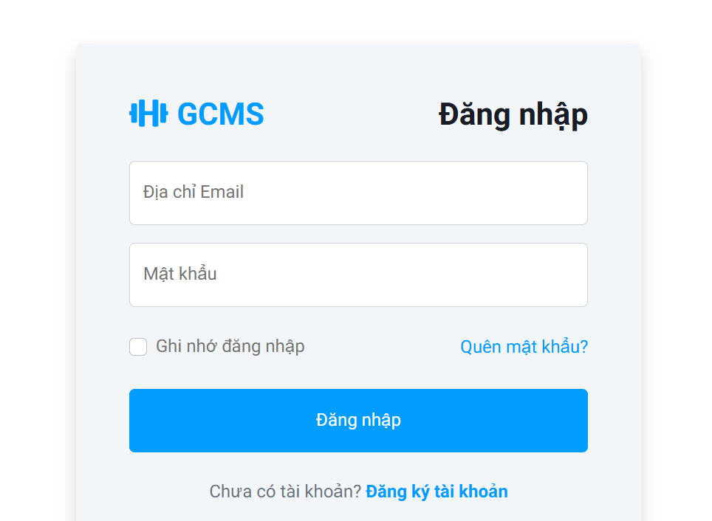
Description
This screen allows registered users to access the Gym Center Management System by signing in with a registered email and password. The system also supports automatic authentication through a valid Remember Me token, validates account status, creates an authenticated session, and redirects the user either to the Change Password screen or to the correct dashboard based on role.
Roles/Actors: Admin, Staff, Member, Personal Trainer
Functions
● Display login form with Email, Password, Remember Me, Forgot Password, and Register Account options
● Validate that Email and Password are not empty before authentication
● Authenticate the account using the registered email and SHA-256 password hash comparison
● Check account status and deny access to Inactive or Locked accounts
● Automatically authenticate the user when a valid Remember Me token is available
● Reuse an existing authenticated session and bypass the login screen
● Create an authenticated session and optionally store a 7-day Remember Me token
● Redirect the user to Change Password or the correct dashboard based on role, and display success or error messages
Field Description
Field Name | Description
Email | Required. Email input used to identify the user account. The entered address must be in valid email format and is compared with a registered account in the system.
Password | Required. Masked password input used for authentication. The entered value is verified by comparing its SHA-256 hash with the stored password hash.
Remember Me | Optional checkbox. When selected, the system stores a persistent remember_me_token cookie and a matching REMEMBER_ME token in the database for automatic login for up to 7 days.
Login Button | Submits the login form. If authentication succeeds, the system creates a session and redirects the user to Change Password or the corresponding dashboard.
Forgot Password | Navigates the user to the Forgot Password screen to start the password reset flow.
Register Account | Navigates the user to the Registration screen to create a new member account.
Notification Message | Displays success or error messages such as blank required fields, invalid credentials, inactive or locked account, or successful redirection from account verification.

3.2 User Management

3.2.1 Profile Screen
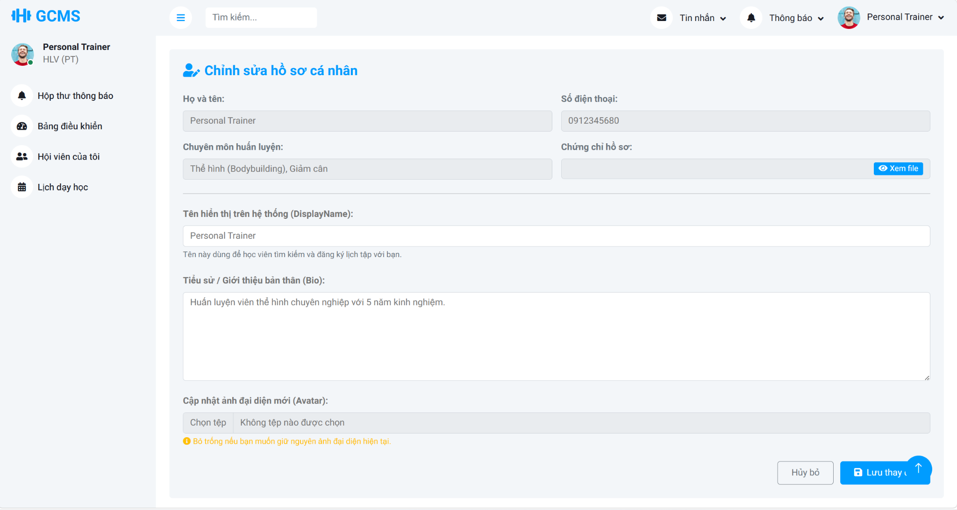
Description
This use case allows an authenticated user to view and update their own profile information according to their role. The system loads the current profile from the authenticated account, protects read-only identity fields such as email, and only allows supported editable fields. Members can update personal details such as gender, date of birth, and address, while Personal Trainers can additionally update limited public profile content such as biography, avatar image, and certificate files subject to validation rules.
Roles/Actors: Admin, Staff, Member, Personal Trainer
Functions
- Load the current user profile based on the authenticated session and user role
- View personal profile information while keeping protected identity fields read-only
- Update basic editable information such as display name and phone number
- Prevent unauthorized email changes and reject tampered read-only values
- Validate phone format, maximum length, and uniqueness across accounts
- Allow Members to update gender, date of birth, and address with future-date and length validation
- Allow Personal Trainers to update biography, avatar image, and certificate file with file type and size validation
- Save valid profile changes and return success or error feedback using the Post-Redirect-Get flow
Field Description
Field Name | Description
Full Name | Required editable name field for the authenticated user. Maximum 100 characters. For Personal Trainer accounts, this value is also used as the trainer full name.
Email | Read-only system email field. The user can view it but cannot change it from the profile screen.
Phone Number | Required editable contact number. Only digits are accepted, the value cannot exceed 10 digits, and the number must remain unique across accounts.
Gender | Optional Member-only field for updating gender information.
Date of Birth | Optional Member-only field. The entered date must not be later than the current date.
Avatar | Optional Member-only field for residence information, maximum 255 characters.
Description | Optional Personal Trainer-only field for public professional introduction. The content must not exceed 500 words.
Avata File | Optional Personal Trainer-only upload field. Only JPG or PNG image files are accepted, with a maximum file size of 5 MB.
Certificate File | Optional Personal Trainer-only upload field. Only PDF, JPG, or PNG files are accepted, with a maximum file size of 5 MB.
Edit/Save/Cancel Button | Control profile editing mode. Save submits allowed changes, while Cancel restores the loaded profile values without persisting updates.
Profile Update Message | Displays success confirmation or validation errors returned during profile update processing.

3.2.2 Change Password Screen
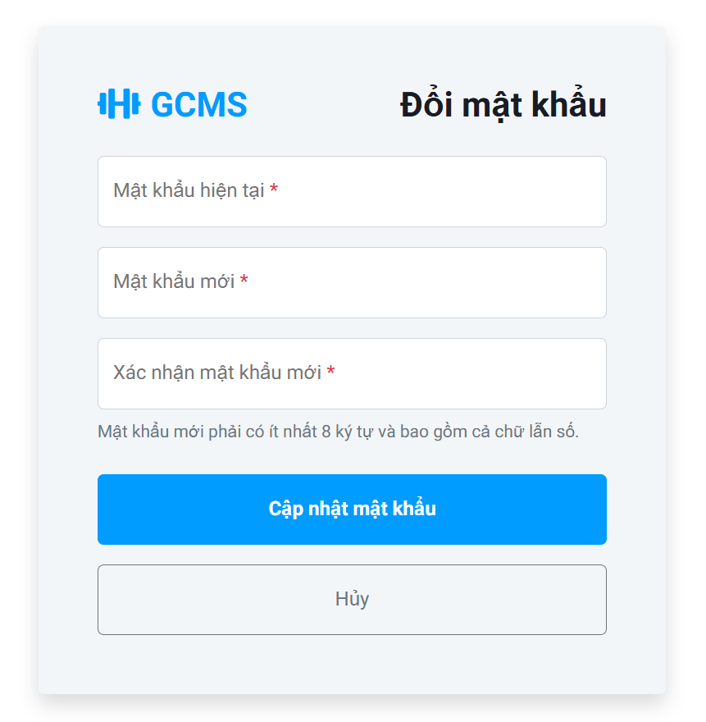
Description
This use case allows an authenticated active user to change their account password in order to maintain account security. It also enforces first-login password change for accounts flagged with MustChangePassword. The system verifies the current password, validates the new password policy, updates the stored password hash, clears the mandatory-change flag, revokes Remember Me tokens, expires the corresponding browser cookie, and invalidates other active sessions of the same account.
Roles/Actors: Admin, Staff, Member, Personal Trainer
Functions
- Display the change password form for authenticated users
- Enforce mandatory password change before access to protected features when MustChangePassword is true
- Validate required current password, new password, and confirmation fields
- Verify the current password against the stored password hash
- Validate new password complexity and confirmation matching rules
- Reject a new password that is identical to the current password
- Update the stored password hash and clear the MustChangePassword flag after a successful change
- Revoke Remember Me tokens, remove the browser cookie, invalidate other active sessions, and redirect the user to the appropriate role-based dashboard
Field Description
Field Name | Description
Current Password | Required. Used to verify that the authenticated user knows the current account password before a password change is allowed.
New Password | Required. Must contain at least 8 characters including letters and numbers, and must be different from the current password.
Confirm Password | Required. Must exactly match the New Password field.
Mandatory Change Notice | Displayed when the account is flagged with MustChangePassword, informing the user that a password update is required before continuing.
Update Password Button | Submits the password change request. On success, the system updates the password hash, clears the mandatory-change flag, revokes remember-me tokens, and invalidates other active sessions.
Cancel Button | Returns the user to the previous permitted page or role dashboard when password change is not mandatory.
Validation Message | Displays blank-field errors, incorrect current password, password policy violations, or success feedback.

3.2.3 Manage Account Screen

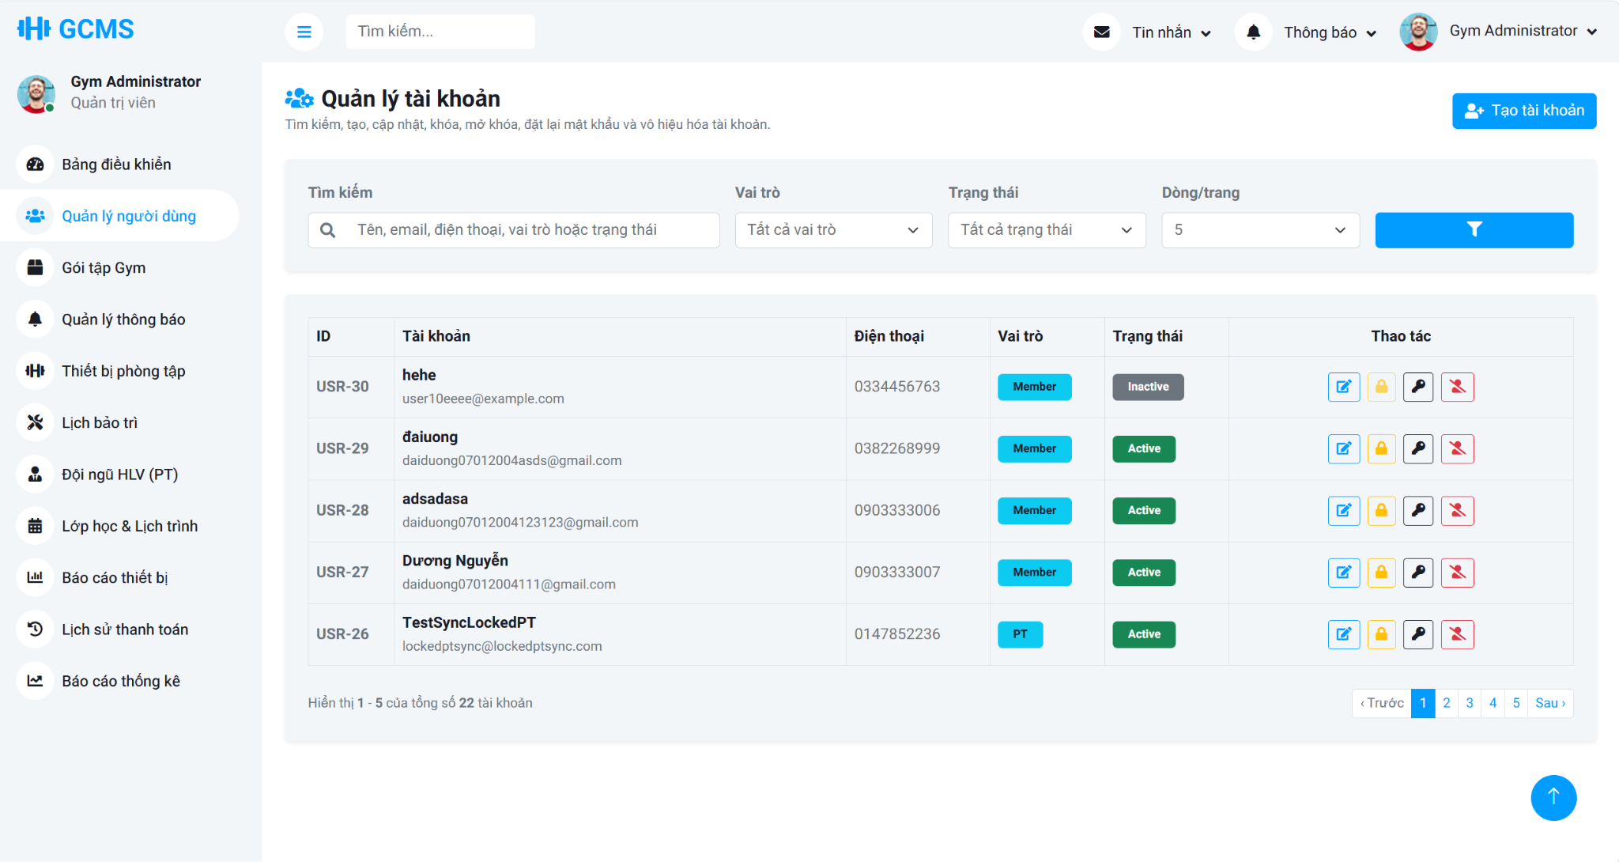
Description
This use case allows an authenticated Admin to manage Staff and Member system accounts. The system supports account list/search/filter operations, managed account creation, account updates, role changes between supported roles, lock and unlock actions, password reset, and deactivation. It also enforces validation rules for uniqueness, supported role and status transitions, self-protection, and Personal Trainer schedule constraints before restricted actions are applied.
Roles/Actors: Admin
Functions
- View the account list with keyword search, role filter, status filter, pagination, and page-size control
- Create new managed accounts for Staff or Member only and generate a temporary password
- Update existing account information such as full name, email, phone number, role, and account status
- Change account role only between Staff and Member when the transition is allowed
- Lock active accounts and unlock locked accounts
- Reset account passwords and force password change at the next login
- Deactivate accounts instead of permanently deleting them from the system
- Block invalid actions such as duplicate email or phone, self-locking, unsupported status transitions, and locking or deactivating PT accounts with blocking schedules
Field Description
Field Name | Description
Keyword Search | Optional search field used to filter accounts by name, email, phone number, role, or status.
Role Filter | Optional filter for managed account roles. The supported roles are Staff and Member.
Status Filter | Optional filter for account status. The supported statuses include Active, Inactive, and Locked.
Page Size | Controls how many accounts are displayed per page and supports navigation through paginated results.
Full Name | Managed account full name used when creating or updating a Staff or Member account.
Email | Managed account email address. It must be in valid format and remain unique in the system.
Phone Number | Managed account phone number used for contact information. It must comply with the system phone validation rules.
Role | Managed role assignment field used in create or edit mode. Only supported managed roles can be selected.
Status | Managed account lifecycle status used in edit mode to keep the account Active, Inactive, or Locked as permitted by business rules.
Account Actions | Available row actions include edit, lock, unlock, deactivate, change role, and reset password, subject to self-protection and role-transition rules.
Temporary Password Result | Displays the generated temporary password after account creation or password reset so the Admin can communicate it securely to the managed user.

3.3 Member Management

3.3.1 Registration Screen
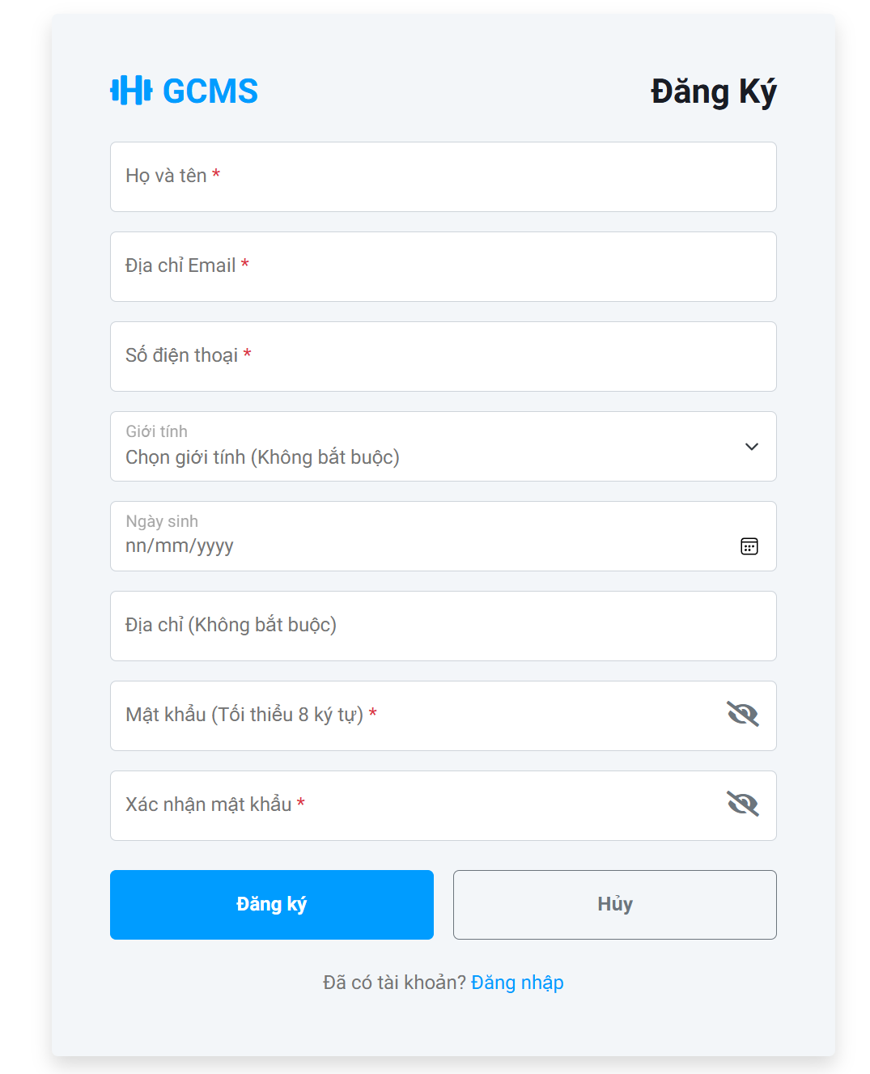
Description
This use case allows a guest to register a new member account in the Gym Center Management System. The system collects required and optional personal information, validates the submitted data, checks email and phone uniqueness, creates an Inactive user account with the Member role, creates a related member profile with Pending membership status, generates a time-limited verification token, and activates the account only after successful email verification.
Roles/Actors: Guest
Functions
- Collect required and optional membership registration information
- Validate required fields, display name, email format, phone format, password confirmation, password complexity, date of birth, and address length
- Check duplicate email address and phone number before account creation
- Create a new User account with the Member role, Inactive status, and hashed password
- Create a related Member profile with Pending membership status
- Generate and store a 24-hour VERIFICATION token for account activation
- Send an activation email and display the registration result message
- Activate the user account and member profile after successful verification, then redirect to Login with a success message and pre-populated email
Field Description
Field Name | Description
Full Name | Required. Member registration name input. Only letters and spaces are accepted, and the value must not exceed 100 characters.
Email | Required. Unique email address in valid format, maximum 100 characters. The system uses this address to send the account verification link.
Phone Number | Required. Must contain exactly 10 digits, start with 0, and be unique in the system.
Gender | Optional. Member gender selection stored in the member profile.
Date of Birth | Optional. Must be a valid past date when provided
Address | Optional. Member address field, maximum 255 characters.
Password | Required. Must contain at least 8 characters including letters and numbers. The password is stored as a password hash after successful registration.
Confirm Password | Required. Must match the Password field before the registration request is accepted.
Register Button | Submits the registration form. When validation succeeds, the system creates an Inactive Member account, creates a pending member profile, and sends an email verification token.
Registration Message | Displays validation errors, duplicate email or phone warnings, or registration success information.

3.3.2 Manage Members Screen

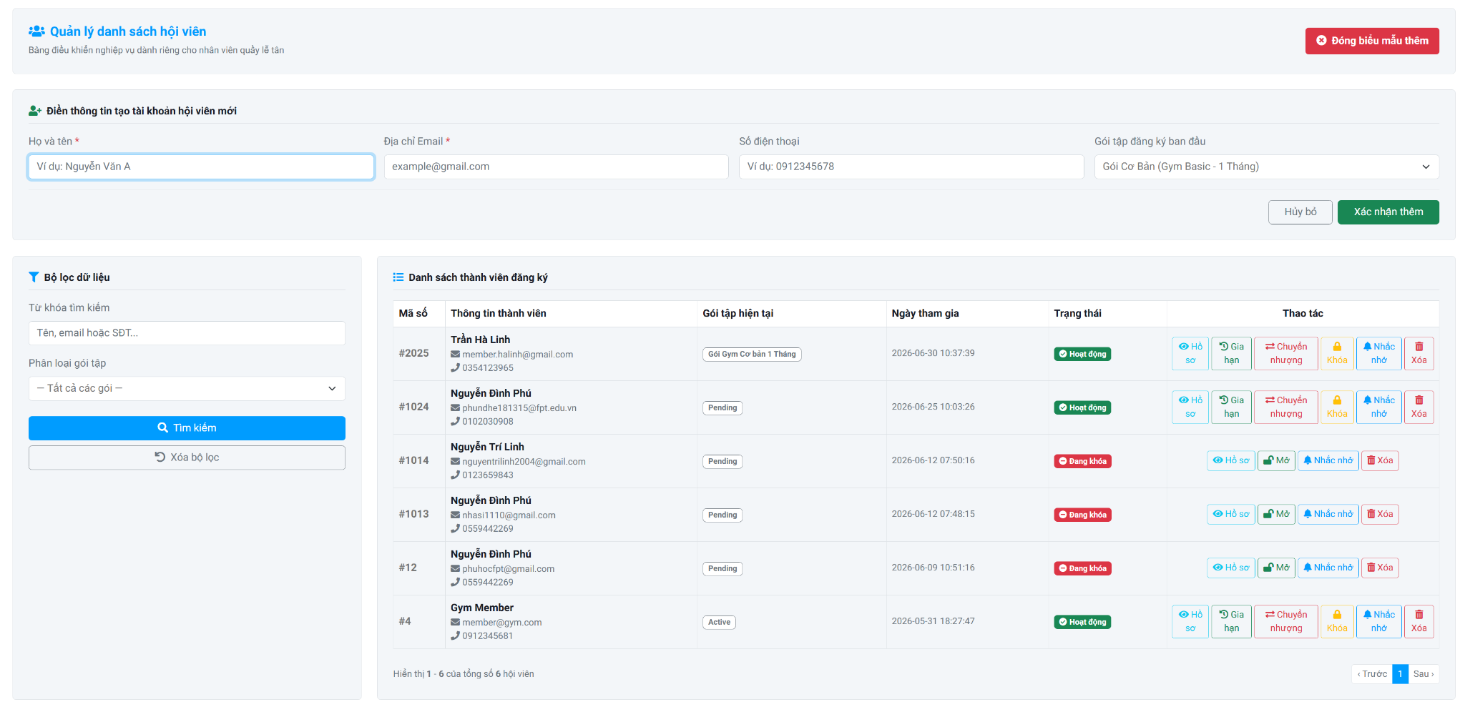
Description
This use case allows Staff to manage member information in the Gym Center Management System through a centralized Member Management screen. Users can create new member accounts, search and filter members, view member information, update member status, send membership reminders, renew or transfer membership packages, and remove member records when permitted. The system validates user input, maintains member information, and keeps the member list synchronized with all performed operations.
Roles/Actors: Staff
Functions
- Display the member management dashboard.
- Display the registered member list.
- Create a new member account.
- Search members by keyword.
- Filter members by membership package.
- View member profile information.
- Renew membership packages.
- Transfer membership packages.
- Update member account status (Active/Locked).
- Send membership reminder notifications.
- Delete member records when permitted.
- Refresh the member list after each successful operation.
Field Description
Field Name | Description
Full Name | Required. Enter the member's full name. Maximum 100 characters.
Email Address | Required. Enter a valid and unique email address. The system validates the email format before saving.
Phone Number | Required. Enter a unique phone number that starts with 0 and contains exactly 10 digits.
Initial Membership Package | Required. Select the initial membership package assigned to the member. Only active packages are displayed.
Add Member Button | Displays the member creation form when selected.
Confirm Add Button | Validates all entered information, creates the member account, assigns the selected membership package, and refreshes the member list after a successful operation.
Cancel Button | Closes the member creation form without saving any changes.
Search Keyword | Allows searching members by Member ID, Full Name, Email Address, or Phone Number.
Membership Package Filter | Filters members based on the selected membership package.
Search Button | Executes the search using the entered keyword and selected filter.
Clear Filter Button | Clears all search conditions and reloads the complete member list.
Member List | Displays all registered members that match the current search and filter conditions.
Member ID | Displays the unique identifier of each member.
Member Information | Displays the member's full name, email address, and phone number.
Current Membership Package | Displays the member's currently assigned membership package.
Join Date | Displays the date and time the member joined the gym.
Status | Displays the current member account status (e.g., Active or Locked).
View Profile Button | Opens the detailed member profile in read-only mode.
Renew Package Button | Opens the membership renewal process for the selected member.
Transfer Package Button | Opens the package transfer process for the selected member.
Lock/Unlock Button | Changes the member account status between Active and Locked after confirmation.
Reminder Button | Sends a membership reminder notification to the selected member.
Delete Button | Removes the selected member record after confirmation if the deletion conditions are satisfied.
Pagination | Allows users to navigate through multiple pages of member records.

3.3.3 View Member Portal Screen
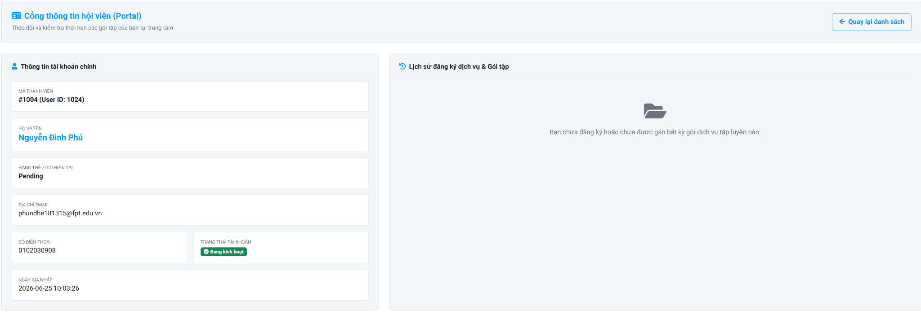
Description
This screen allows Staff to view their personal membership information and registered service history in the Gym Center Management System. Members can review their account information, current membership package, account status, join date, and the history of registered membership packages and services in a read-only format.
Roles/Actors: Staff
Functions
- View personal member information.
- View current membership package.
- View account status.
- View membership join date.
- View membership package and service registration history.
- Return to the previous page.
Field Description
Field Name | Description
Back to List Button | Returns the user to the previous page or member list.
Member Information Panel | Displays the primary account information of the current member.
Member ID | Displays the unique identifier assigned to the member.
Full Name | Displays the member's full name.
Current Membership Package | Displays the currently assigned membership package or membership status.
Email Address | Displays the registered email address of the member.
Phone Number | Displays the registered phone number of the member.
Account Status | Displays the current account status, such as Active, Inactive, or Locked.
Join Date | Displays the date and time when the member joined the gym.
Membership & Service Registration History | Displays the list of membership packages and additional services registered by the member.
Registration History List | Displays historical registration records, including registered packages or services, registration dates, expiration dates, and current registration status when available.
Empty Data Message | Displays a notification when the member has not registered any membership package or additional service.

3.4 Membership Management

3.4.1 Package List Screen
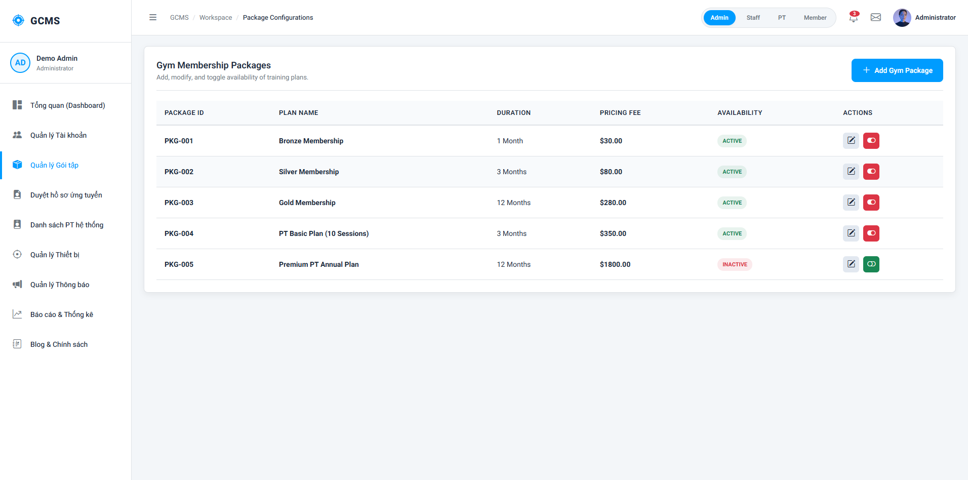
Description
This screen allows administrators to manage gym training packages.
Roles/Actors: Admin
Functions
- View package list
- Create new package
- Update package information
- Enable/Disable package status
- Search packages
Field Description
Field Name | Description
Package Name | Required. Maximum 100 characters.
Duration | Number of valid days/months.
Price | Positive decimal value.
Status | Active/Inactive.
Description | Maximum 255 characters.
Create Button | Add new package.
Edit Button | Update selected package.

3.4.2 Package Registration Screen
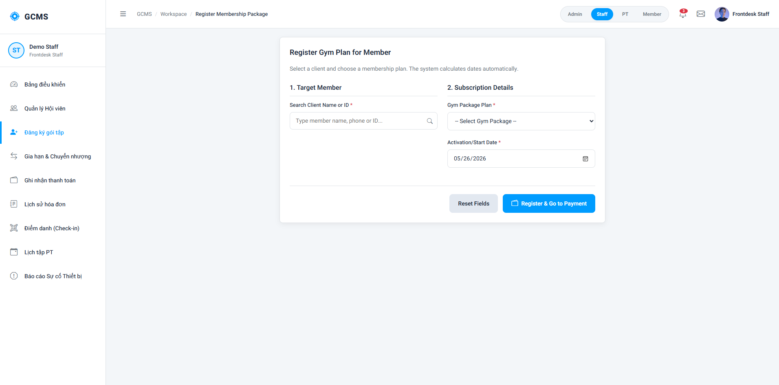
Description
This screen allows staff and admin to register training packages for members.
Roles/Actors: Staff
Field Description
Field Name | Description
Member Selection | Select member from system.
Package Selection | Select available package.
Start Date | Membership start date.
Expiration Date | Auto-calculated expiration date.
Register Button | Confirm package registration.

3.4.3 Package Renewal & Transfer Screen
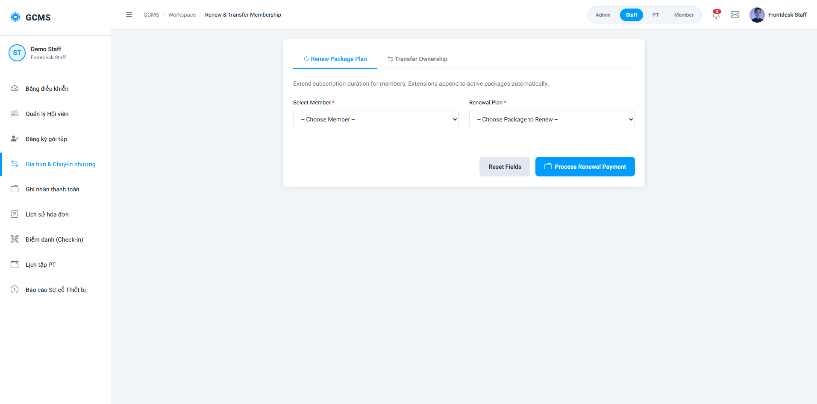
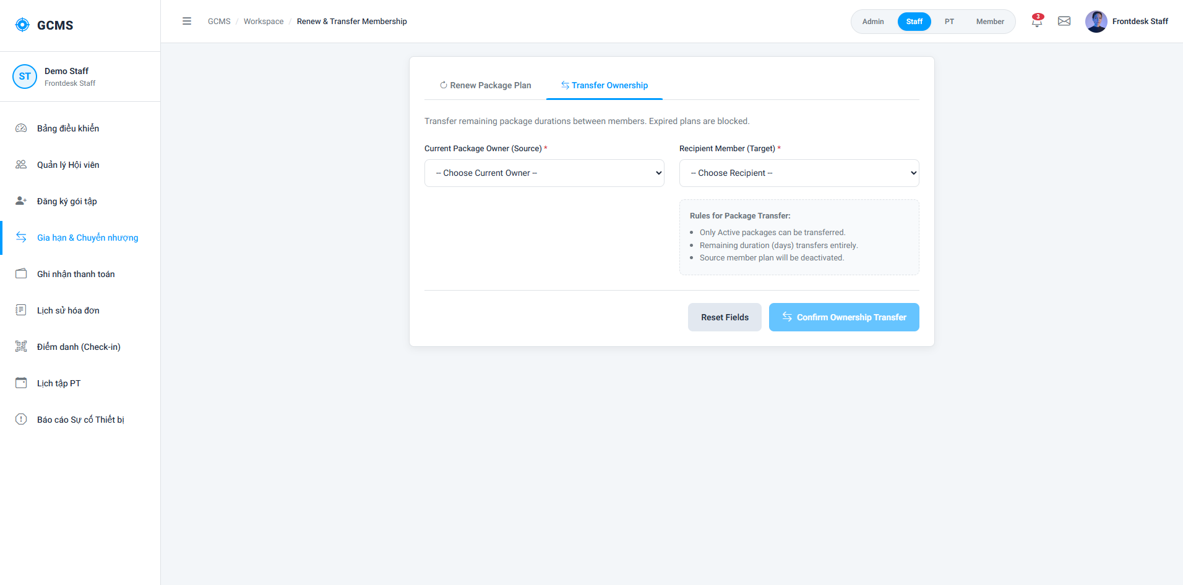Description
This screen allows staff and admin to renew or transfer membership packages.
Roles/Actors: Staff
Field Description
Field Name | Description
Current Member | Existing member account.
Target Member | Transfer target member.
Remaining Duration | Remaining package duration.
Renewal Duration | Additional membership duration.
Confirm Button | Confirm transfer or renewal action.

3.5. Payment Management

3.5.1 Record Payment Screen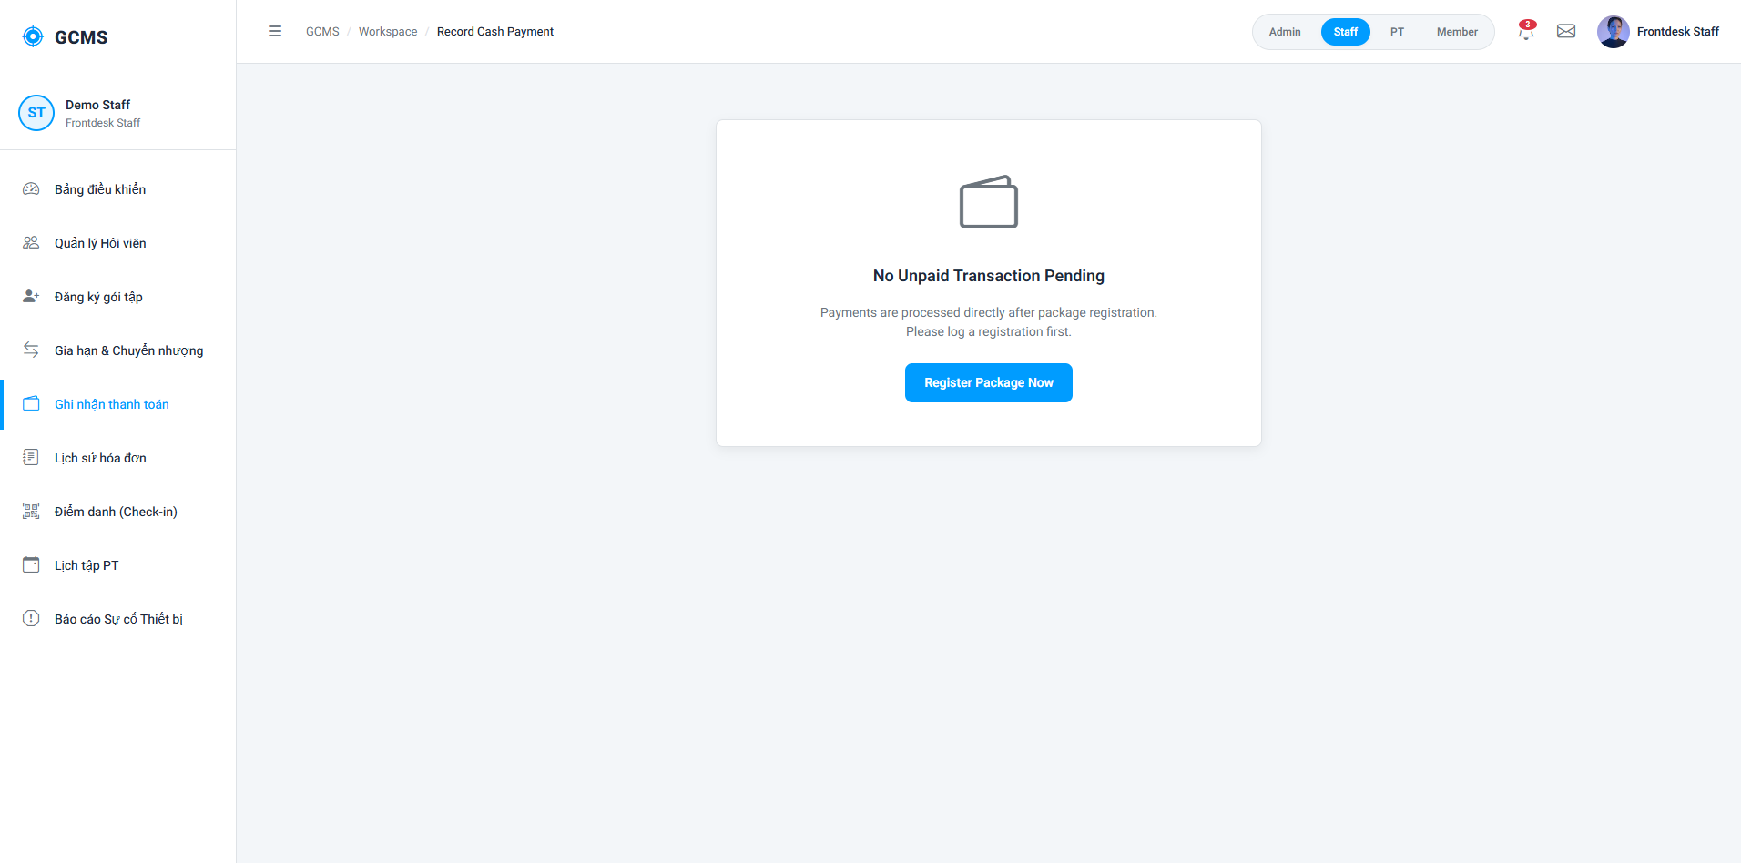
Description
This screen allows staff and admin to record payment transactions and generate invoices.
Roles/Actors: Staff
Field Description
Field Name | Description
Invoice ID | Auto-generated invoice number.
Member Name | Display member information.
Payment Amount | Total payable amount.
Payment Method | Cash.
Payment Date | System-generated date/time.
Print Invoice | Print payment invoice.

3.5.2 Payment History Screen
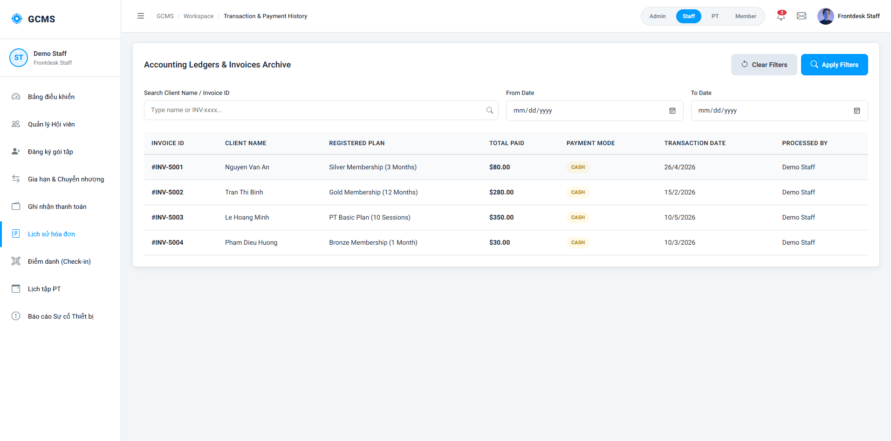
Description
This screen allows staff and admin to view and search payment history records.
Roles/Actors: Staff, Admin
Field Description
Field Name | Description
Invoice ID | Payment invoice number.
Member Name | Member who made payment.
Payment Amount | Transaction amount.
Payment Method | Payment type used.
Payment Date | Transaction date/time.
Search Box | Search by member or invoice.
Filter Date | Filter by payment period.

3.6. Attendance Management

3.6.1 Manage Staff & PT Check-ins Screen
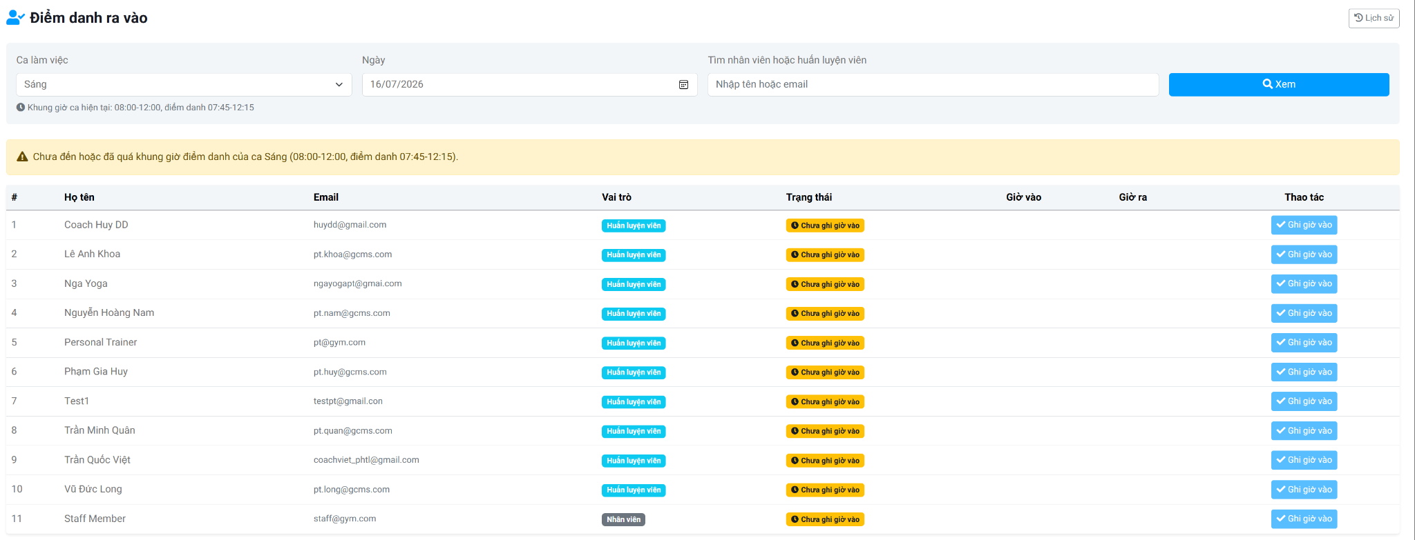
Description
This screen allows Staff and Admin to manage daily attendance records for Staff and Personal Trainers. Users can view attendance records by work shift and date, search employees, record check-in and check-out times, monitor attendance status, and access attendance history. The system validates attendance time according to the configured work shift and automatically updates attendance information after each successful operation.
Roles/Actors: Admin
Functions
- View attendance records by work shift and date.
- Search Staff or Personal Trainers by name or email.
- Record check-in time.
- Record check-out time.
- Display attendance status.
- Display check-in and check-out times.
- View attendance history.
- Refresh the attendance list after successful operations.
Field Description
Field Name | Description
Work Shift | Required. Select the work shift to display attendance records. Only configured work shifts are available.
Attendance Date | Required. Select the attendance date for attendance management.
Search Staff/PT | Optional. Search Staff or Personal Trainers by full name or email address.
View Button | Displays attendance records based on the selected work shift, attendance date, and search criteria.
History Button | Opens the attendance history page to view previously recorded attendance records.
Shift Information | Displays the configured working hours and the permitted check-in/check-out time range for the selected shift.
Attendance Notification | Displays system messages related to attendance conditions, such as attendance outside the allowed time range.
Attendance List | Displays the attendance records that match the selected search conditions.
No. | Displays the sequential number of each attendance record.
Full Name | Displays the full name of the Staff or Personal Trainer.
Email | Displays the registered email address.
Role | Displays the account role (Staff or Personal Trainer).
Check-in Time | Displays the recorded check-in time after a successful check-in.
Check-out Time | Displays the recorded check-out time after a successful check-out.
Attendance Action | Allows users to record attendance by selecting the available action (Check In or Check Out) according to the current attendance status.
Pagination | Allows users to navigate through multiple pages of attendance records when available.

3.6.2 View Staff & PT Work History

3.6.2.1 Staff & Personal Trainer Screen
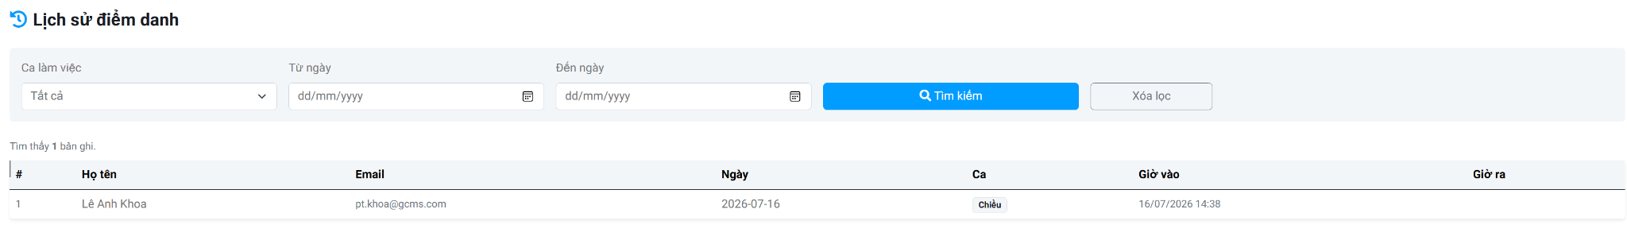
Description
This screen allows Staff and Personal Trainers to view their own attendance history. Users can filter attendance records by work shift and attendance date range, review check-in and check-out times, and monitor their attendance history for personal reference.
Roles/Actors: Staff, Personal Trainer
Functions
- View personal attendance history.
- Filter attendance records by work shift.
- Filter attendance records by attendance date range.
- Clear search filters.
- Display attendance history records.
- Display total attendance records.
- Navigate through attendance history pages.
Field Description
Field Name | Description
Work Shift | Optional. Filters attendance history by the selected work shift.
From Date | Optional. Specifies the starting date of the attendance history search range.
To Date | Optional. Specifies the ending date of the attendance history search range.
Search Button | Retrieves attendance history records based on the selected search criteria.
Clear Filter Button | Removes all search conditions and reloads the complete attendance history list.
Total Records | Displays the total number of attendance records that match the current search criteria.
Attendance History List | Displays the user's attendance history records.
No. | Displays the sequential number of each attendance record.
Full Name | Displays the user's full name.
Email | Displays the user's registered email address.
Attendance Date | Displays the attendance date of the recorded work session.
Work Shift | Displays the work shift associated with the attendance record.
Check-in Time | Displays the recorded check-in date and time.
Check-out Time | Displays the recorded check-out date and time.
Pagination | Allows users to navigate through multiple pages of attendance history records when available.

3.6.2.2 Admin Screen

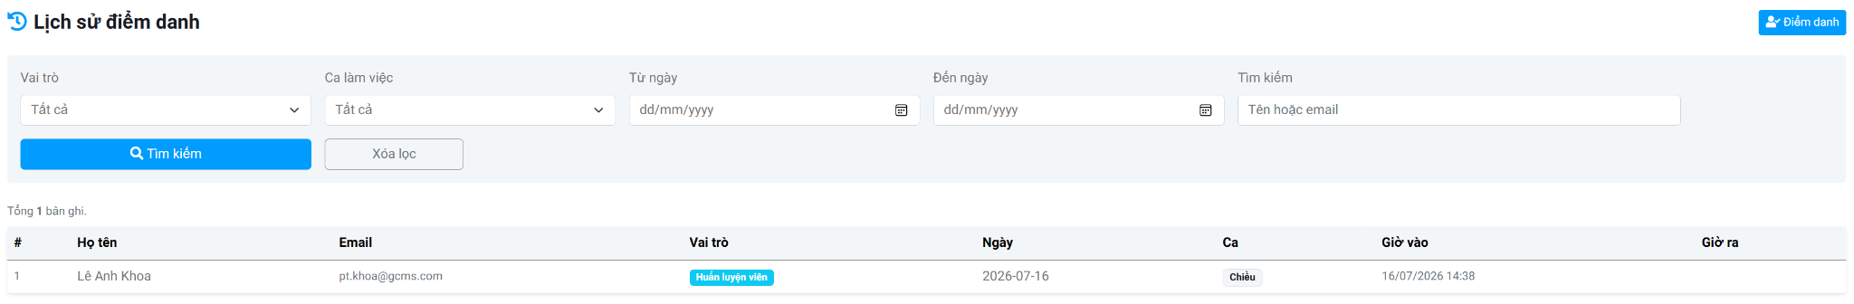
Description
This screen allows Admin to view, search, and monitor attendance history records of all Staff and Personal Trainers. The system enables filtering attendance records by role, work shift, attendance period, and keyword, helping administrators review historical attendance information for monitoring and auditing purposes.
Roles/Actors: Admin
Functions
- View attendance history records.
- Search Staff and Personal Trainers by name or email.
- Filter attendance records by role.
- Filter attendance records by work shift.
- Filter attendance records by attendance date range.
- Clear all search filters.
- Return to the attendance management screen.
- Display attendance history with pagination.
Field Description
Field Name | Description
Role | Optional. Filters attendance records by account role, such as Staff or Personal Trainer.
Work Shift | Optional. Filters attendance records by the selected work shift.
From Date | Optional. Specifies the starting date of the attendance history search range.
To Date | Optional. Specifies the ending date of the attendance history search range.
Search Keyword | Optional. Searches attendance records by Staff or Personal Trainer name or email address.
Search Button | Retrieves attendance history records based on the selected search criteria and filters.
Clear Filter Button | Clears all search conditions and reloads the complete attendance history list.
Attendance Button | Returns to the Manage Staff & PT Check-ins screen.
Total Records | Displays the total number of attendance records that satisfy the current search conditions.
Attendance History List | Displays attendance history records matching the selected filters.
No. | Displays the sequential number of each attendance record.
Full Name | Displays the full name of the Staff or Personal Trainer.
Email | Displays the registered email address.
Role | Displays the account role of the employee.
Attendance Date | Displays the attendance date of the recorded work session.
Work Shift | Displays the work shift associated with the attendance record.
Check-in Time | Displays the recorded check-in date and time.
Check-out Time | Displays the recorded check-out date and time.
Pagination | Allows administrators to navigate through multiple pages of attendance history records.

3.7. Personal Trainer Management

3.7.1 Create Personal Trainer

3.7.1.1 Add Personal Trainer
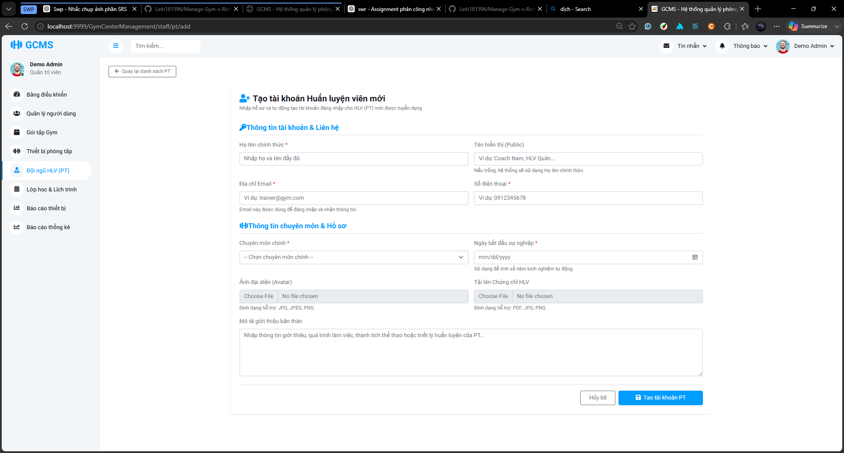
Description
This screen allows Staff/Admin to create a new Personal Trainer account and profile after the trainer has passed the offline recruitment process. Staff/Admin enters official account information, contact information, professional information, public display information, and optional profile files. After submission, the system creates the PT account and redirects to the PT Account Creation Result screen.
Roles/Actors: Staff, Admin
Functions:
- Enter official trainer account and contact information.
- Enter public display name and biography.
- Select one or more trainer specializations.
- Enter career start date for experience calculation.
- Upload avatar image.
- Upload trainer certificate file.
- Submit the form to create a new PT account and profile.
- Cancel the creation process or return to the PT list.
Field Description
Field Name | Description
Back to PT List Button | Navigates back to the Personal Trainer list screen.
Full Name | Required. Official full name of the trainer.
Display Name | Optional. Public trainer name shown to members. If empty, the system uses the official full name.
Email | Required. Login email address of the trainer.
Phone Number | Required. Contact phone number of the trainer.
Specialization | Required. Checkbox group for trainer specializations. At least one specialization should be selected.
Career Start Date | Required. Used to calculate trainer experience years automatically.
Avatar | Optional. Upload trainer avatar image. Supported formats: JPG, JPEG, PNG.
Certificate File | Optional. Upload trainer certificate file. Supported formats: PDF, JPG, PNG.
Biography / Description | Optional. Public introduction about experience, achievements, or training philosophy.
Cancel Button | Cancels the creation process and returns to the previous screen.
Create PT Account Button | Submits the form to create the PT account and profile.

3.7.1.2 PT Account Creation Result Screen
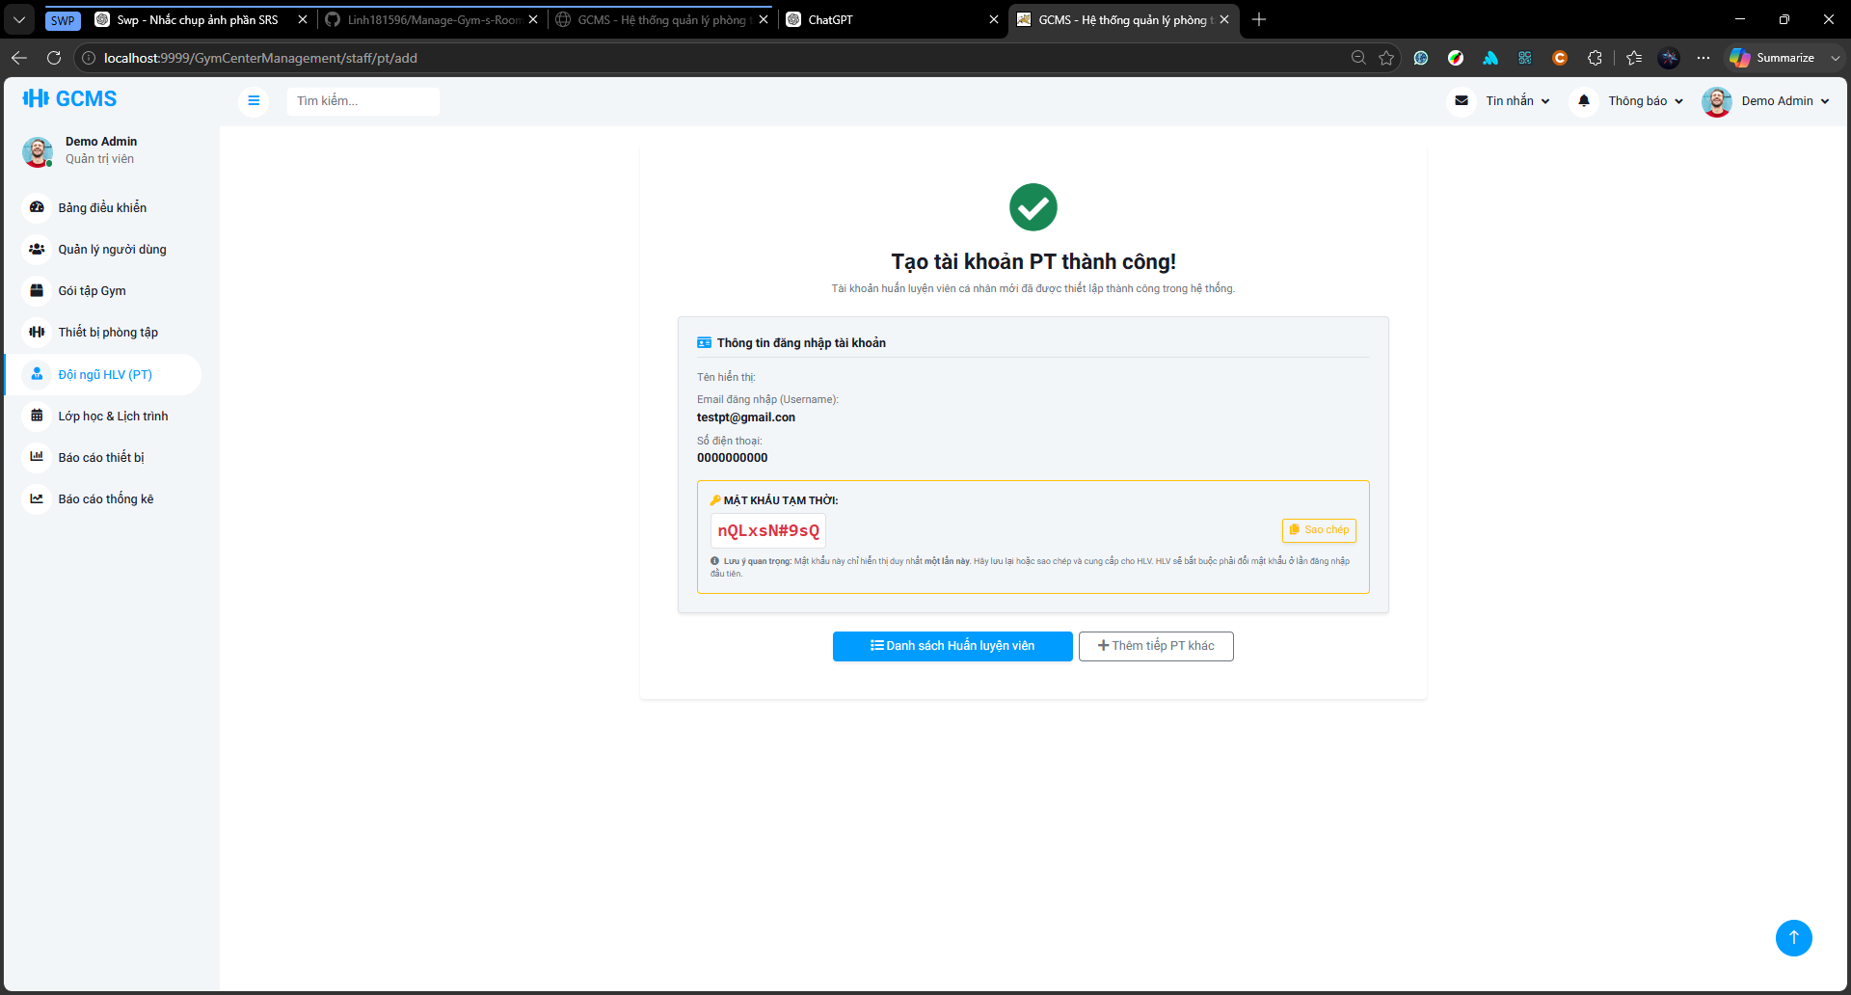
Description
This screen displays the result after a Personal Trainer account is created successfully. It shows the trainer’s login information and the system-generated temporary password. Staff/Admin can copy the temporary password and securely hand it over to the trainer. The screen also reminds Staff/Admin that the trainer must change the temporary password at first login.
Roles/Actors: Staff, Admin
Functions:
- Display created PT account information.
- Display the system-generated temporary password.
- Copy the temporary password.
- Show first-login password change instruction.
- Navigate to the PT list.
- Create another PT account.
Field Description
Field Name | Description
Success Message | Confirms that the PT account has been created successfully.
Trainer Name | Displays the created trainer’s full name.
Login Email | Displays the trainer’s login email.
Phone Number | Displays the trainer’s phone number.
Temporary Password | Displays the system-generated temporary password for handover.
Copy Password Button | Copies the temporary password.
Temporary Password Instruction | Informs Staff/Admin to securely hand over the password to the trainer.
First Login Password Change Notice | Informs that the trainer must change the temporary password at first login.
Personal Trainer List Button | Navigates to the Personal Trainer list screen.
Add Another Personal Trainer Button | Returns to the Add Personal Trainer screen.

3.7.2 View Personal Trainer List Screen
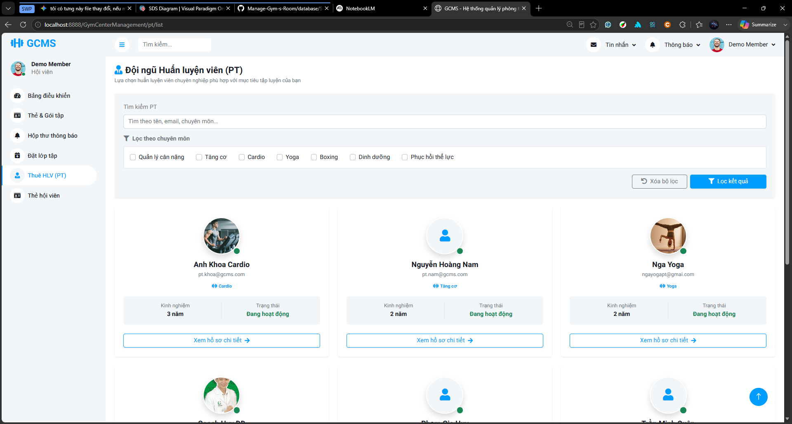
Description
This screen allows Guests and Members to view the list of official and active Personal Trainers. Both Guests and Members can search trainers by keyword and filter trainers by specialization. The list screen displays basic public trainer information such as avatar, display name, email, specialization, experience years, and working status. Only authenticated Members can open the Personal Trainer Detail screen to view detailed biography, contact information, active PT service packages, service prices, and registration actions.
Roles/Actors: Guest, Member
Functions:
- View active Personal Trainer cards.
- Search trainers by name, email, or specialization.
- Filter trainers by specialization.
- Clear selected filters.
- View basic public trainer information.
- Open Personal Trainer Detail screen for authenticated Members.
Field Description
Field Name | Description
Search Bar | Allows users to search Personal Trainers by name, email, or specialization.
Specialization Filter | Checkbox filter that allows users to filter trainers by selected specializations.
Clear Filter Button | Clears all search and specialization filter conditions.
Filter Button | Applies the selected search and specialization filters.
Result Counter | Displays the number of trainers currently shown and the total matching trainers.
Trainer Card | Displays basic public trainer information, including avatar, display name, email, specialization, experience years, and working status.
Avatar | Displays the trainer’s public avatar.
Display Name | Displays the trainer’s public name.
Email | Displays the trainer’s public contact email if available.
Specialization Tags | Displays the trainer’s selected specializations.
Experience Years | Displays the trainer’s calculated experience years.
Status | Displays the trainer’s current working status.
View Detail Button | Allows authenticated Members to open the Personal Trainer Detail screen. For Guests, the system redirects to login or displays a login-required message.
Pagination | Allows users to navigate between trainer list pages.

3.7.3 Manage PT Registrations

3.7.3.1 PT Service Registration Screen
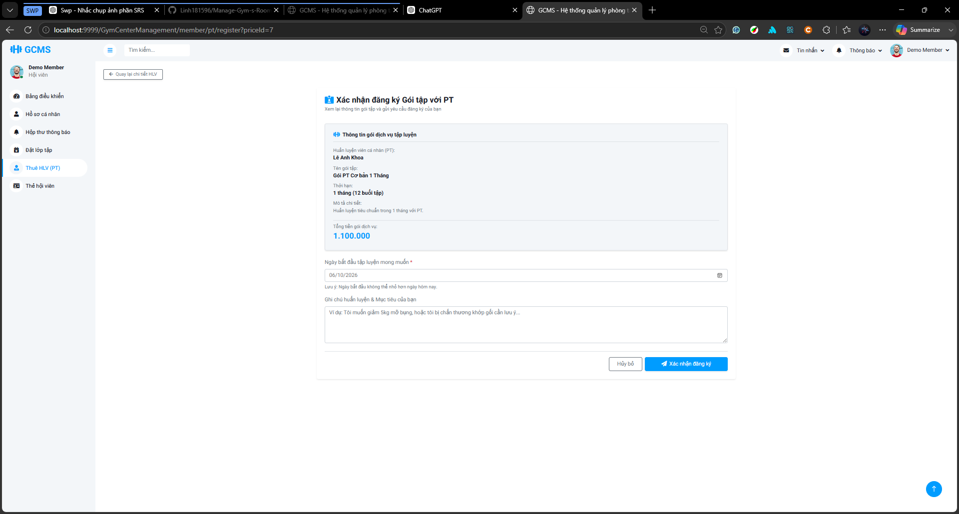
Description
This screen allows a Member to confirm registration for a selected Personal Trainer service package. The screen displays the selected trainer, package name, number of sessions, service description, and total service fee. The Member selects a preferred training start date and may enter training goals or notes before submitting the registration request. After submission, the registration is created with Pending status and Unpaid payment status.
Roles/Actors: Member
Functions:
- Display selected Personal Trainer service package information.
- Display trainer name, package name, number of sessions, description, and total fee.
- Allow the Member to select a preferred training start date.
- Allow the Member to enter training goals or notes.
- Submit the PT service registration request.
- Cancel the registration and return to the trainer detail screen.
Field Description
Field Name | Description
Back to Trainer Detail Button | Returns to the selected trainer detail screen.
Trainer Name | Displays the selected Personal Trainer.
Package Name | Displays the selected PT service package name.
Package Sessions | Displays the number of training sessions included in the package.
Package Description | Displays a short description of the selected PT package.
Total Service Fee | Displays the total amount to be paid for the selected PT service.
Preferred Start Date | Required. Member’s desired start date for PT training. This is not the actual schedule start date. Must not larger than 1 year from current date.
Training Goal / Note | Optional. Member can enter training goals, health notes, or preferred training information.
Cancel Button | Cancels the registration confirmation and returns to the previous screen.
Confirm Registration Button | Submits the PT service registration request.

3.7.3.2 Manage PT Registration Requests

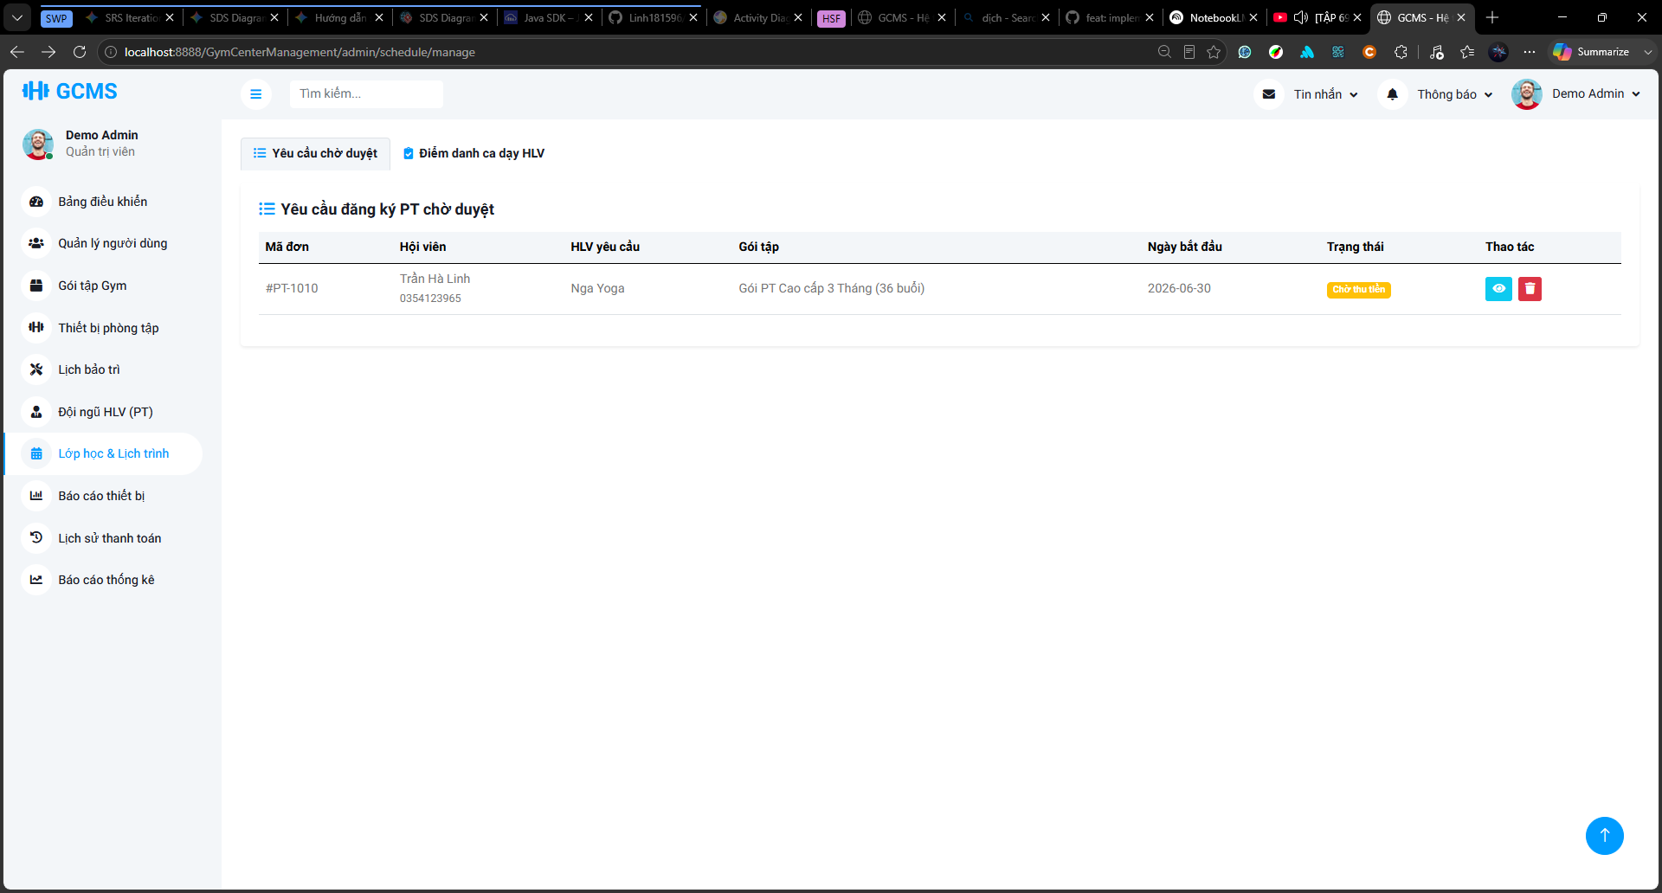
Description: This screen allows Staff/Admin to view and process pending Personal Trainer service registration requests submitted by Members. The screen displays registration information such as registration ID, Member, requested Personal Trainer, selected package, preferred start date, payment status, and available actions. Staff/Admin can confirm payment collection for a pending request. After payment is confirmed, the system approves the PT registration, changes it to Active/Paid, and sends the registration to the assigned Personal Trainer so that the trainer can generate the training schedule.
Roles/Actors: Staff, Admin
Functions:
- View pending PT service registration requests.
- View Member information and requested Personal Trainer.
- View selected PT package and preferred start date.
- View current payment/registration status.
- Confirm payment collection for a pending PT registration.
- Approve the registration after payment confirmation.
- Remove or reject an invalid pending registration if allowed.
- View PT registration approval history.
- Display success toast after payment confirmation and approval.
Field Description
Field Name | Description
Pending Requests Tab | Displays PT service registrations that are waiting for Staff/Admin processing.
Attendance Tab | Navigates to the PT training session attendance/status update area.
Schedule Support Tab | Navigates to the Staff/Admin support area for escalated reschedule or make-up requests.
Registration ID | Displays the PT registration code.
Member | Displays the Member name and phone number who submitted the PT registration.
Requested Personal Trainer | Displays the Personal Trainer selected by the Member.
Package | Displays the selected PT service package and number of purchased sessions.
Preferred Start Date | Displays the Member’s desired training start date. This is not the actual generated schedule start date.
Status | Displays the current processing/payment status of the registration, such as Waiting for Payment.
Collect Payment Button | Allows Staff/Admin to confirm that payment has been collected and approve the PT registration.
Delete/Remove Button | Removes or cancels an invalid pending request if the system allows this action.
Approval History Button | Opens the PT registration approval history screen.
Empty State Message | Displays a message when there are no pending PT registrations to process.
Success Toast | Displays a confirmation message after Staff/Admin successfully confirms payment and approves the registration.

3.7.3.3 PT Service Registration Result Screen Description
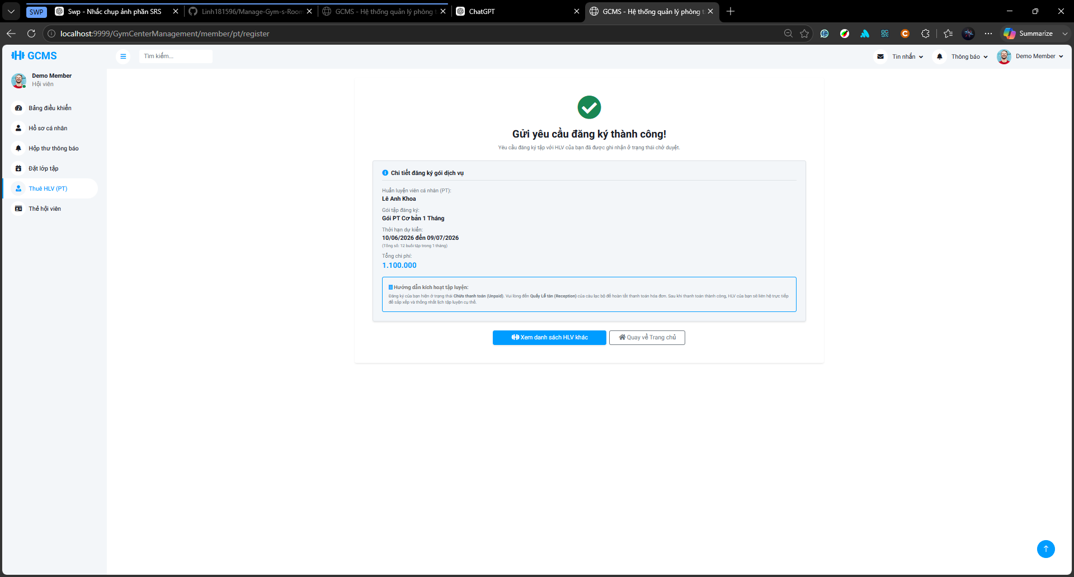
Description
This screen displays the result after a Member successfully submits a Personal Trainer service registration request. The screen shows the selected PT service information, total fee, and payment instruction. The registration is not active immediately; it remains Pending and Unpaid until Staff/Admin confirms payment. After payment is confirmed, the PT registration becomes Active and the Personal Trainer can generate the training schedule later.
Roles/Actors: Member
Functions:
- Display successful registration submission message.
- Display selected PT service registration details.
- Display payment instruction.
- Inform the Member that the request is waiting for payment confirmation.
- Navigate back to the PT list.
- Navigate back to the home/dashboard page.
Field Description
Field Name | Description
Success Message | Confirms that the PT service registration request has been submitted successfully.
Trainer Name | Displays the selected Personal Trainer.
Package Name | Displays the selected PT package.
Preferred Start Date | Displays the Member’s desired training start date.
Number of Sessions | Displays the purchased number of PT sessions.
Total Fee | Displays the total service fee.
Payment Instruction | Informs the Member to complete payment at the reception/front desk.
View Other Trainers Button | Navigates back to the Personal Trainer list screen.
Back to Home Button | Navigates back to the Member home/dashboard page.

3.7.4 Manage Personal Trainers

3.7.4.1 Personal Trainer Detail Screen
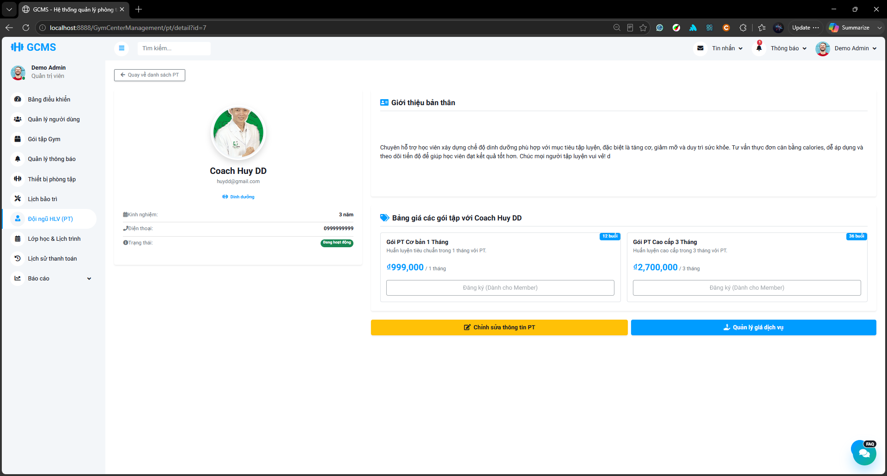
Description
This screen allows Admin/Staff to view detailed information of a selected Personal Trainer, including profile information, specialization, experience years, phone number, working status, certificate file, biography, and configured PT service packages. Admin can navigate to edit the trainer profile or manage PT service prices. Staff can view details and edit allowed trainer profile information, but cannot manage service prices or change the trainer status.
Roles/Actors: Admin/Staff
Functions:
- View detailed Personal Trainer profile.
- View trainer avatar, display name, email, phone number, specialization, experience years, and working status.
- View trainer certificate file if available.
- View trainer biography.
- View configured PT service packages and prices.
- Navigate to Edit PT Profile screen.
- Navigate to Manage PT Service Price screen for Admin only.

Field Description
Field Name | Description
Back to PT List Button | Returns to the Personal Trainer list screen.
Avatar | Displays the trainer’s profile avatar.
Display Name | Displays the trainer’s public display name.
Email | Displays the trainer’s login/contact email.
Specialization | Displays the trainer’s specialization tags.
Experience Years | Displays calculated trainer experience years.
Phone Number | Displays trainer contact number.
Working Status | Displays trainer working status such as Active, Inactive, or Locked.
Certificate File | Displays the uploaded certificate file and allows authorized users to view it.
Biography | Displays trainer introduction or professional description.
PT Service Package Cards | Displays package name, number of sessions, duration label, and configured price.
Register Button | Disabled for Admin/Staff; available only for Member in member-facing detail screen.
Edit PT Information Button | Opens the Edit PT Profile screen.
Manage Service Price Button | Opens the Manage PT Service Price screen. (Visible to Admin only. Hidden for Staff role).

3.7.4.2 Edit PT Profile Form Screen

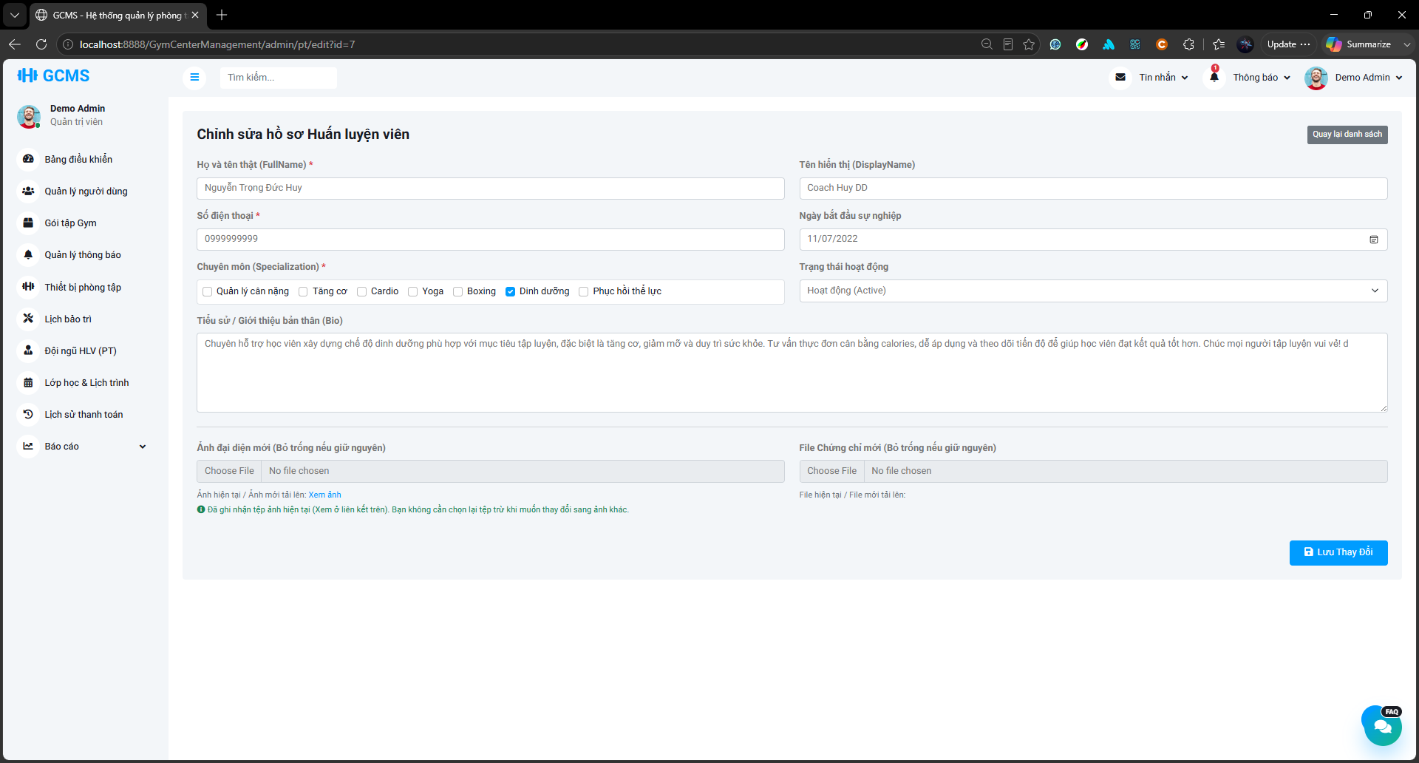
Description
This screen allows Staff/Admin to update Personal Trainer profile information. Staff can update allowed trainer profile fields such as full name, phone number, specialization, career start date, biography, avatar, and certificate file. Admin can update those fields and additionally change the trainer working status. Staff cannot change the trainer status.
Roles/Actors: Admin/Staff
Functions:
- Update trainer full name.
- Update public display name.
- Update phone number.
- Update specialization.
- Update career start date.
- Update biography.
- Upload a new avatar image.
- Upload a new certificate file.
- Keep existing avatar/certificate if no new file is uploaded.
- Change trainer working status for Admin only.
- Save profile changes.
- Return to the trainer list or detail screen.
Field Description
Field Name | Description
Full Name | Required. Official full name of the Personal Trainer.
Display Name | Optional. Public trainer name shown to members.
Phone Number | Required. Trainer contact phone number.
Career Start Date | Required. Used to calculate trainer experience years.
Specialization | Required. Checkbox group of trainer specializations.
Working Status | Trainer working status. Editable by Admin only; read-only or hidden for Staff.
Biography | Optional. Public trainer introduction or professional description.
New Avatar | Optional. Upload a new avatar image. If left empty, the current avatar is kept.
Current Avatar Link | Displays the existing avatar file if available.
New Certificate File | Optional. Upload a new certificate file. If left empty, the current certificate is kept.
Current Certificate Link | Displays the existing certificate file if available.
Save Changes Button | Saves the updated trainer profile.
Back to List Button | Returns to the Personal Trainer list screen.

3.7.4.3 Manage PT Service Price Screen
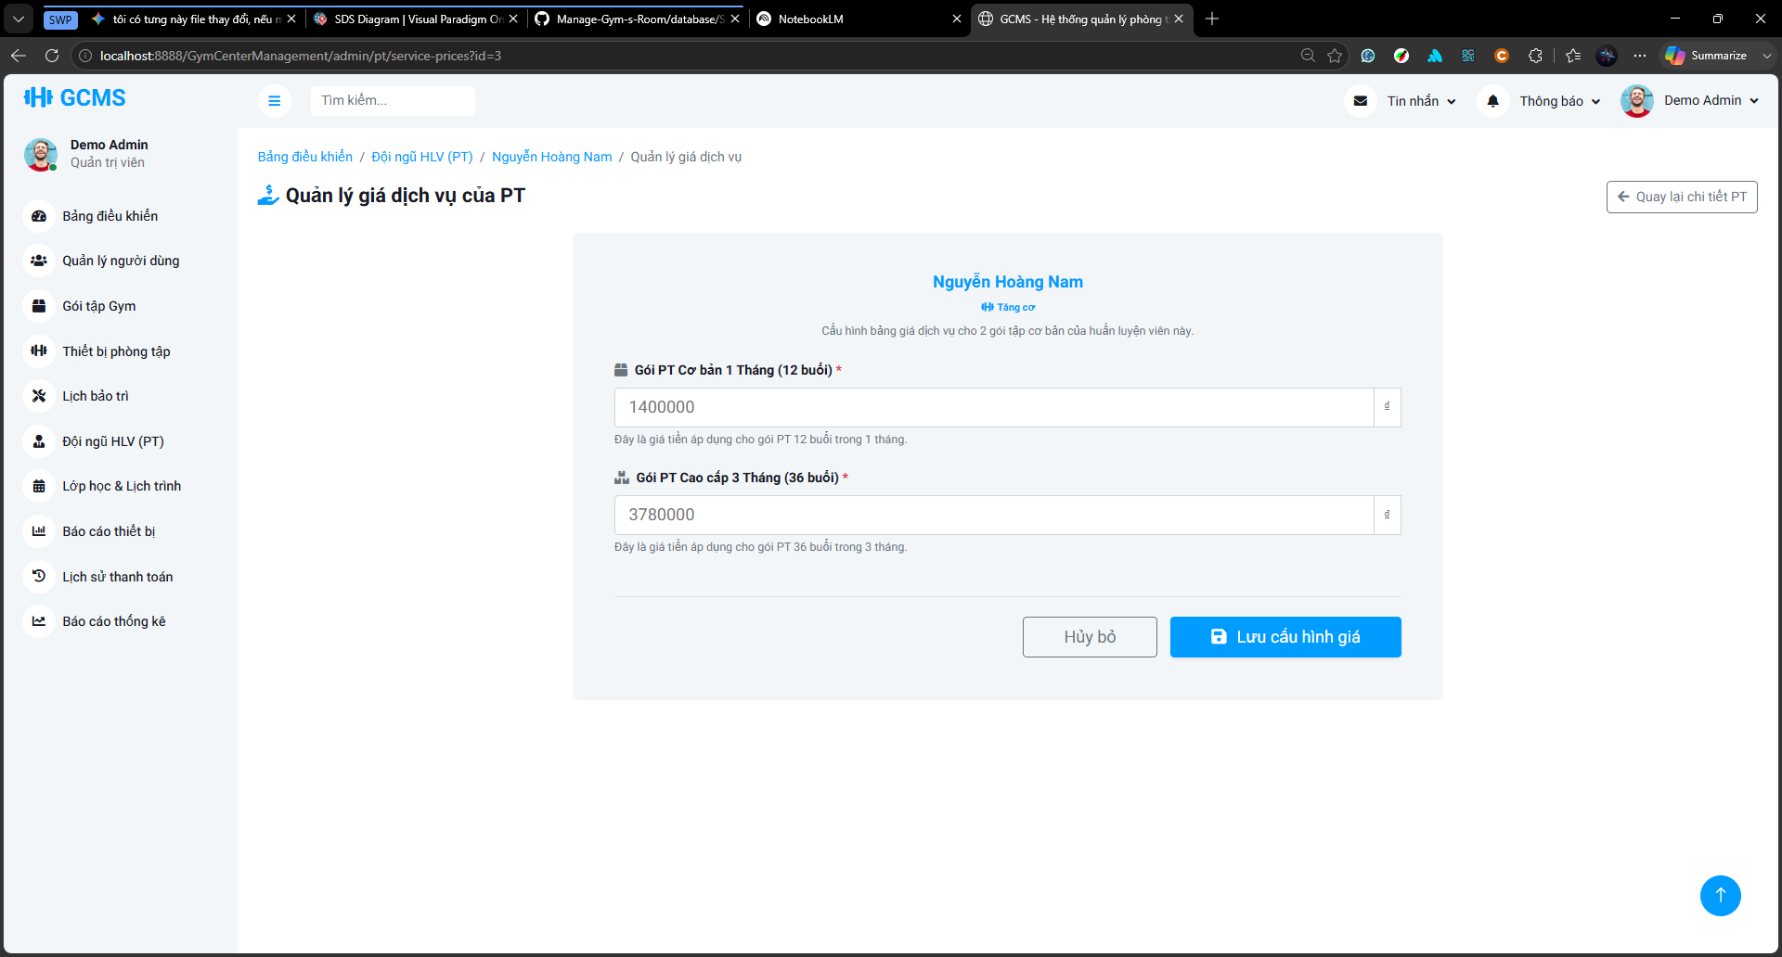
Description
This screen allows Admin to configure service prices for a selected Personal Trainer based on available PT package types. Staff cannot access this screen. The configured prices are used for future PT service registrations and do not affect existing registrations or paid invoices.
Roles/Actors: Admin
Functions:
- View the selected trainer information.
- View available PT package types.
- Configure service price for each PT package type.
- Save updated PT service price configuration.
- Cancel changes and return to the trainer detail screen.
Field Description
Field Name | Description
Breadcrumb | Shows navigation path to the service price management screen.
Trainer Name | Displays the selected trainer name.
Specialization | Displays trainer specialization.
Package Price Input | Required. Price configured for each PT package type.
Package Name | Displays the PT package type name.
Package Sessions | Displays the number of sessions in the package.
Price Unit | Displays currency unit.
Cancel Button | Cancels changes and returns to the trainer detail screen.
Save Price Configuration Button | Saves the updated service prices.
Back to PT Detail Button | Returns to the selected trainer detail screen.

3.7.4.4 Personal Trainer Self-Edit Profile Screen
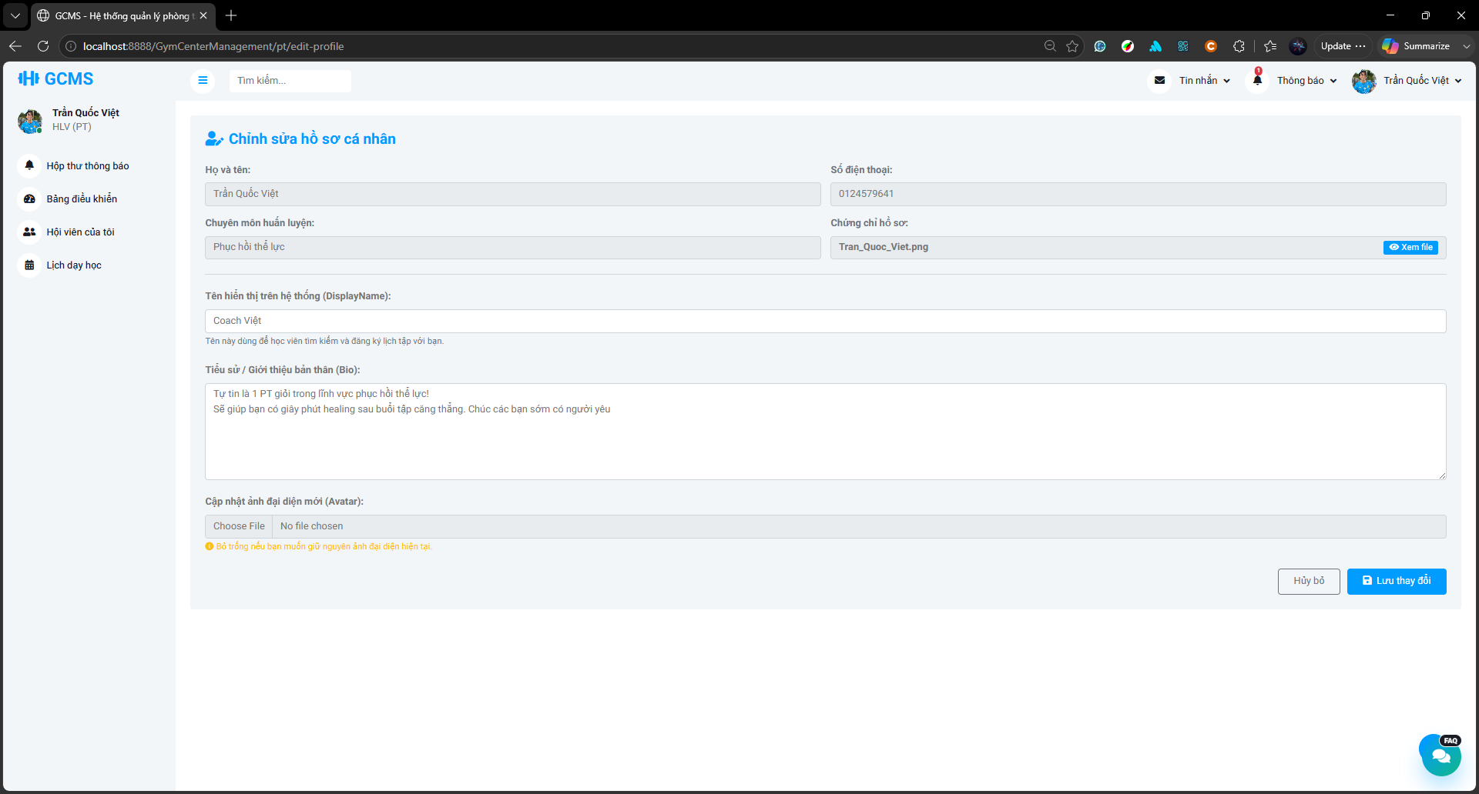
Description:
This screen allows a Personal Trainer to update limited public profile information for their own profile. Verified professional information such as full name, phone number, specialization, certificate file, career start date, trainer status, and service prices is displayed as read-only and cannot be changed by the trainer.
Roles/Actors: Personal Trainer
Functions:
- View verified trainer information in read-only mode.
- Update public display name.
- Update biography.
- Upload a new avatar image.
- View certificate file if available.
- Save public profile changes.
Field Description
Field Name | Description
Full Name | Read-only. Official trainer full name.
Phone Number | Read-only. Trainer phone number.
Specialization | Read-only. Trainer specialization.
Certificate File | Read-only. Allows viewing uploaded certificate file if available.
Display Name | Editable. Public trainer name shown to members.
Biography | Editable. Public trainer introduction.
New Avatar | Optional. Upload a new avatar image.
Cancel Button | Cancels the update.
Save Changes Button | Saves public profile changes.

3.7.5 Manage PT Schedules
Description: This section describes the screens used to manage Personal Trainer training schedules. The schedule management flow starts after a PT service registration has been approved and paid by Staff/Admin. The assigned Personal Trainer can view paid registrations waiting for schedule generation and create training schedules based on fixed time slots. Members and Personal Trainers can view their weekly PT schedules, send reschedule requests for Upcoming sessions, and send make-up requests for Cancelled sessions. Staff/Admin can review escalated schedule support requests, update training session attendance/status, assign substitute Personal Trainers, and perform mass cancellation when required.
Roles/Actors: Personal Trainer, Member, Staff, Admin
Functions:
- Display paid PT registrations waiting for schedule generation.
- Allow Personal Trainers to generate schedules for approved and paid registrations.
- Display weekly PT schedules for Members and Personal Trainers.
- Allow Members and Personal Trainers to send reschedule requests for Upcoming sessions.
- Allow Members and Personal Trainers to send make-up requests for Cancelled sessions.
- Display request status such as Pending, Approved, Rejected, or Escalated.
- Allow the receiver to approve, reject, or escalate a reschedule request.
- Allow Staff/Admin to review escalated reschedule or make-up requests.
- Allow Staff/Admin to update PT session attendance/status.
- Allow Staff/Admin to assign a substitute Personal Trainer for an Upcoming session.
- Allow Admin to mass cancel Upcoming PT sessions on a selected date.
- Display cancellation reason, substitute trainer information, and schedule conflict indicators.

3.7.5.1 Pending PT Registrations Screen
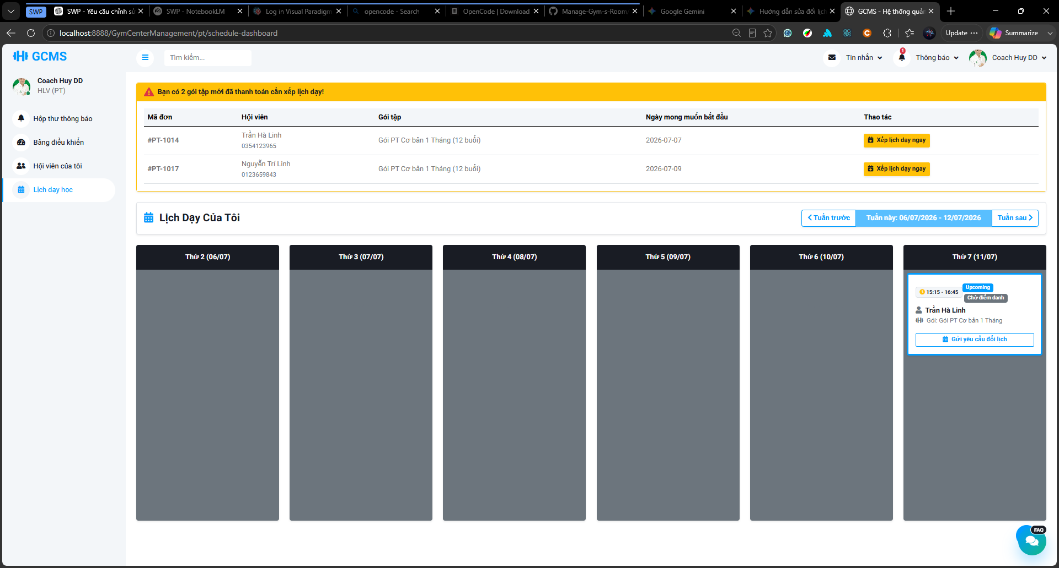
Description
This screen allows a Personal Trainer to view PT service registrations that have been approved and paid by Staff/Admin but have not been scheduled yet. The screen displays a list of paid registrations waiting for schedule generation, including registration ID, Member information, selected PT package, number of purchased sessions, preferred start date, and registration status. The Personal Trainer can select a registration and proceed to the schedule setup screen to generate official PT training sessions.
Roles/Actors: Personal Trainer
Functions:
- View paid PT registrations waiting for schedule generation.
- Display the number of registrations that need scheduling.
- View registration ID, Member, PT package, purchased sessions, and preferred start date.
- Open the schedule setup screen for a selected registration.
- Hide or show an empty-state message when there is no paid registration waiting for scheduling.
Field Description
Field Name | Description
Pending Schedule Alert | Displays a warning or notification when the Personal Trainer has paid registrations that need schedule generation.
Registration ID | Displays the PT registration code.
Member | Displays the Member name and basic contact information.
PT Package | Displays the selected PT service package.
Purchased Sessions | Displays the number of PT sessions purchased by the Member.
Preferred Start Date | Displays the Member’s desired start date. This is not the actual schedule start date.
Registration Status | Displays the current registration status, usually Active/Paid or Waiting for Schedule.
Schedule Now Button | Opens the PT Schedule Setup screen for the selected registration.
Empty State Message | Displays a message when there are no paid registrations waiting for schedule generation.

3.7.5.2 Generate PT Schedule Screen
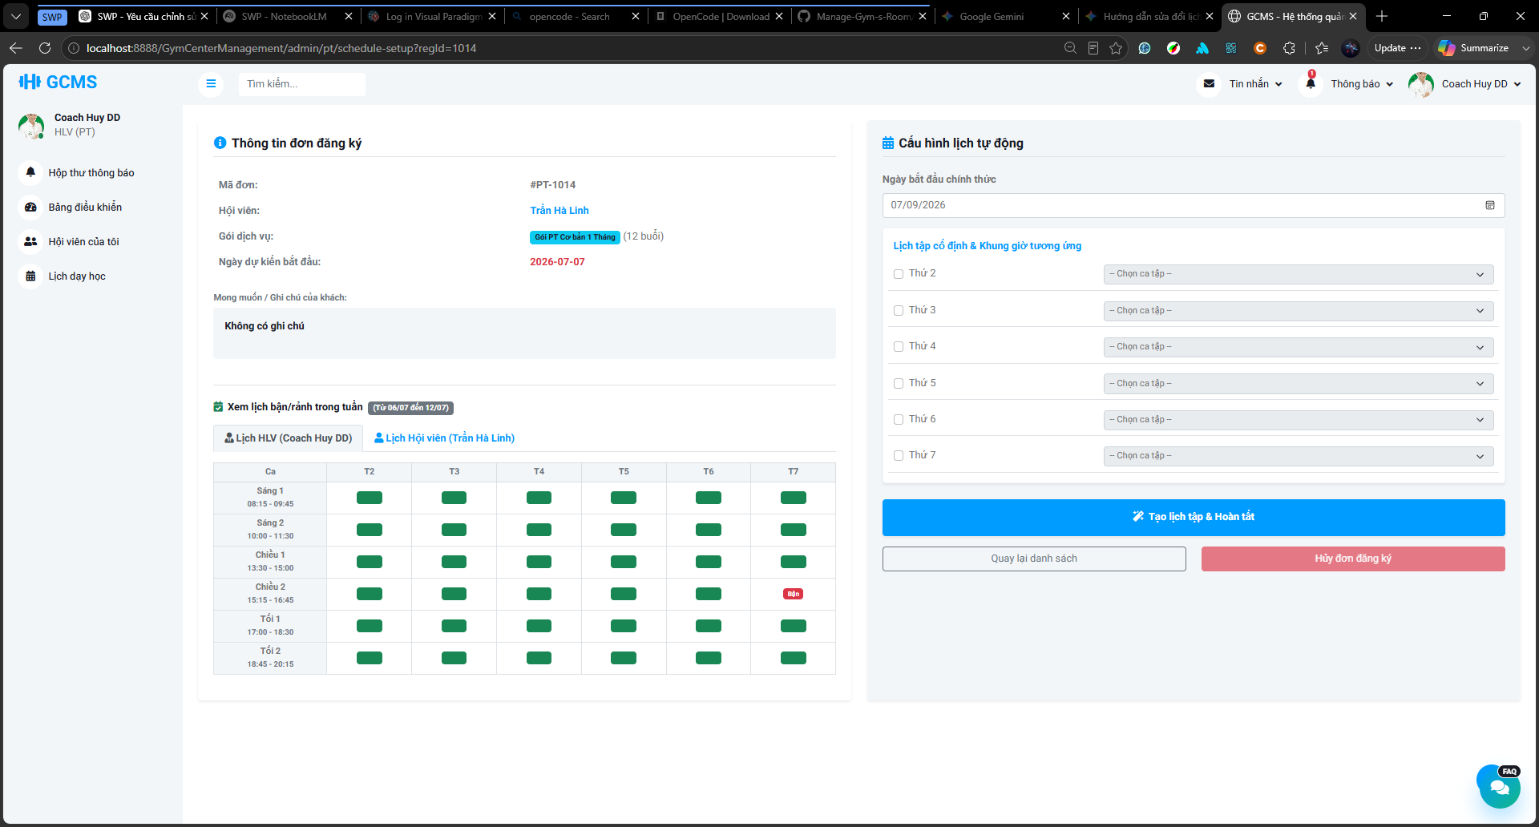
Description
This screen allows the assigned Personal Trainer to generate official training sessions for a paid and approved PT registration. The screen displays registration information, Member information, selected PT package, purchased sessions, preferred start date, and Member notes. The Personal Trainer selects the official start date, chooses training weekdays, and selects a fixed time slot for each selected weekday. The screen also provides availability tabs so the trainer can check both the PT schedule and the Member schedule before generating sessions.
Roles/Actors: Personal Trainer
Functions:
- View selected PT registration information.
- View Member information, selected package, purchased sessions, and preferred start date.
- View Member training goals or notes.
- Select the official schedule start date.
- Select training weekdays.
- Select a fixed training slot for each selected weekday.
- View PT busy schedule by date.
- View Member busy schedule by date.
- Disable slot selection for weekdays that are not selected.
- Mark unavailable slots when the PT or Member is busy.
- Generate all required PT sessions based on purchased sessions.
- Return to the pending paid registration list.
Field Description
Field Name | Description
Registration ID | Displays the PT registration code selected for schedule generation.
Member Information | Displays the Member name and basic contact information.
PT Package | Displays the selected PT service package.
Purchased Sessions | Displays the number of sessions that must be generated.
Preferred Start Date | Displays the Member’s desired start date from the registration request.
Member Note / Training Goal | Displays the Member’s training goals, health notes, or preferred information if available.
Official Start Date | Required. The actual start date used for generating the PT schedule.
Weekday Selection | Allows the Personal Trainer to select training weekdays.
Slot Selection Per Weekday | Allows the Personal Trainer to select one fixed slot for each selected weekday.
Disabled Weekday Slot | Shows disabled slot selection for weekdays that are not selected.
PT Busy Schedule Tab | Displays the Personal Trainer’s existing busy schedule for checking conflicts.
Member Busy Schedule Tab | Displays the Member’s existing busy schedule for checking conflicts.
Busy Slot Indicator | Shows that a slot is unavailable because the PT or Member already has another schedule.
Generate Schedule Button | Generates all PT training sessions for the selected registration.
Back Button | Returns to the pending paid registration list.

3.7.5.3 Member/PT Weekly Schedule Screen
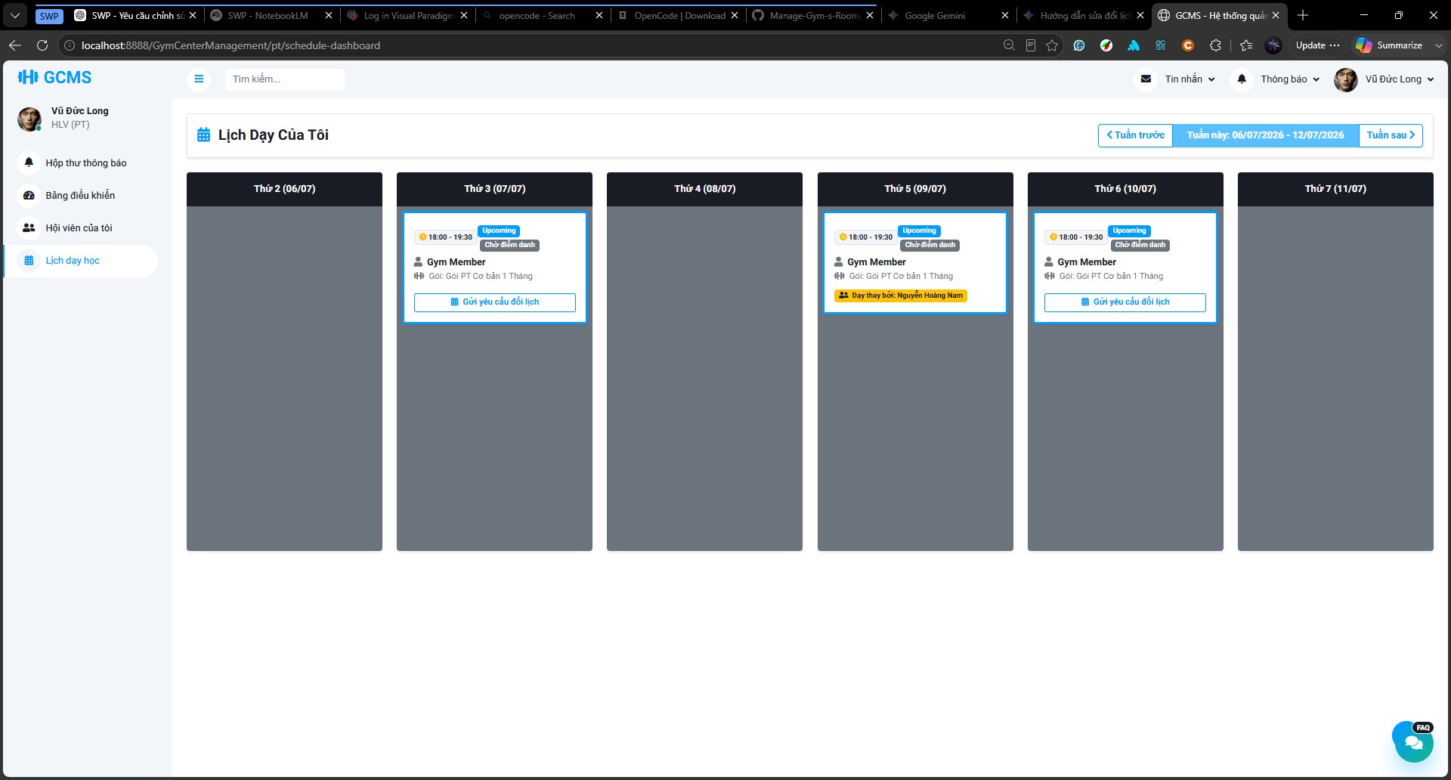
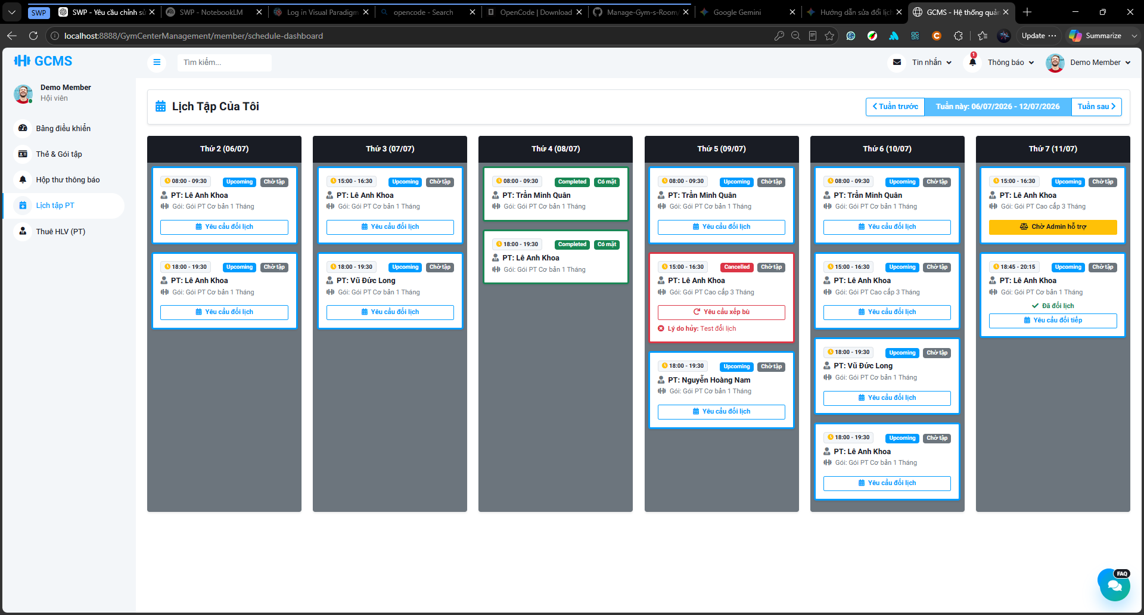
Description
This screen allows Members and Personal Trainers to view their weekly PT training schedule. The screen displays PT sessions by date and time, including session status, attendance result, package information, trainer/member information, cancellation reason, reschedule request status, and substitute trainer information if applicable. Members and the currently assigned Personal Trainer can request reschedule for Upcoming sessions. For Cancelled sessions, users may request a make-up session if no pending or approved make-up request exists.
Roles/Actors: Personal Trainer, Member
Functions:
- View weekly PT training sessions.
- Navigate to previous or next week.
- Display session date, time, trainer, member, package, and status.
- Display Upcoming, Completed, Cancelled, and request-related session states.
- Allow Member or current assigned PT to request reschedule for Upcoming sessions.
- Allow Member or current assigned PT to request make-up for Cancelled sessions.
- Display pending reschedule or make-up request status.
- Allow users to view request detail after a request has been submitted.
- Display cancellation reason for Cancelled sessions.
- Display substitute trainer label when a session has been assigned to another PT.
- Allow substitute PT to view and request reschedule for the assigned substitute session.
- Allow original PT to view substitute session information in read-only mode.
Field Description
Field Name | Description
Week Navigation | Allows users to move to previous or next week.
Date Column | Displays each date in the selected week.
Session Card | Displays a PT training session in the weekly schedule.
Session Time | Displays the start time and end time of the PT session.
Member Name | Displays the Member assigned to the session. Visible mainly for PT view.
Trainer Name | Displays the Personal Trainer assigned to the session. Visible mainly for Member view.
Package Name | Displays the PT package related to the session.
Session Status | Displays the current session status such as Upcoming, Completed, or Cancelled.
Attendance Result | Displays attendance results such as Pending, Attended, or Absent if available.
Request Reschedule Button | Displays for eligible future Upcoming sessions. Opens the reschedule request modal.
Request Make-up Button | Displays for eligible Cancelled sessions. Opens the make-up request modal.
Pending Request Label | Indicates that a reschedule or make-up request is waiting for response.
Request Detail Button | Opens the submitted request detail.
Cancellation Reason | Displays the reason when the session status is Cancelled.
Substitute Label | Displays substitute information, such as “Substitute Session” or “Taught by Substitute PT”.
Substitute Reason Tooltip | Shows the substitute assignment reason when the user hovers over the substitute label.
Read-only Substitute Session | For the original PT, the substituted session remains visible but cannot be rescheduled or updated.

3.7.5.4 Reschedule / Make-up Request Form
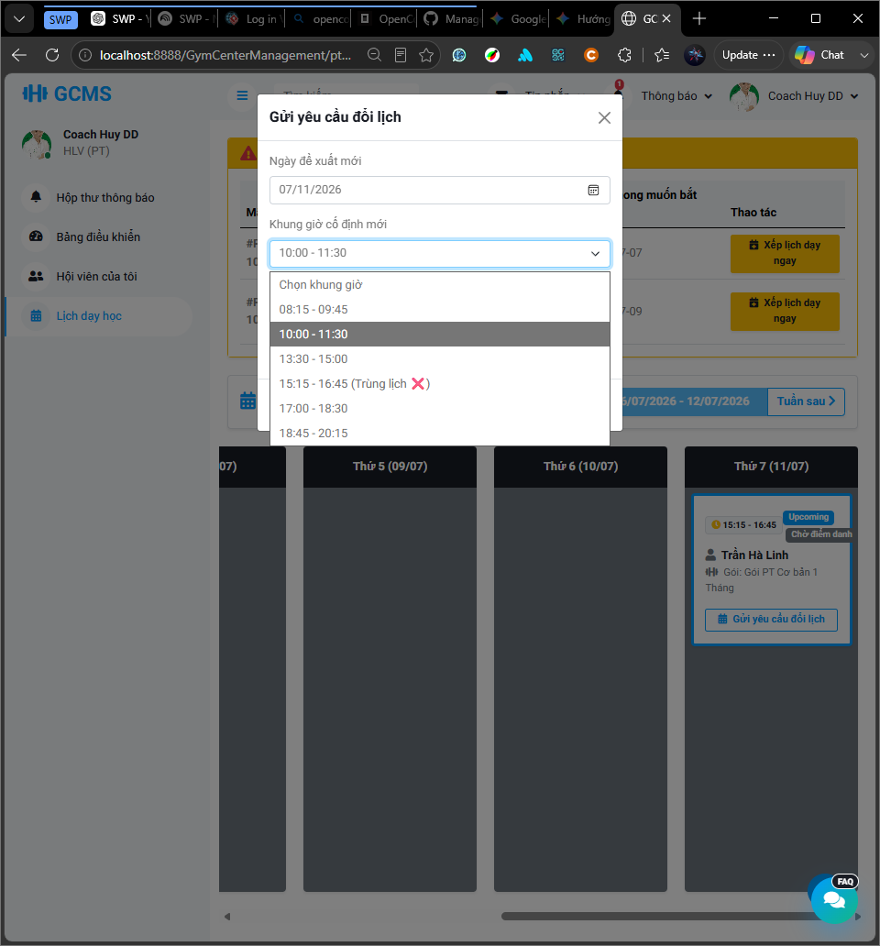
Description
This form allows a Member or the currently assigned Personal Trainer to submit a schedule change request for a PT session. For an Upcoming session, the form is used to request a reschedule. For a Cancelled session, the same form layout is used to request a make-up session. The requester selects a proposed future date, selects an available fixed time slot, enters a required reason, and submits the request. For make-up requests, the form disables dates or slots that are invalid, already mass-cancelled, or conflicting with the Personal Trainer or Member schedule. The backend validates the same conditions again before creating the request.
Roles/Actors: Personal Trainer, Member
Functions:
- Allow the requester to select a proposed future date.
- Display fixed time slots for the selected proposed date.
- Mark busy slots when the Personal Trainer or Member has a schedule conflict.
- Disable unavailable or invalid slots.
- Require the requester to enter a reason.
- Submit a reschedule request for an Upcoming session.
- Submit a make-up request for a Cancelled session.
- Close the form without submitting the request.
Field Description
Field Name | Description
Proposed Date | Required. The new date proposed by the requester. The date must be in the future and must not be a mass-cancelled date.
Proposed Time Slot | Required. A predefined fixed slot selected for the proposed date.
Busy Slot Indicator | Shows that a fixed slot is unavailable because the Personal Trainer or Member already has another schedule.
Reason | Required. Explains why the requester wants to change or make up the session.
Submit Request Button | Submits the reschedule or make-up request.
Cancel/Close Button | Closes the modal without submitting the request.

3.7.5.5 Request Detail / Response Modal
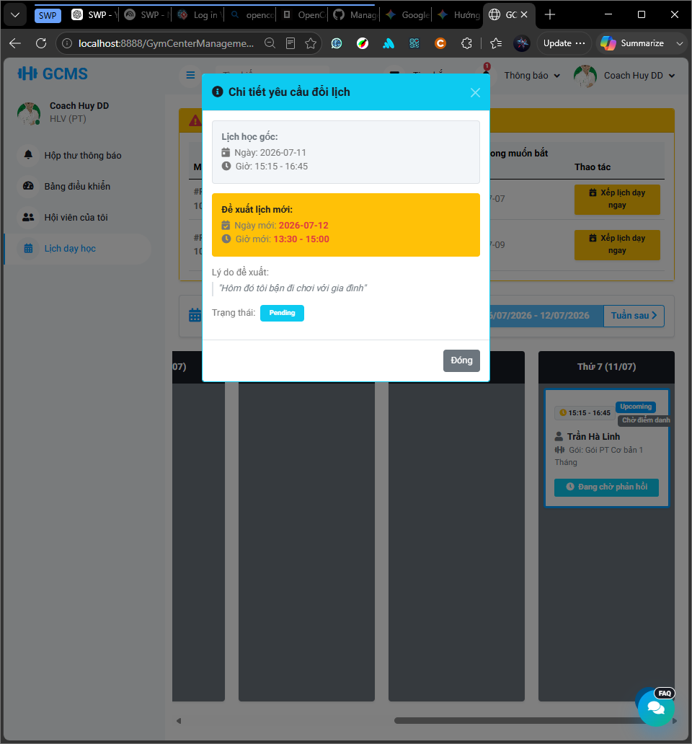
Image 3.5.6.5.1: Submitted Request Detail Modal
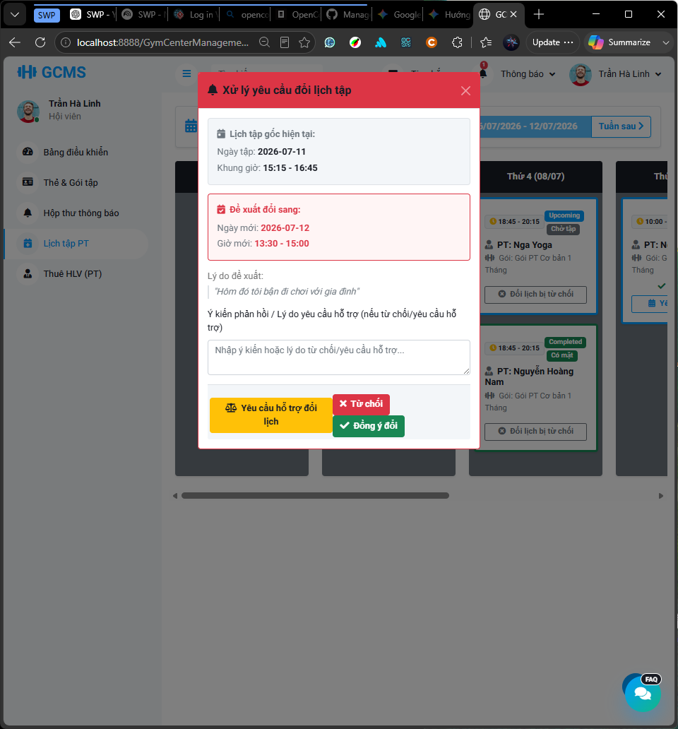
Image 3.5.6.5.2: Request Response Modal
Description
This modal allows users to view the details of a submitted reschedule or make-up request. The requester can open the modal to review request information and current status after submission. The receiver can open the modal from the schedule card to review the original schedule, proposed new schedule, request reason, and then approve, reject, or escalate the request to Staff/Admin support. When a request is approved, the session is updated or a make-up session is created according to the request type. When a request is rejected, the original session remains unchanged.
Roles/Actors: Personal Trainer, Member
Functions:
- Display request detail information.
- Display original schedule information.
- Display proposed new date and fixed time slot.
- Display requester, receiver, reason, and request status.
- Allow the requester to view submitted request status.
- Allow the receiver to approve the proposed slot.
- Allow the receiver to reject the request with a reason.
- Allow the receiver to escalate the request to Staff/Admin support.
- Display processed request result after approval or rejection.
Field Description
Field Name | Description
Request Status | Displays the current status of the request, such as Pending, Approved, Rejected, or Escalated.
Original Schedule | Displays the original session date and time.
Proposed Schedule | Displays the proposed new date and fixed time slot.
Request Reason | Displays the reason entered by the requester.
Response Reason | Displays or collects the reason when the receiver rejects the request.
Approve Button | Approves the proposed schedule change if the current user is the receiver.
Reject Button | Rejects the request and records a rejection reason.
Escalate to Staff/Admin Button | Sends the request to Staff/Admin support when the receiver cannot resolve it directly.
Close Button | Closes the modal.

3.7.5.6 Staff/Admin Schedule Support Screen
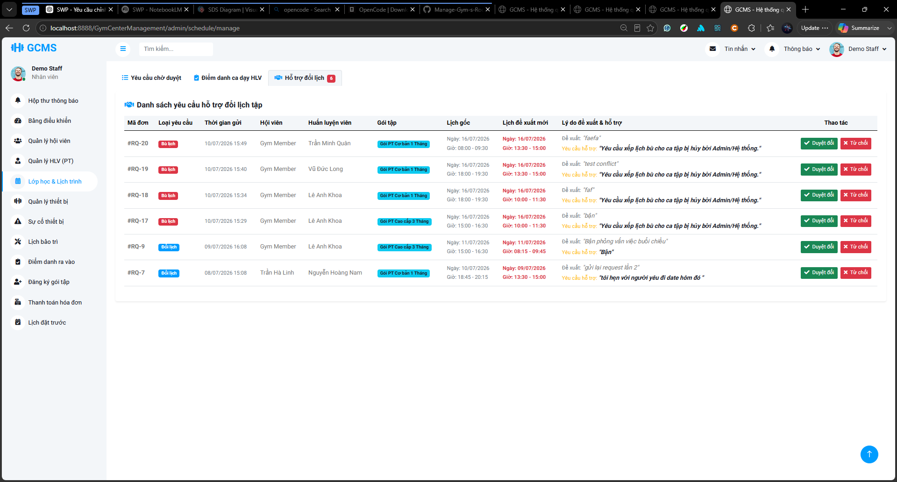
Description
This screen allows Staff/Admin to review schedule support requests, including reschedule requests for Upcoming sessions and make-up requests for Cancelled sessions. The screen displays request type, request ID, submitted time, Member, Personal Trainer, PT package, original schedule, proposed schedule, request reason, support reason, and available actions. Staff/Admin can approve or reject the proposed slot, but cannot manually select another date or time slot.
Roles/Actors: Staff, Admin
Functions:
- View the list of escalated schedule support requests.
- Display request ID and submitted time.
- Display Member and Personal Trainer information.
- Display PT package information.
- Display original schedule date and time.
- Display proposed new schedule date and fixed slot.
- Display request reason and support reason.
- Approve the proposed schedule change.
- Reject the support request with a reason.
- Show a confirmation dialog before approval.
- Show a rejection reason dialog before rejecting.
- Remove processed requests from the pending support list.
Field Description
Field Name | Description
Schedule Support Tab | Displays the list of escalated reschedule or make-up requests.
Request ID | Displays the request code.
Request Type | Displays whether the request is a Reschedule request or a Make-up request.
Original Schedule | Displays the original session. For make-up requests, this is the Cancelled session.
Proposed Schedule | Displays the proposed date and fixed slot submitted by Member/PT.
Cancellation Reason | Displays the reason why the original session was cancelled, if the request type is Make-up.
Submitted Time | Displays when the request was submitted or escalated.
Member | Displays the Member related to the request.
Personal Trainer | Displays the PT related to the request.
PT Package | Displays the PT service package of the session.
Original Schedule | Displays the original session date and time.
Proposed Schedule | Displays the proposed new date and fixed time slot.
Request Reason | Displays the reason submitted by the requester.
Support Reason | Displays the reason why the request was escalated to Staff/Admin.
Approve Button | Approves the proposed slot after confirmation.
Reject Button | Opens a rejection dialog for Staff/Admin to enter the rejection reason.
Approval Confirmation Dialog | Confirms that Staff/Admin wants to approve the proposed schedule change.
Rejection Reason Dialog | Allows Staff/Admin to enter the reason for rejecting the support request.

3.7.5.7 Assign Substitute PT Modal
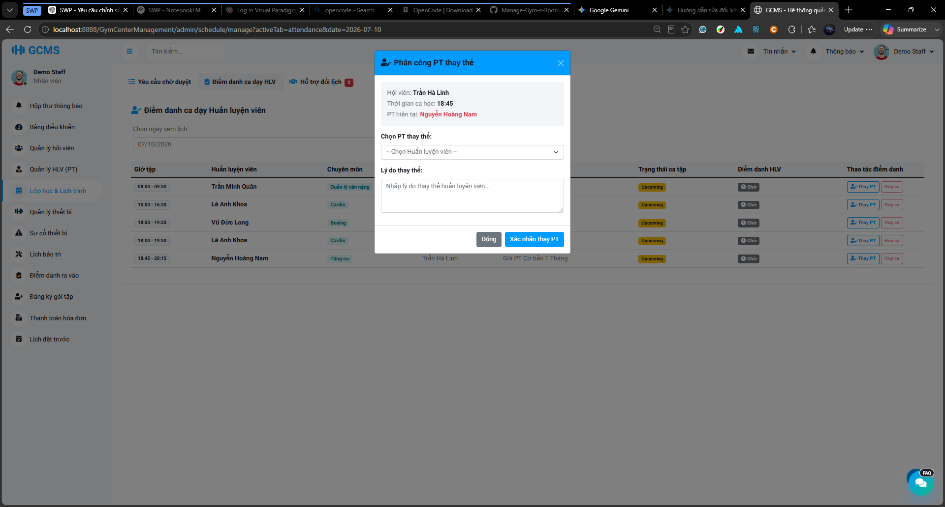
Description
This modal allows Staff/Admin to assign another active Personal Trainer as a substitute trainer for one specific Upcoming PT session. The modal displays the selected session information, including Member, session time, and current Personal Trainer. Staff/Admin selects a substitute trainer, enters a required substitute reason, and confirms the assignment. After successful assignment, the selected substitute trainer becomes the current assigned trainer for that session, while the original trainer information is kept for tracking.
Roles/Actors: Staff, Admin
Functions:
- Display selected PT session information.
- Display Member name and session time.
- Display the current assigned Personal Trainer.
- Allow Staff/Admin to select an active substitute Personal Trainer.
- Require Staff/Admin to enter a substitute reason.
- Confirm substitute trainer assignment.
- Update the selected session to use the substitute trainer as the current trainer.
- Keep the original trainer information for tracking.
- Send notification to the substitute trainer.
- Send notification to the original trainer.
- Close the modal without saving changes.
Field Description
Field Name | Description
Member | Displays the Member assigned to the selected session.
Session Time | Displays the start time and end time of the selected session.
Current Personal Trainer | Displays the currently assigned trainer before substitution.
Substitute Trainer Dropdown | Allows Staff/Admin to select an active substitute trainer.
Substitute Reason | Required. Explains why the substitute trainer is assigned.
Confirm Substitute Button | Confirms the substitute assignment.
Close Button | Closes the modal without assigning a substitute trainer.

3.7.5.8 Update Training Session Status Screen
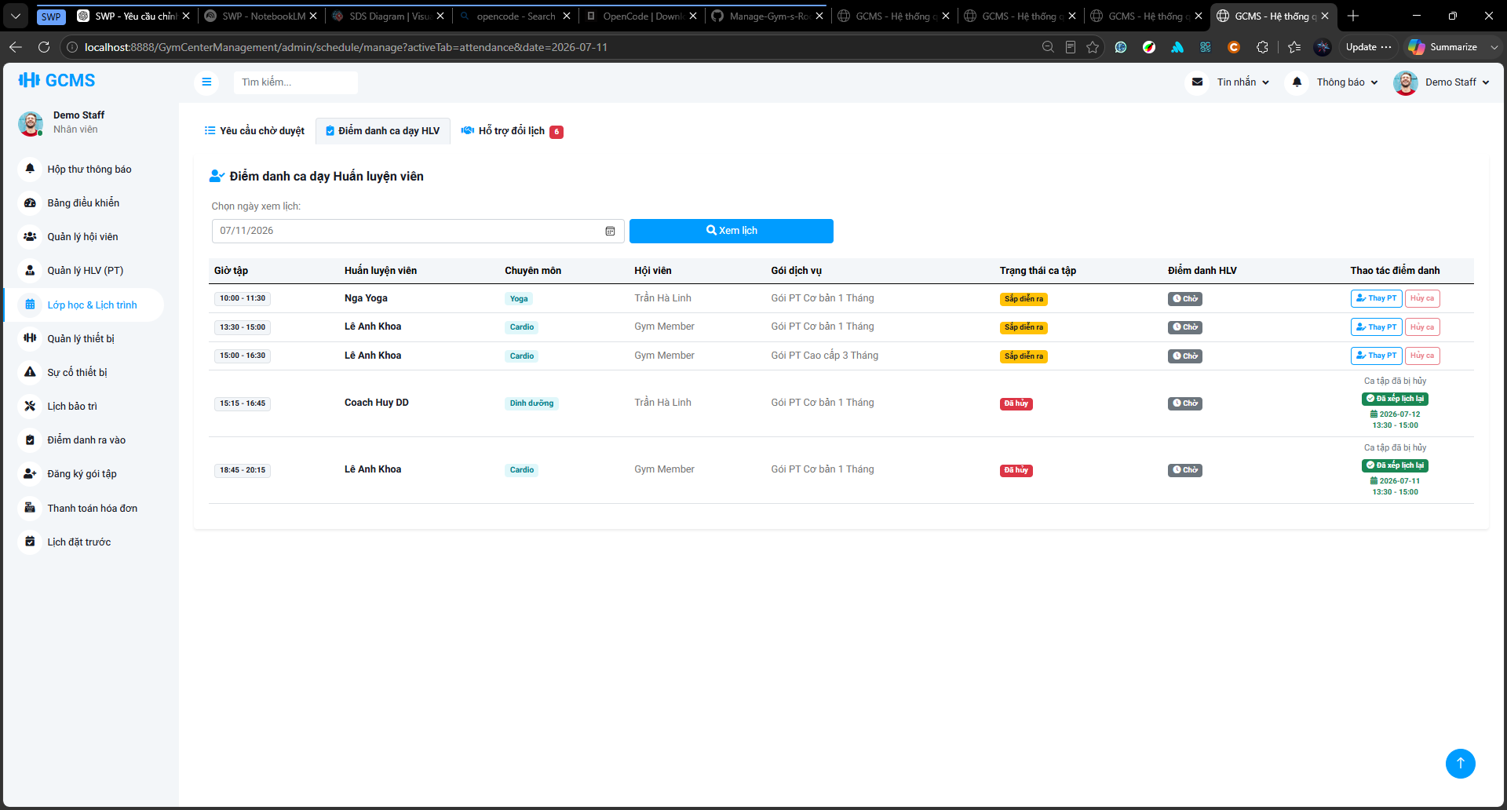
Description
This screen allows Staff/Admin to view PT training sessions by selected date and update the attendance or training result of eligible sessions. The screen displays session time, Personal Trainer, specialization, Member, PT package, session status, attendance result, and available attendance actions. Staff/Admin can mark an eligible session as Attended, Absent, or Pending. Cancelled sessions are displayed but cannot be updated.
Roles/Actors: Staff, Admin
Functions:
- Select a date to view PT training sessions.
- Display PT sessions on the selected date.
- Display session time, trainer, specialization, member, package, session status, and attendance result.
- Mark an eligible session as Attended.
- Mark an eligible session as Absent.
- Reset an eligible session to Pending.
- Display Cancelled sessions as non-editable.
- Display substitute trainer information if the session has been assigned to another PT.
- Display make-up request status for Cancelled sessions.
- Display approved make-up date and fixed slot when a make-up session has been scheduled.
- Display pending make-up request status when the request is waiting for Staff/Admin review.
- Open the Assign Substitute PT modal for eligible Upcoming sessions.
Field Description
Field Name | Description
Date Picker | Allows Staff/Admin to select the date used to load PT sessions.
View Schedule Button | Loads PT sessions for the selected date.
Session Time | Displays the start time and end time of the PT session.
Personal Trainer | Displays the current assigned trainer. If the session is substituted, this field displays the substitute trainer and may show the original trainer as additional information.
Specialization | Displays the trainer specialization.
Member | Displays the Member assigned to the session.
PT Package | Displays the related PT service package.
Session Status | Displays the session status, such as Upcoming, Completed, or Cancelled.
Attendance Result | Displays the attendance result, such as Pending, Attended, or Absent.
Make-up Status Label | Displays the make-up status of a Cancelled session, such as No Make-up Request, Pending, or Scheduled.
Make-up Schedule Information | Displays the approved make-up date and fixed time slot when the make-up session has been scheduled.
Assign Substitute Button | Opens the substitute trainer modal for eligible Upcoming sessions.
Attended Button | Marks the session as Completed with Attended result.
Absent Button | Marks the session as Completed with Absent result.
Pending Button | Resets the session to Upcoming/Pending if allowed.
Cancelled Session Label | Displays that the session has been cancelled and disables attendance actions.

3.7.5.9 Mass Cancel PT Sessions Screen / Modal
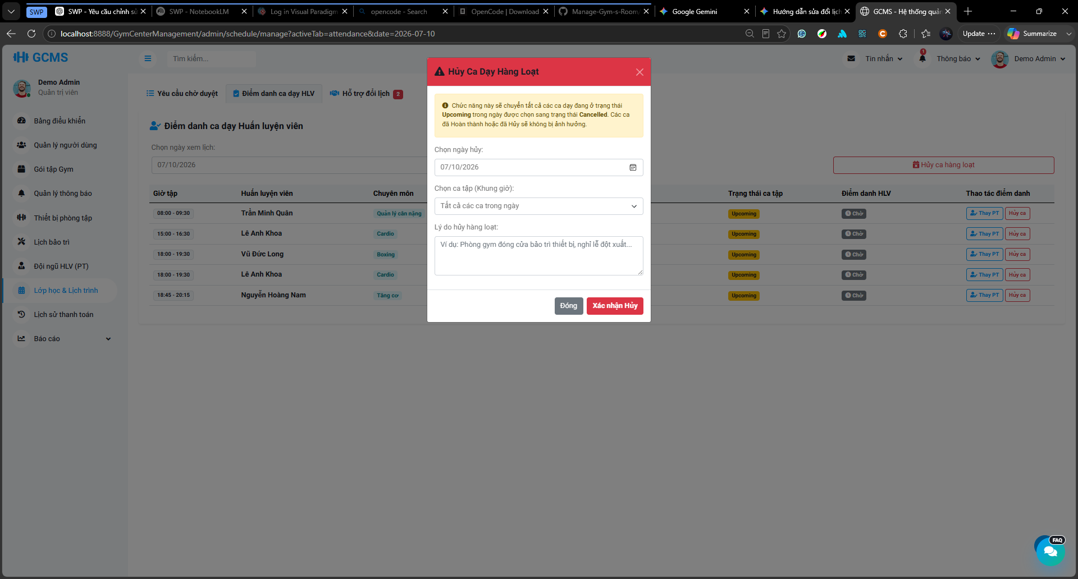
Description
This screen/modal allows Admin to cancel all eligible Upcoming PT sessions on a selected date. Admin selects the cancellation date, enters a required cancellation reason, and confirms the mass cancellation action. The system only cancels PT sessions with Upcoming status on the selected date. Completed, already Cancelled, and soft-deleted sessions are not affected. Cancelled sessions remain visible in Member/PT schedules with the cancellation reason and may be handled later through make-up requests.
Roles/Actors: Admin
Functions:
- Select a date for mass cancellation.
- Display or process eligible Upcoming PT sessions on the selected date.
- Require Admin to enter a cancellation reason.
- Confirm mass cancellation before applying changes.
- Cancel all eligible Upcoming PT sessions on the selected date.
- Keep Completed sessions unchanged.
- Keep already Cancelled sessions unchanged.
- Display cancellation reason on Member/PT schedule cards.
- Allow affected Cancelled sessions to be handled later through make-up requests.
- Display success or empty-result message after processing.
Field Description
Field Name | Description
Cancellation Date | Required. The selected date whose Upcoming PT sessions will be cancelled.
Cancellation Reason | Required. Explains why sessions on the selected date are cancelled.
Eligible Session Count | Displays the number of Upcoming PT sessions that may be affected, if available.
Confirm Button | Confirms and performs the mass cancellation action.
Cancel Button | Closes the screen/modal without cancelling sessions.
Success Message | Displays the number of PT sessions cancelled successfully.
Empty Result Message | Displays when no Upcoming PT sessions are found on the selected date.

3.7.6 View PT Work Dashboard

3.7.6.1 View Personal Trainer Schedule & Work History
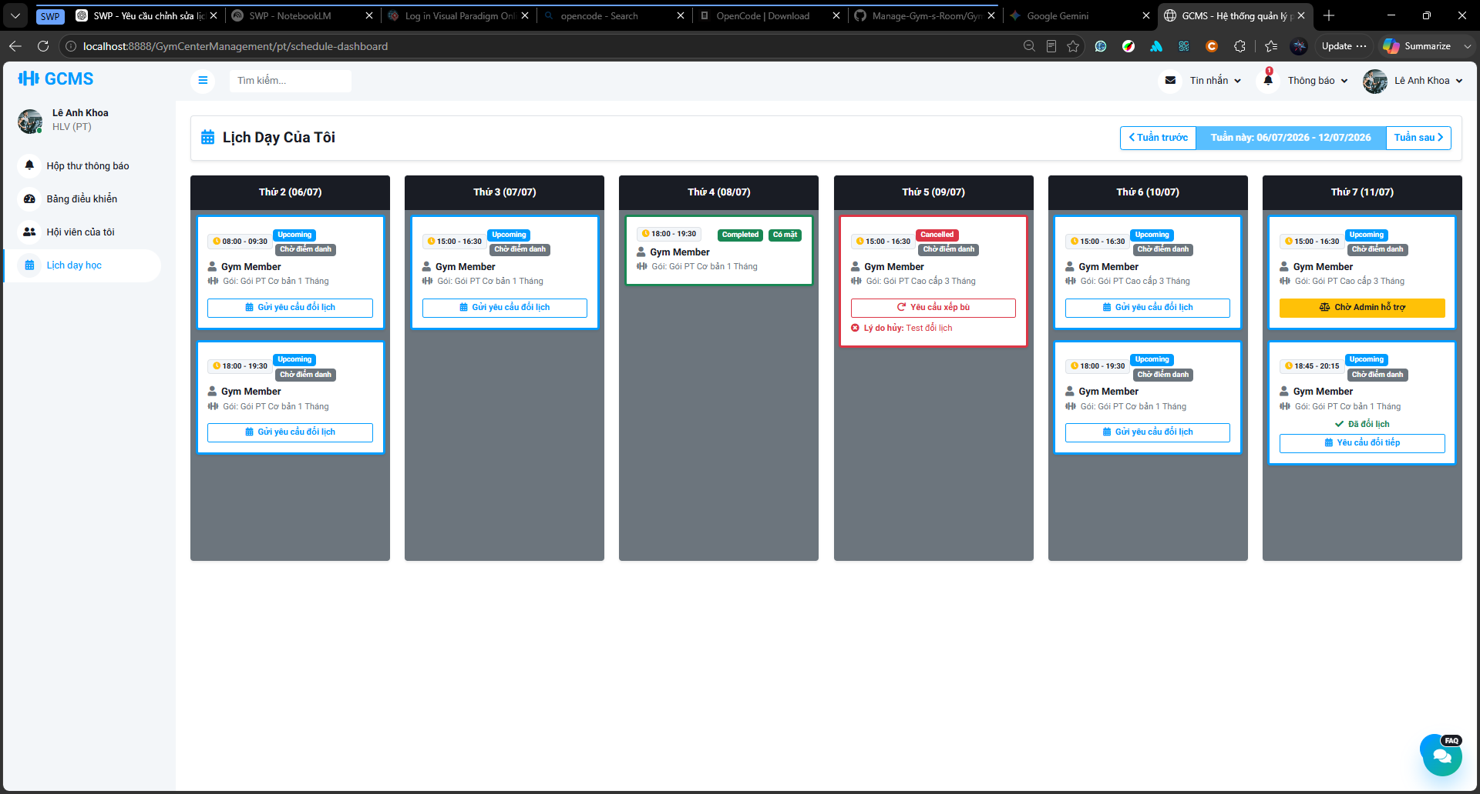
Description:
This screen allows a Personal Trainer to view their assigned PT training sessions, weekly work schedule, and completed teaching history. The screen displays session information such as date, time, Member, PT package, session status, attendance result, reschedule/make-up request status, cancellation reason, and substitute teaching information if applicable. The screen helps the Personal Trainer track upcoming work, completed sessions, cancelled sessions, and sessions taught as a substitute trainer.
Roles/Actors: Personal Trainer
Functions:
- View weekly assigned PT training sessions.
- Navigate to previous or next week.
- View Upcoming, Completed, and Cancelled PT sessions.
- View Member name and related PT package.
- View attendance result for completed sessions.
- View cancellation reason for Cancelled sessions.
- View pending reschedule or make-up request status.
- Open request detail for submitted or received requests.
- Request reschedule for eligible Upcoming sessions.
- Request make-up for eligible Cancelled sessions.
- View substitute teaching sessions assigned to the trainer.
- View original trainer information when teaching as a substitute.
- View read-only substitute information when another trainer is assigned to teach the original session.
Field Description
Field Name | Description
Week Navigation | Allows the PT to move to the previous or next week.
Date Column | Displays sessions grouped by date.
Session Card | Displays detailed information of one PT training session.
Session Time | Displays the start time and end time of the session.
Member Name | Displays the Member assigned to the session.
PT Package | Displays the related PT service package.
Session Status | Displays the status of the session, such as Upcoming, Completed, or Cancelled.
Attendance Result | Displays the result of the session, such as Pending, Attended, or Absent.
Request Status Label | Displays whether a reschedule or make-up request is Pending, Approved, Rejected, or Escalated.
Request Detail Button | Opens the request detail modal for the related request.
Request Reschedule Button | Opens the reschedule request form for an eligible Upcoming session.
Request Make-up Button | Opens the make-up request form for an eligible Cancelled session.
Cancellation Reason | Displays the reason when the session is Cancelled.
Substitute Trainer Label | Shows that the session is taught by another trainer or assigned to the current PT as substitute.
Substitute Reason Tooltip | Displays the reason for substitute assignment.

3.7.6.2 PT's Assigned Members Screen
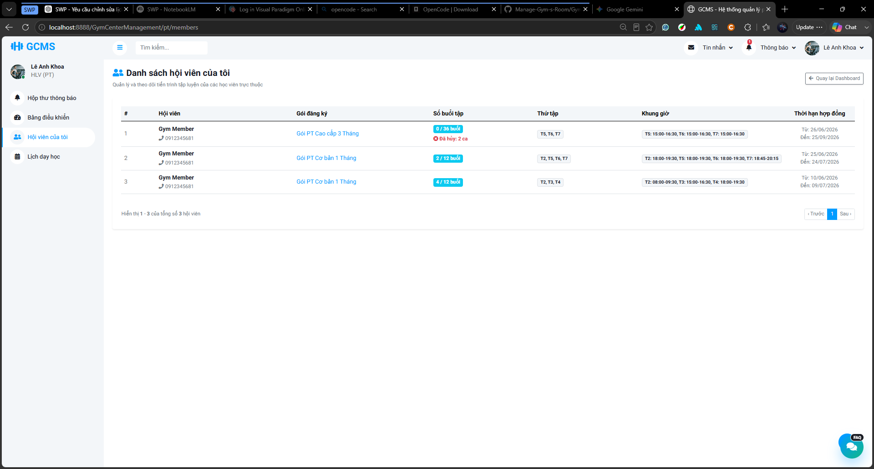
Description:
This screen allows a Personal Trainer to view the list of Members currently assigned to them through active PT registrations. The screen displays each Member’s registered PT package, completed session progress, cancelled session count, training weekdays, fixed training time slots, and contract period. This screen helps the Personal Trainer monitor assigned Members and track their training progress.
Roles/Actors: Personal Trainer
Functions:
- View the list of assigned Members.
- Search assigned Members by keyword.
- Display Member name and phone number.
- Display the registered PT package.
- Display completed sessions over purchased sessions.
- Display the number of cancelled sessions if any.
- Display training weekdays.
- Display fixed training time slots.
- Display contract start date and end date.
- Navigate between pages of assigned Members.
- Return to the Personal Trainer dashboard.
Field Description
Field Name | Description
Search Bar | Allows the PT to search assigned Members by keyword.
Member List Table | Displays Members currently assigned to the PT.
No. | Displays the row number.
Member | Displays the Member name and phone number.
Registered Package | Displays the PT package purchased by the Member.
Session Progress | Displays completed sessions over purchased sessions, such as 2/12 sessions
Cancelled Session Count | Displays the number of cancelled sessions, if any. Link to PT schedule
Training Weekdays | Displays the weekdays selected for the Member’s PT schedule.
Time Slots | Displays the fixed training slots assigned to the Member.
Contract Period | Displays the start date and end date of the PT registration or training contract.
Pagination | Allows the PT to move between pages when there are many assigned Members.
Back to Dashboard Button | Returns the PT to the dashboard screen.

3.7.7 Manage PT Package Types
Description: This management use case allows administrators to create, view, update, and delete Personal Trainer packages. Staff members only have the right to view those Personal Trainer packages

3.7.7.1 View list PT Package Screen
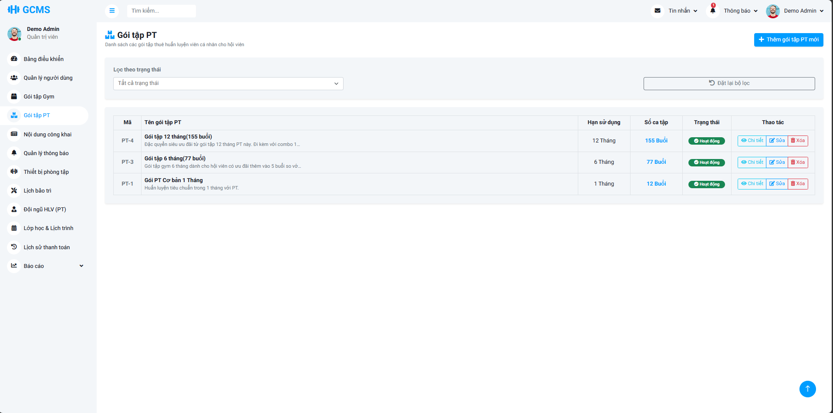
Description:
This screen serves as the centralized catalog for Personal Trainer service packages. It allows Administrators to perform full management operations (CRUD) on packages, while restricting Staff members to read-only access for customer consultation and reference
Roles/Actors: Staff, Admin
Functions:
- View a comprehensive list of all PT packages
- Filter the package list based on working status (e.g., Active, Inactive)
- Navigate to the creation screen to add a new PT package (Restricted to Admin)
- Open a modal/screen to view the full details of a specific package
- Navigate to the update form to modify an existing package (Restricted to Admin)
- Trigger a soft-delete action for a package (Restricted to Admin)
Field Description
Field Name | Description
Add New Package Button | Button located at the top-right. Navigates the user to the package creation form. Visible to Admin only; hidden for Staff.
Status Filter | Dropdown list. Allows users to filter the data table by package status (e.g., All, Active, Inactive).
Reset Filter Button | Button to reset the filter. Clears the selected status filter and reloads the default package list.
Package ID | Read-only. Displays the system-generated unique identifier for the package (e.g., PT-4, PT-3).
Package Name & Description | Read-only. Displays the primary name of the package in bold, accompanied by a truncated sub-text containing the package description.
Duration | Read-only. Displays the validity period of the package, typically in months (e.g., 12 Months, 6 Months).
Sessions | Read-only. Displays the total number of training sessions allocated to this package (e.g., 155 Sessions).
Status Badge | Read-only. A visual badge indicating the current operational status of the package (e.g., Green badge for "Active", Gray badge for "Inactive").
Action: View Detail | Button with an eye icon. Opens the package detail view (Modal/Screen) to show full information. Available to both Admin and Staff.
Action: Edit | Button with an edit icon. Navigates to the package update form. Visible to Admin only.
Action: Delete | Button with a trash icon in red. Triggers the confirmation modal for soft-deletion. Visible to Admin only.

3.7.7.2 PT Package Detail Modal
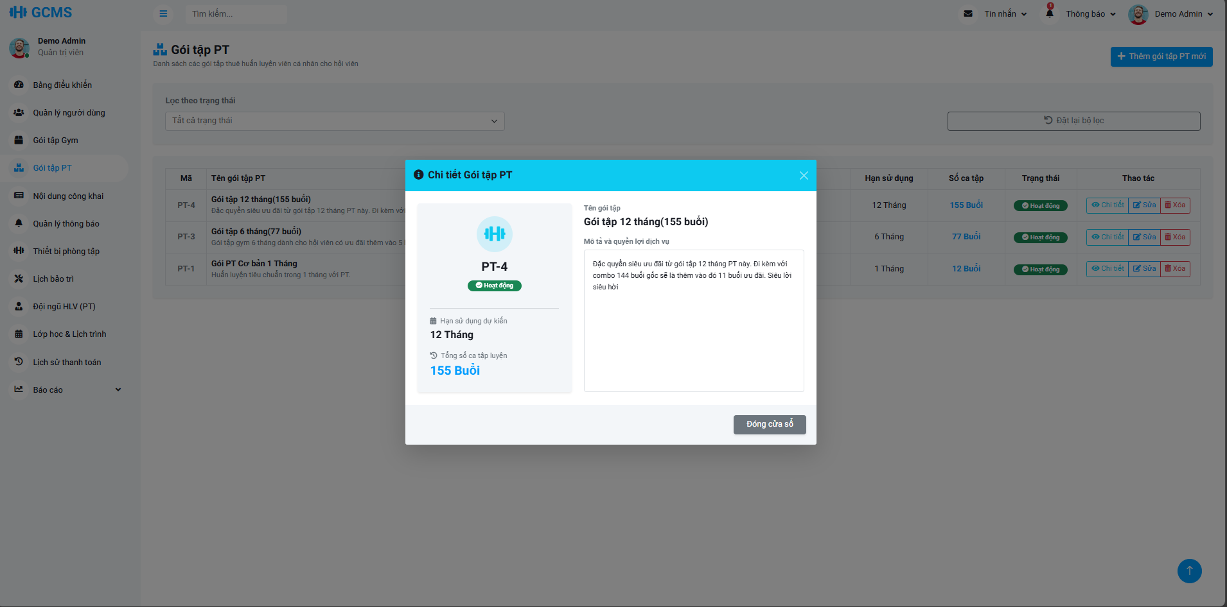
Description:
This modal interface provides a comprehensive, read-only view of a specific Personal Trainer package's details without requiring page redirection.
Roles/Actors: Staff, Admin
Functions: Display the complete and detailed information of a selected PT package including its operational status Provide a quick way to dismiss the information and return to the underlying list view
Field Description
Field Name | Description
Modal Title | Read-only. Displays the title of the modal indicating it is the detail view.
Close Icon | Icon at the top right corner to close the modal window.
Package ID | Read-only. Displays the system-generated unique identifier for the package.
Status Badge | Read-only. A visual badge indicating the current operational status of the package.
Duration | Read-only. Displays the expected validity period of the package in months.
Total Sessions | Read-only. Displays the total number of training sessions allocated to this package.
Package Name | Read-only. Displays the full name of the PT package.
Description | Read-only. Displays the comprehensive description, benefits, and features of the package.
Close Button | Button at the bottom to close the modal window.

3.7.7.3 Create PT Package Screen
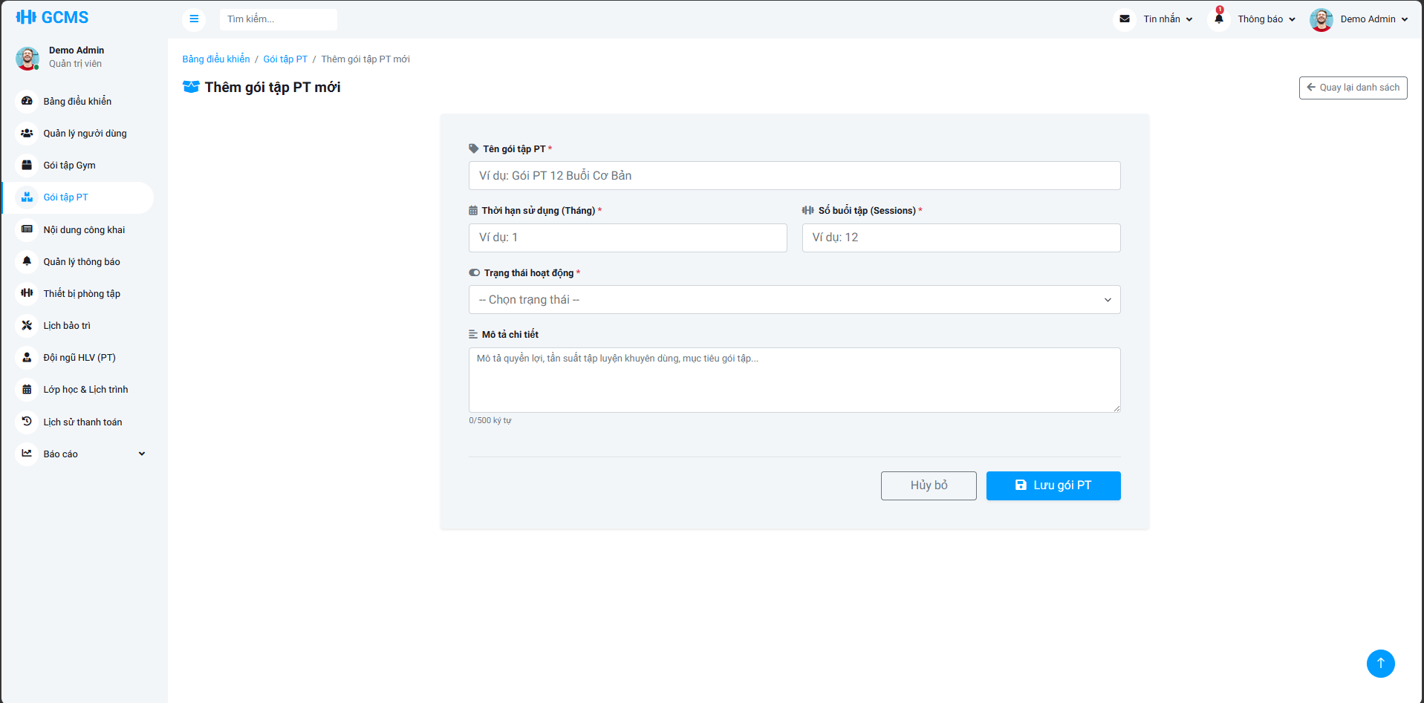
Description:
This screen provides a dedicated form for Administrators to configure and add a new Personal Trainer service package to the system catalog.
Roles/Actors: Admin
Functions: Provide input fields to configure new PT package parameters including name, duration, and session count Validate mandatory fields and numeric constraints upon submission Save the newly created package to the system database Allow the user to discard the current inputs and navigate back to the package list
Field Description
Field Name | Description
Back Button | Button located at the top right. Navigates the user back to the PT package list screen.
Package Name | Required. Text input for the title of the new PT package. Max length 100 characters.
Duration (Months) | Required. Numeric input for the package's validity period in months. In range [1-120]
Sessions | Required. Numeric input for the total number of training sessions included in the package. In range [1-500]
Status | Required. Dropdown list to select the initial operational status of the package.
Description | Optional. Text area to input detailed benefits or rules of the package. Includes a dynamic character counter (up to 500 characters).
Cancel Button | Button to discard all entered information and return to the package list.
Save Button | Button to submit the form, trigger validation, and create the new PT package.

3.7.7.4 Edit PT Package Screen
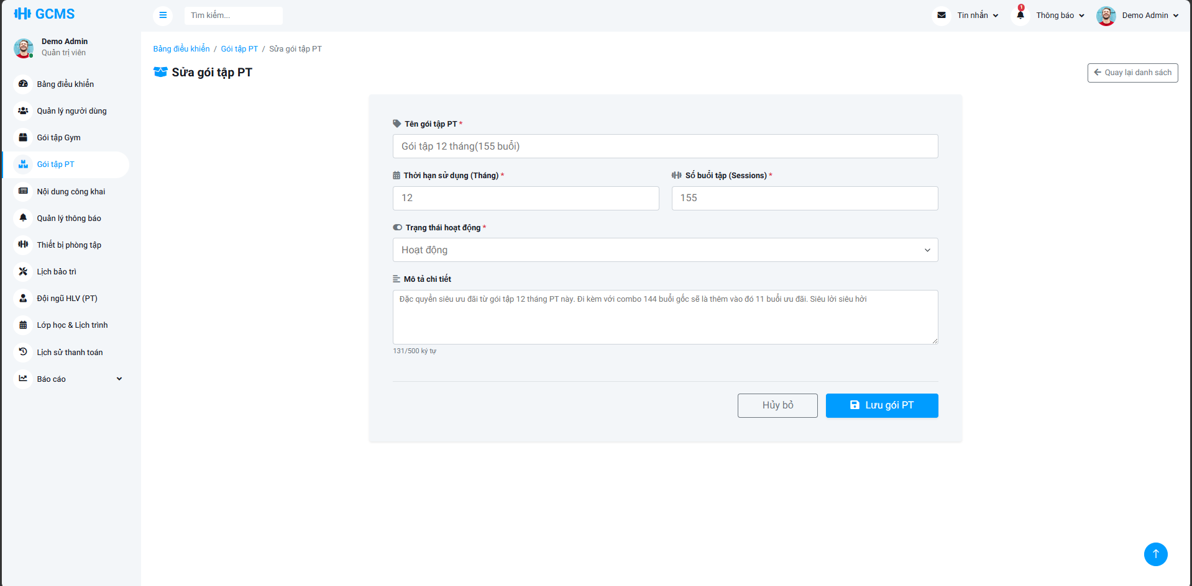
Description:
This screen provides a pre-filled form allowing Administrators to modify the configuration and details of an existing Personal Trainer service package.
Roles/Actors: Admin
Functions: Retrieve and display the current details of the selected PT package inside the form inputs Provide input fields to update the package name, duration, session count, status, and description Validate the updated inputs upon form submission Update the package record in the database Allow the user to discard uncommitted changes and return to the package list
Field Description
Field Name | Description
Back Button | Button located at the top right. Navigates the user back to the PT package list screen.
Package Name | Required. Text input to modify the title of the PT package. Pre-filled with existing data. Max length 100 characters.
Duration (Months) | Required. Numeric input to modify the package's validity period. Pre-filled with existing data. In range [1 - 120]
Sessions | Required. Numeric input to modify the total number of training sessions. Pre-filled with existing data. In range [1 - 500]
Status | Required. Dropdown list to update the operational status of the package. Pre-filled with the current status.
Description | Optional. Text area to update detailed benefits or rules. Includes a dynamic character counter (up to 500 characters). Pre-filled with existing text.
Cancel Button | Button to discard all changes and return to the package list.
Save Button | Button to submit the form, trigger validation, and update the package record.

3.7.7.5 Delete PT Package Confirmation Modal
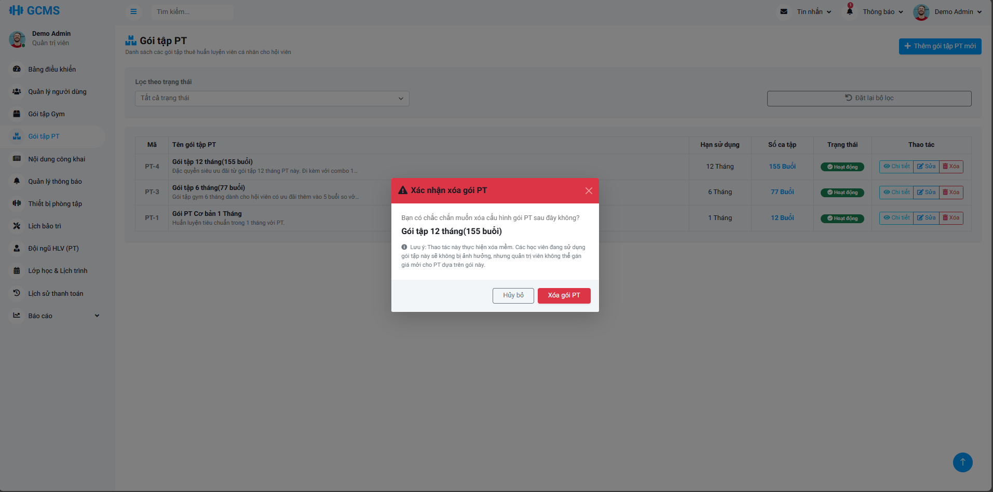
Description:
This modal serves as a critical safety checkpoint, prompting Administrators to confirm their intent before executing a soft deletion on a specific Personal Trainer package, while explaining the data preservation mechanism.
Roles/Actors: Admin
Functions: Prompt the user for final confirmation before removing a PT package from the active catalog Display the specific package name and session count to prevent accidental deletion Warn the user about the soft delete mechanism and assure them that active member registrations remain unaffected Provide clear options to either proceed with the deletion or abort the action
Field Description
Field Name | Description
Modal Title | Read-only. Displays a warning title with a warning icon indicating a deletion confirmation.
Close Icon | Icon located at the top right corner to dismiss the modal window.
Confirmation Message | Read-only. Explicitly asks the user to confirm if they want to delete the selected configuration.
Target Package Name | Read-only. Displays the specific name and total sessions of the package targeted for deletion in bold text.
Warning Note | Read-only. Displays a detailed informational note explaining that the action is a soft delete and will not impact currently active members.
Cancel Button | Button with a neutral style to close the modal without making any changes to the database.
Confirm Delete Button | Button with a red danger style to execute the soft deletion process and close the modal.

3.8. Equipment Management

3.8.1 Manage Equipment

3.8.1.1 Equipment List Screen
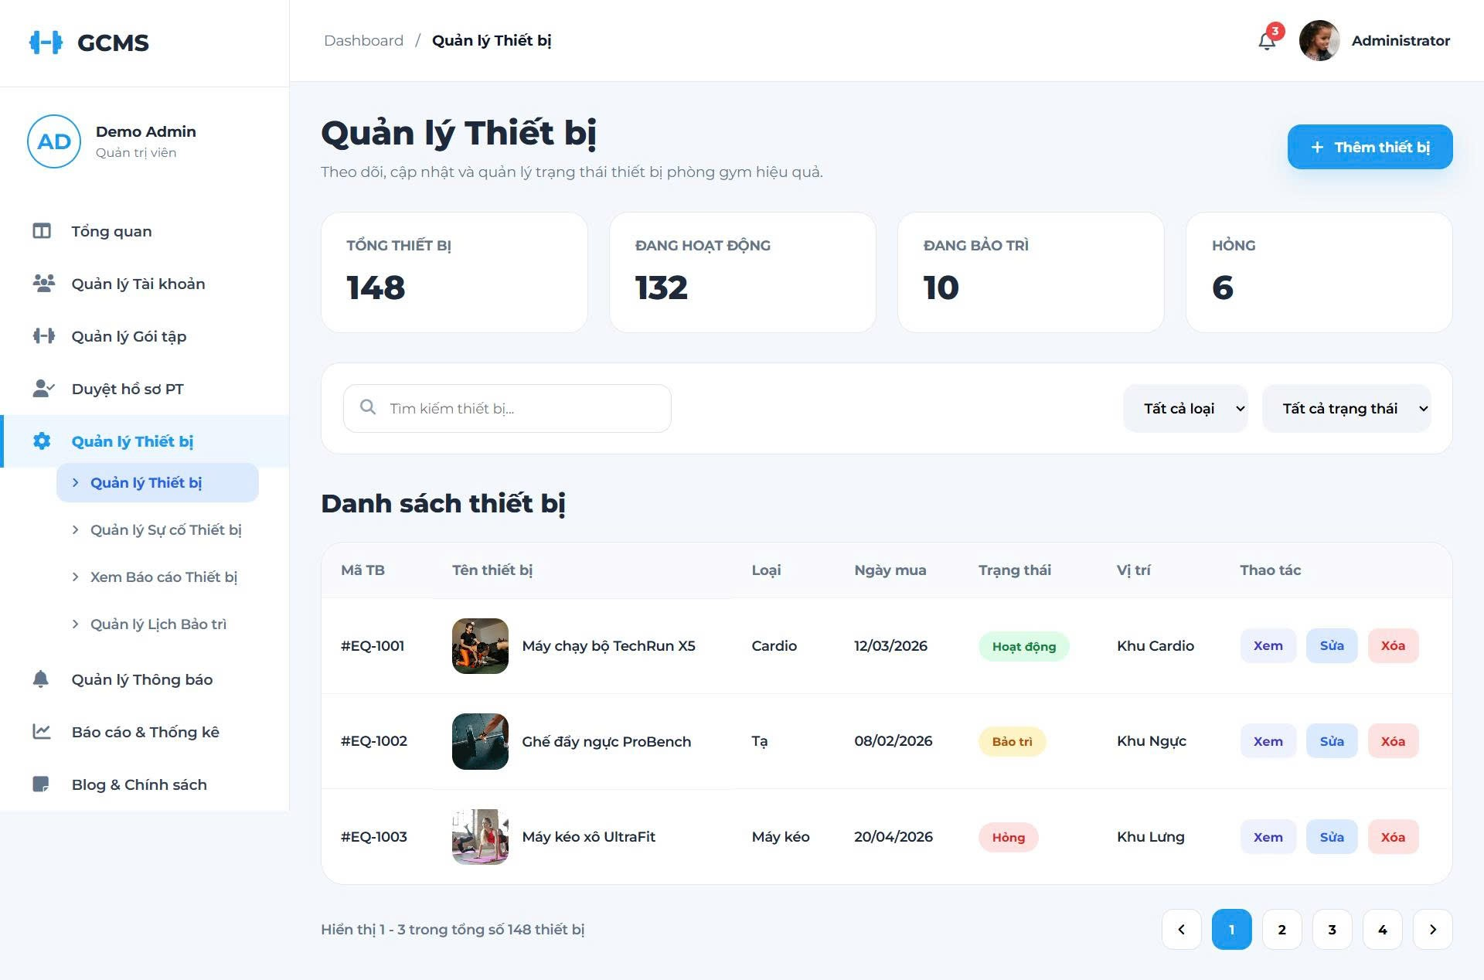
Description
This screen allows administrators and staff to manage gym equipment.
Roles/Actors: Admin, Staff
Functions
- View equipment list
- Search equipment
- Filter equipment status
- View equipment statistics
- Open equipment details
Field Description
Field Name | Description
Total Equipment | Displays the total number of gym equipment in the system.
Active | Displays the total number of equipment currently active and available for use.
Under Maintenance | Displays the total number of equipment currently undergoing maintenance.
Broken | Displays the total number of broken/out-of-order equipment.
Add Equipment | Button to navigate to the screen for adding new gym equipment.
Search Equipment | Input box to search for equipment by name or code.
All Types | Dropdown menu to filter the equipment list by its category.
All Statuses | Dropdown menu to filter the equipment list by its operational status.
Equipment ID | Column displaying the unique identification code for each equipment item.
Equipment Name | Column displaying the image and official name of the equipment.
Type | Column displaying the category/type of the equipment.
Purchase Date | Column showing the acquisition or purchase date of the equipment.
Status | Column displaying the current condition badge (Active, Maintenance, Broken).
Location | Column indicating the specific gym area where the equipment is placed.
Actions | Action links allowing the user to View, Edit, or Delete an equipment record.

3.8.2 Manage Equipment Issues

3.8.2.1 Equipment Issue Report Screen
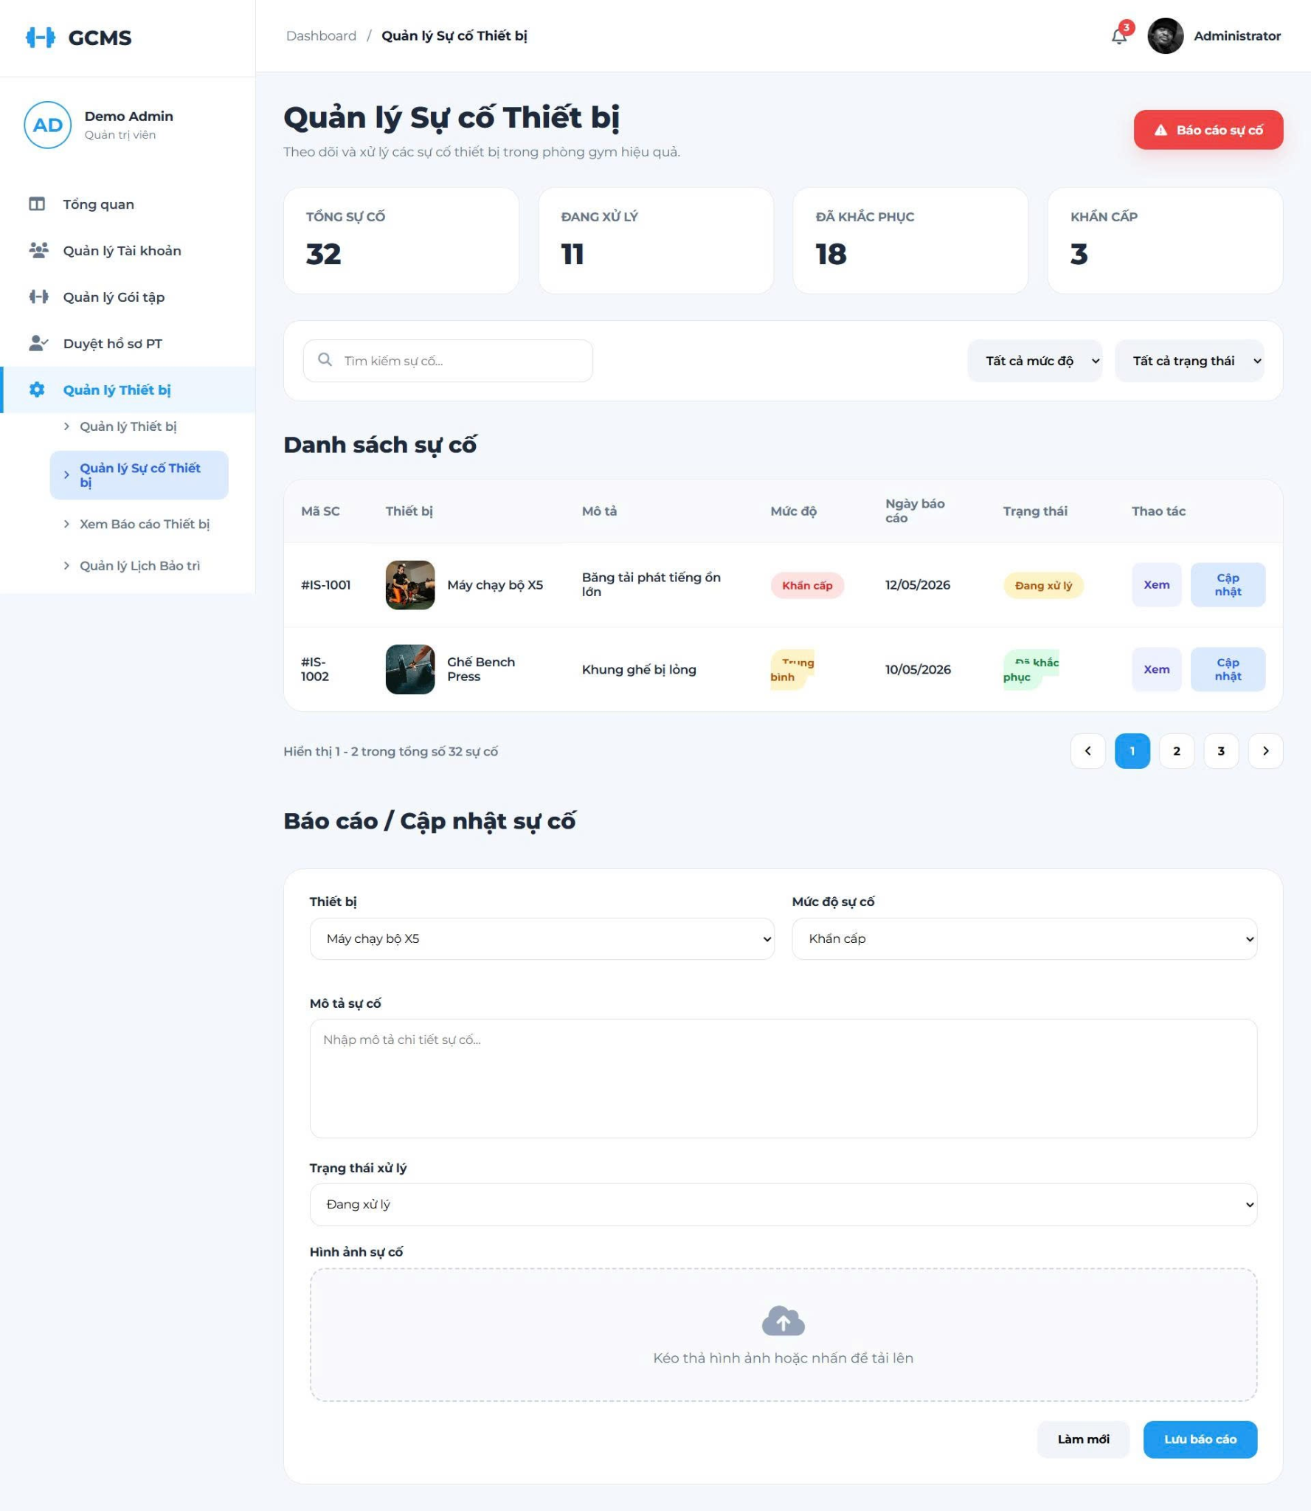
Description
This screen allows staff and admin to report damaged or problematic equipment.
Roles/Actors: Staff, Admin
Field Description
Field Name | Description
Total Issues | Displays the total number of reported equipment issues in the system.
Processing | Displays the total number of issues currently being handled or processed.
Resolved | Displays the total number of issues that have been successfully fixed.
Urgent | Displays the total number of issues flagged with high/urgent priority.
Report Issue Button | Button to navigate or scroll to the incident reporting section.
Search Box | Input box to search for specific issues by code or description.
Filter Severity | Dropdown menu to filter the incident list by its severity level.
Filter Status | Dropdown menu to filter the incident list by its resolution status.
Issue ID | Column displaying the unique identification code for each reported incident.
Equipment | Column displaying the name and image of the affected gym equipment.
Description | Column providing details regarding the equipment failure or malfunction.
Severity Level | Column indicating the priority level of the issue (e.g., Urgent, Medium).
Reported Date | Column showing the exact date when the issue was submitted.
Status | Column displaying the progress tracking badge (e.g., Processing, Resolved).
Actions | Action links allowing the user to View or Update the incident status.
Select Equipment | Dropdown field in the form to select which equipment has the issue.
Severity Level Dropdown | Dropdown field in the form to set the priority level of the incident.
Issue Description Input | Text area field in the form to write down detailed notes about the problem.
Processing Status Dropdown | Dropdown field in the form to set or modify the handling status.
Issue Image Upload | Drag-and-drop area or click-to-upload tool for adding a photo of the issue.
Reset Button | Action button to clear all inputs currently entered in the form.
Save Report Button | Action button to submit and save the new or updated incident report.

3.8.3 View Equipment Reports

3.8.3.1 Equipment Report Screen
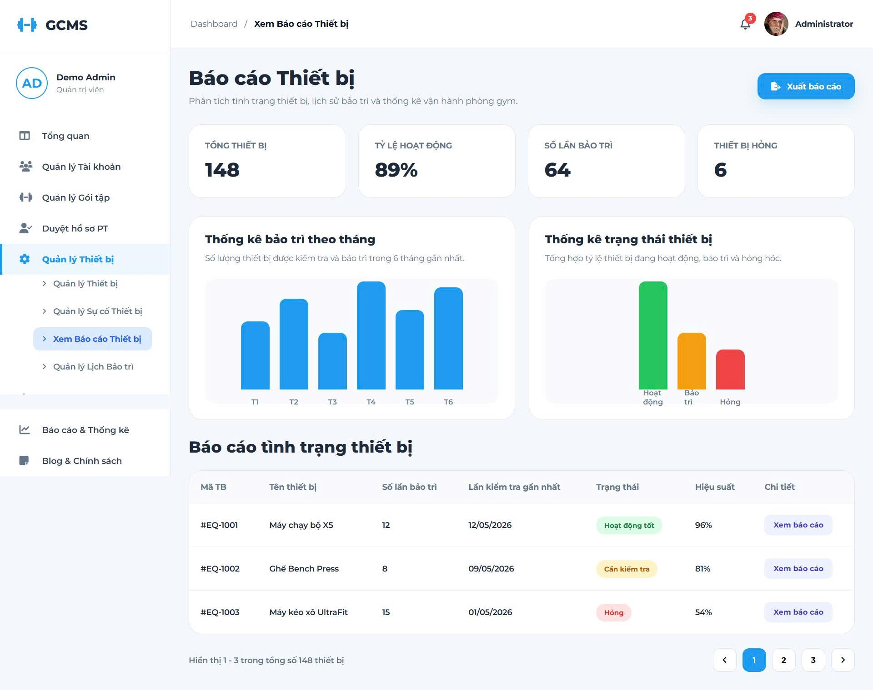
Description
This screen allows administrators to monitor equipment conditions and maintenance activities.
Roles/Actors: Admin
Field Description
Field Name | Description
Total Equipment | Displays the total number of all gym assets in the system
Active | Counts the equipment currently available and ready for use
Under Maintenance | Counts the equipment currently being repaired or serviced
Broken | Counts the faulty equipment that is out of order
Search Box | Text input to search equipment by Name or ID
Type Filter | Dropdown menu to filter items by their category
Status Filter | Dropdown menu to filter items by operational status
Add Equipment Button | Button that redirects to the equipment creation form.
Equipment ID | Unique identifier for each equipment piece
Equipment Name | Displays the equipment's Thumbnail Image alongside its Display Name.
Type | The category of the gym equipment
Purchase Date | The date the item was registered/purchased
Status | The current condition of the asset, color-coded as follows:  - Active (Green)  - Maintenance (Yellow)  - Broken (Red)
Location | Specific zone within the gym gym where the equipment is placed
Actions | Action triggers for each row item:  - (View): Opens the detailed view profile.  - (Edit): Opens the information modification form.  - (Delete): Removes the item from the system (requires confirmation).
Entries Info | Label showing current view range out of total items
Pagination Controls | Controls containing Previous, page numbers (1, 2, 3, 4), and Next buttons.

3.8.4 Manage Maintenance Schedules

3.8.4.1 Manage Equipment Screen
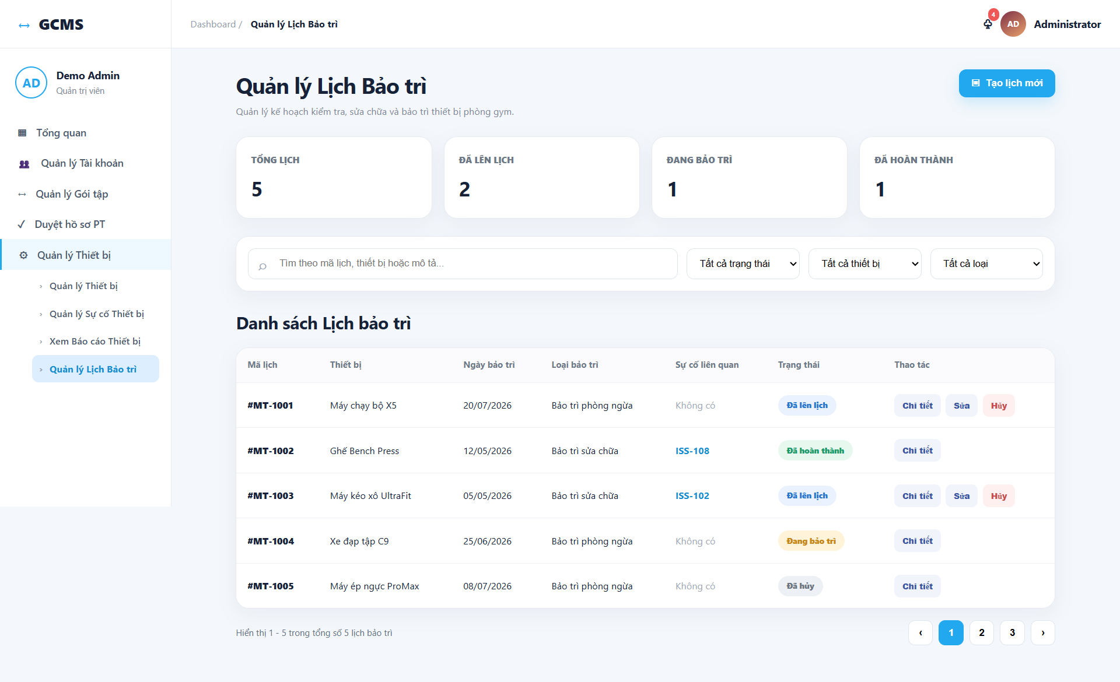

Description
This screen allows administrators and staff members to monitor and manage equipment maintenance schedules within the gym system. Users can view maintenance statistics, search and filter schedules, and review maintenance details. Administrators can create, edit, and cancel maintenance schedules for gym equipment.
Roles/Actors: Admin,Staff
Field Description
Field Name | Description
Maintenance Statistics | Displays summary information about equipment maintenance schedules.
Total Schedules | Displays the total number of maintenance schedules recorded in the system.
Scheduled | Displays the number of maintenance schedules that have been created but have not started.
In Progress | Displays the number of maintenance activities currently being performed.
Completed | Displays the number of maintenance schedules that have been completed.
Create New Schedule | Opens the maintenance schedule form for creating a new maintenance plan.
Schedule Search | Allows users to search schedules by schedule ID, equipment name, related issue, or maintenance description.
Status Filter | Allows users to filter maintenance schedules by status, such as Scheduled, In Progress, Completed, or Cancelled.
Equipment Filter | Allows users to display maintenance schedules for a selected equipment item.
Maintenance Type Filter | Allows users to filter schedules by Preventive Maintenance or Corrective Maintenance.
Maintenance Schedule List | Displays all maintenance schedules matching the selected search and filter conditions.
Schedule ID | Displays the unique identifier of a maintenance schedule.
Equipment | Displays the equipment associated with the maintenance schedule.
Maintenance Date | Displays the planned date for performing the maintenance activity.
Maintenance Type | Displays whether the activity is Preventive Maintenance or Corrective Maintenance.
Related Issue | Displays the equipment issue linked to the maintenance schedule, if applicable. This field may be empty for preventive maintenance.
Schedule Status | Displays the current maintenance schedule status, such as Scheduled, In Progress, Completed, or Cancelled.
View Detail | Opens the detailed information of the selected maintenance schedule.
Edit Schedule | Opens the maintenance schedule form and allows an administrator to update a schedule that has not started.
Cancel Schedule | Allows an administrator to cancel a maintenance schedule that has not started.
Equipment Selection | Allows an administrator to select the equipment that requires maintenance.
Scheduled Date | Allows an administrator to select the planned maintenance date.
Maintenance Type Selection | Allows an administrator to select Preventive Maintenance or Corrective Maintenance.
Related Issue Selection | Allows an administrator to optionally link the schedule to an existing equipment issue.
Work Description | Allows an administrator to enter the inspection, repair, or maintenance work that needs to be performed.
Save Schedule | Validates and saves a new or updated maintenance schedule.
Cancel Form | Closes the maintenance schedule form without saving changes.

3.9. Dashboard & Reporting

3.9.1 View Dashboard Screen
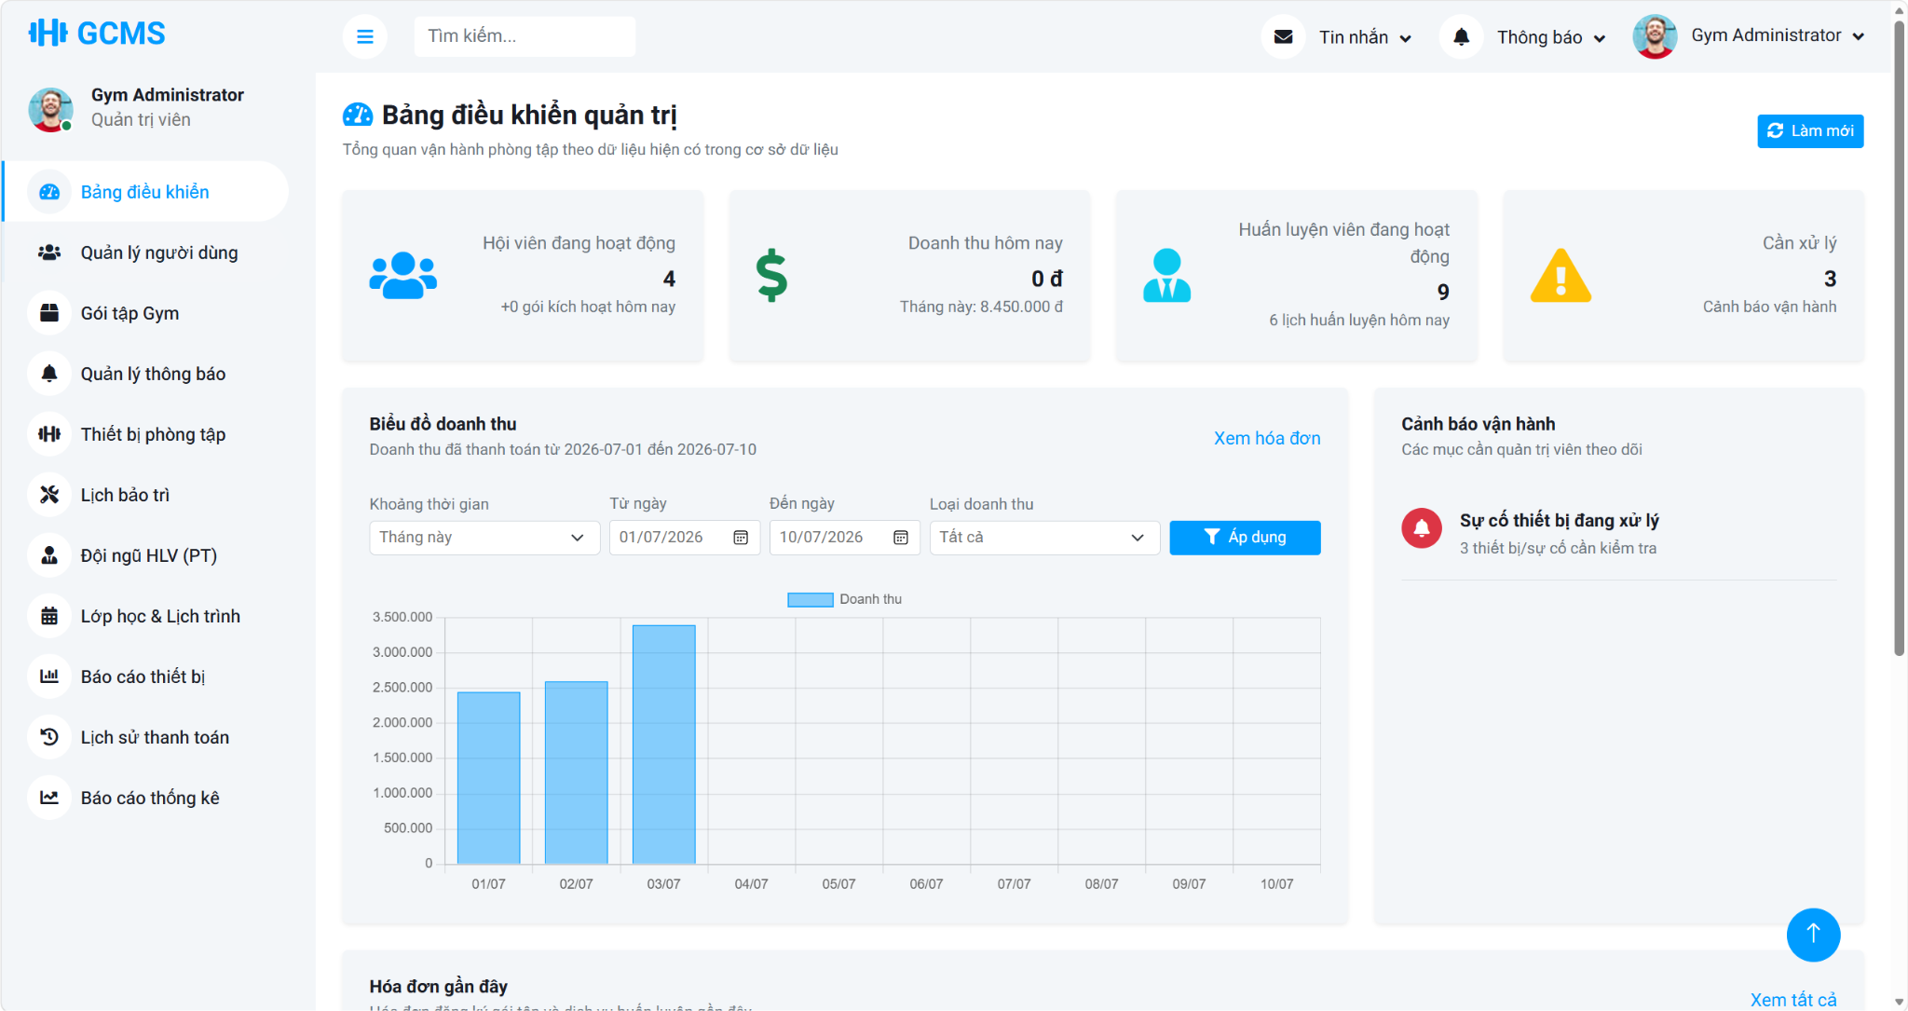
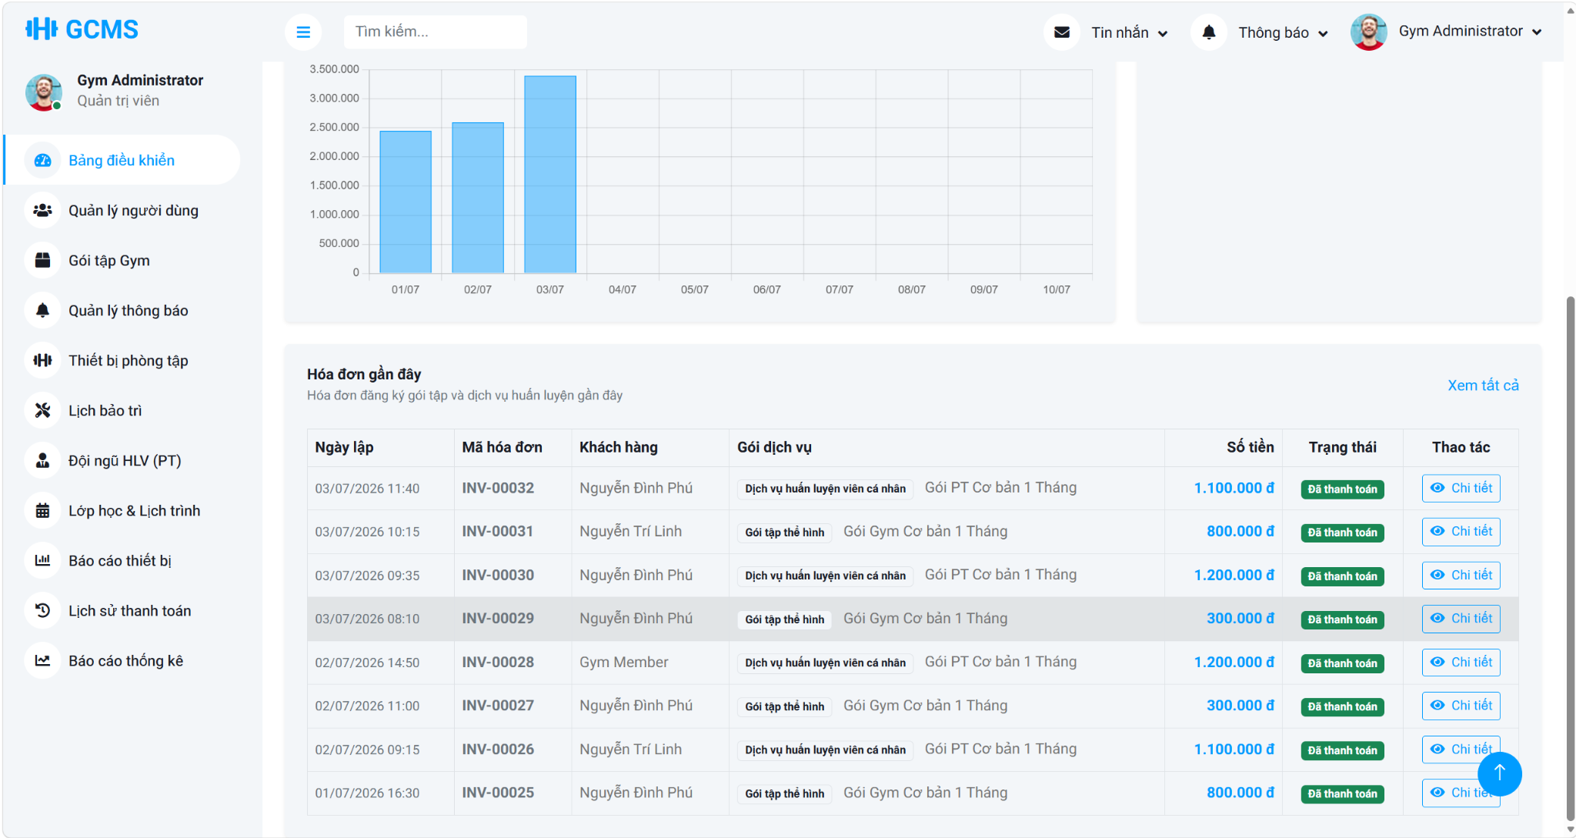
Description: This use case allows an authenticated Admin to view an operational dashboard that summarizes current gym business activity. The system aggregates membership, revenue, trainer, invoice, and alert data, supports revenue analysis by preset or custom date ranges and by revenue source type, and presents recent operational records for monitoring and decision support.
Roles/Actors: Admin
Functions
- View core dashboard metrics such as active members, new memberships today, today revenue, month revenue, active trainers, today PT sessions, and pending alerts
- Filter revenue trend data by preset or custom date range
- Filter revenue analytics by revenue source type including all revenue, gym package revenue, or PT service revenue
- View revenue trend charts with automatic daily, weekly, or monthly grouping based on the selected period
- View recent invoices with customer, service, amount, and payment status summaries
- View operational alerts such as equipment issues, pending PT registrations, expiring packages, and pending payments
- Reload dashboard data safely and display an error message when dashboard data cannot be retrieved
Field Description
Field Name | Description
Revenue Range | Selects a preset revenue analysis period such as last 7 days, last 30 days, current month, current quarter, current year, or a custom range.
From Date | Custom revenue filter start date used when the Admin wants to analyze a specific period.
To Date | Custom revenue filter end date used together with From Date for a specific reporting range.
Revenue Type | Filters analytics by revenue source, including all revenue, gym package revenue, or Personal Trainer service revenue.
Apply Filter Button | Submits the dashboard filter form and reloads the revenue chart data according to the selected date range and revenue type.
Metric Cards | Display the main operational indicators such as active members, new memberships today, today revenue, month revenue, active trainers, PT sessions today, and pending alerts.
Revenue Chart | Visualizes paid revenue data for the selected period and revenue type.
Operational Alerts Panel | Lists important business alerts that require Admin monitoring, such as expiring packages or operational follow-up items.
View Invoices Link | Navigates to the payment or invoice management area for more detailed transaction review.
Recent Invoices table | Displays recently recorded payment transactions for quick operational review on the dashboard.

3.9.2 View Membership Growth Report Screen

3.9.3 Package Registration Screen

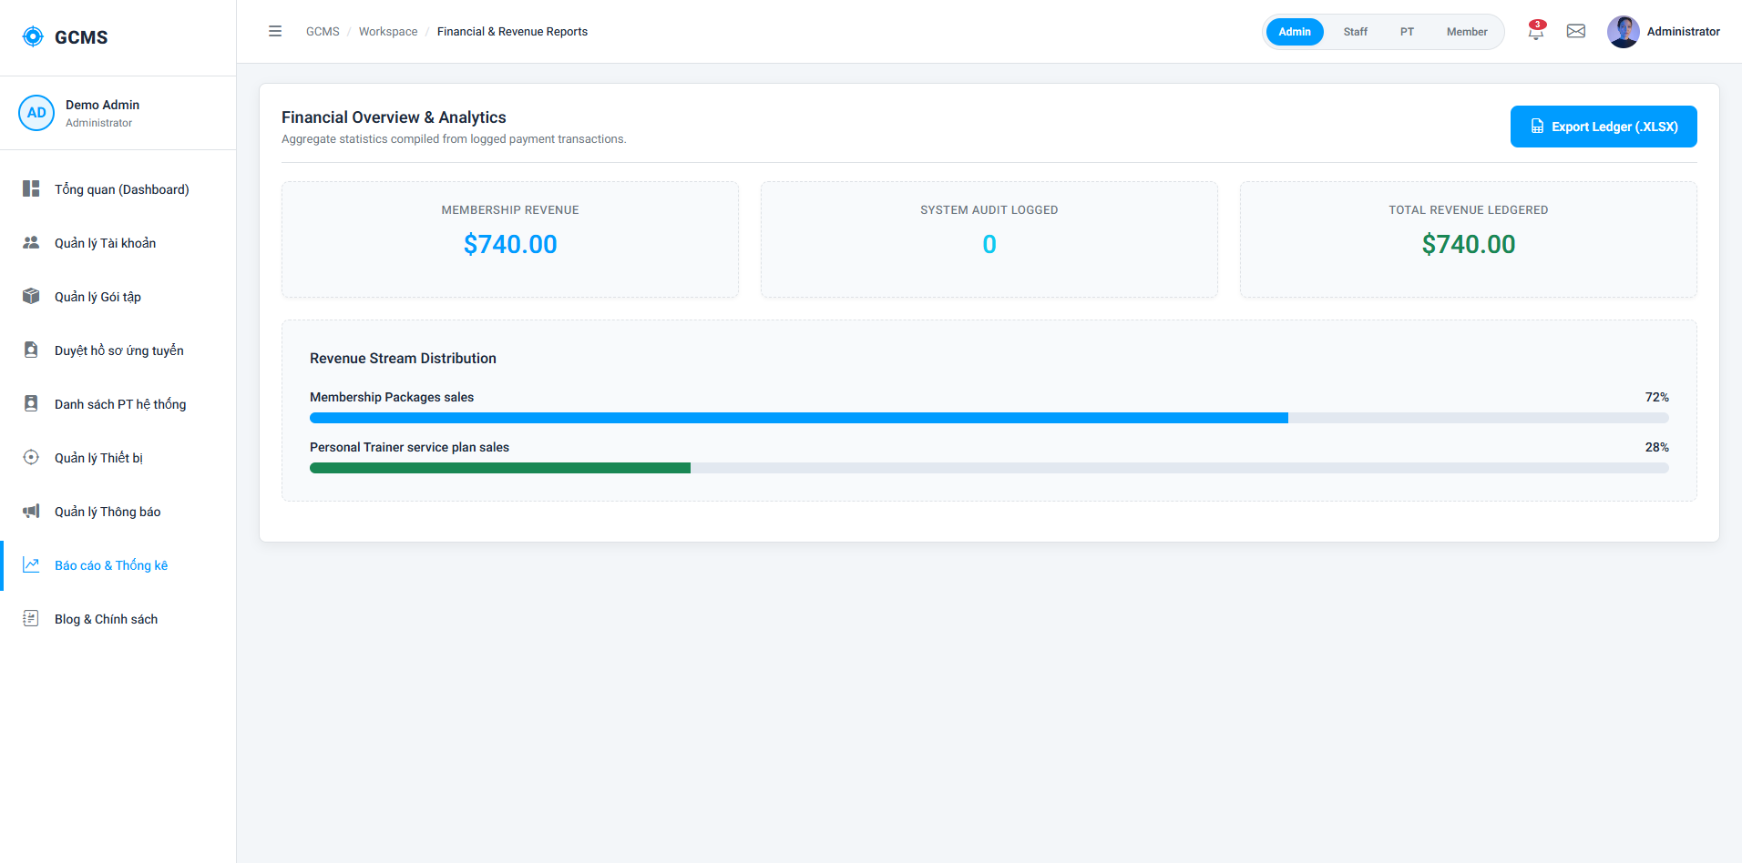
Description
This screen allows administrators to view, analyze, and export financial and revenue statistics of the gym center.
Roles/Actors: Admin
Field Description
Field Name | Description
Date Range Filter | Select start and end date for filtering report records.
Report Category | Select report type (e.g., Membership Revenue, PT Service Revenue, Overall Revenue).
Payment Method Filter | Filter by payment methods (e.g., Cash, Card, Bank Transfer).
Total Revenue Indicator | Displays total collected revenue for the selected scope.
Charts & Graphs | Interactive charts showing revenue distribution and growth.
Export Button | Generate and download the report file.

3.10. Notification

3.10.1 Manage Notifications Screen
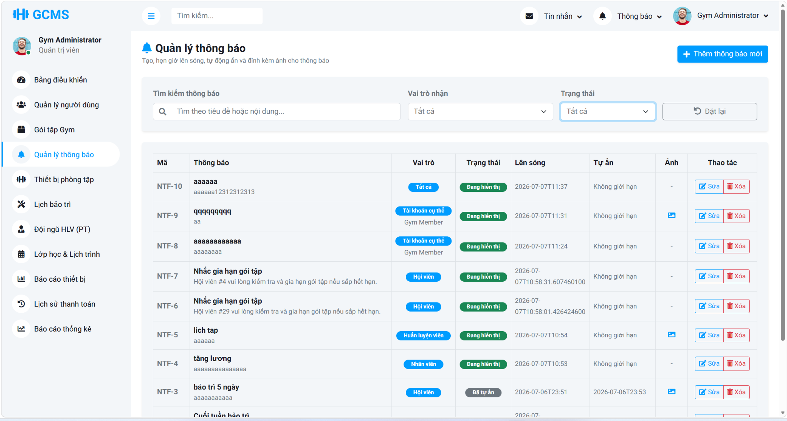
Description
This use case allows an authenticated Admin to manage system notifications that are delivered to users by role or by specific account. The system supports listing, creating, updating, and deleting notifications, scheduling their publish and expiry time, optionally attaching a notification image, and delivering active notifications to recipient mailboxes for Member, Staff, and Personal Trainer users.
Roles/Actors: Admin
Functions
- View the notification list with pagination support
- Create a notification with title, content, publish time, optional expiry time, and optional image
- Target a notification to all users, a specific role, or a specific active account
- Validate recipient selection, publish and expiry time rules, and allowed image file types
- Edit existing notification details when updates are required
- Delete notifications from the management function
- Deliver active notifications to role-based and account-based recipient mailboxes
- Support notification read tracking when recipients open a notification detail view
Field Description
Field Name | Description
Search Input | Optional list filter used to search notifications by title or content.
Role Filter | Optional list filter used to narrow notifications by recipient role or specific-account targeting mode.
Status Filter | Optional list filter used to narrow notifications by effective status such as Scheduled, Active, or Expired.
Title | Required notification title, maximum 255 characters.
Delivery Mode | Required target selection mode. The Admin can send the notification by role or to one specific account.
Target Mode | Required when sending by role. Only supported recipient roles may be selected.
Recipient Mode | Required when sending to one specific account. The selected recipient must exist and remain active in the system.
Publish Date | Required date and time when the notification becomes visible to recipients.
Expiry Date | Optional date and time when the notification automatically becomes hidden. When provided, it must be later than the Publish Date.
Content | Required notification body content delivered to recipients.
Notification Image | Optional image upload attached to the notification. Supported formats are JPG, JPEG, PNG, GIF, and WEBP, with a maximum upload size of 5 MB.
Remove Image | Optional checkbox used during edit mode to remove the current notification image.
Notification Actions | Management actions include create, edit, delete, and list filtering or reset operations for notification records.

3.10.2 View Member Notifications Screen
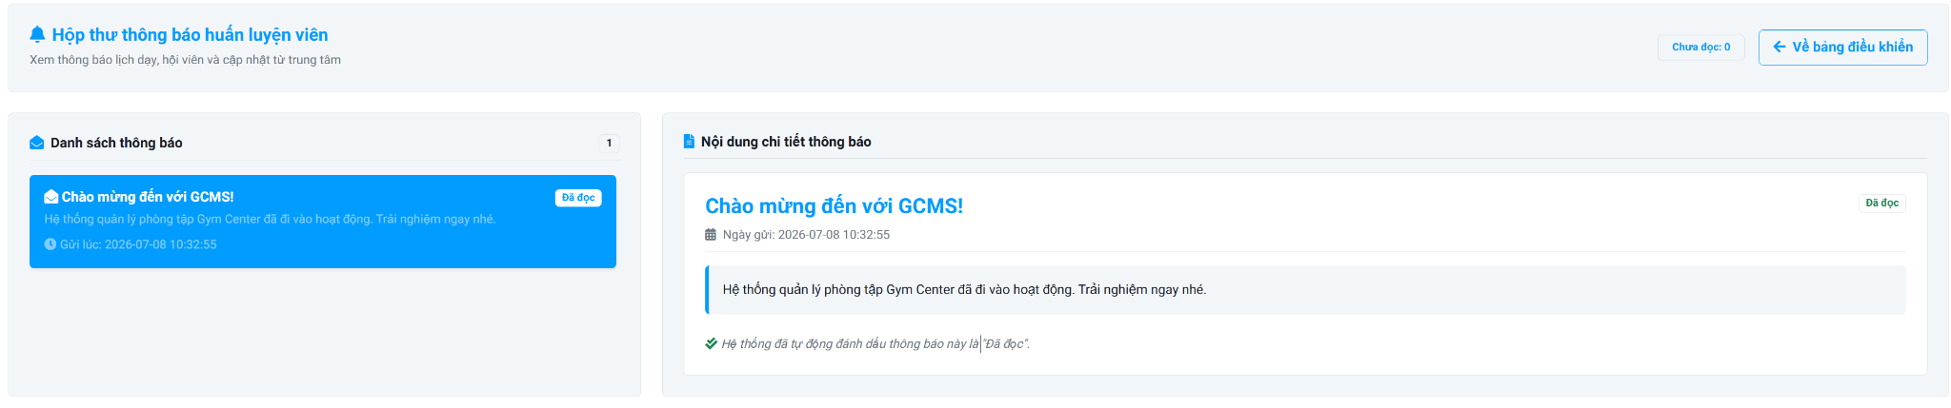
Description
This screen allows Personal Trainers to view system notifications related to training schedules, assigned members, announcements, and other updates from the Gym Center Management System. Users can browse notification messages, read notification details, view unread notification counts, and monitor notification status.
Roles/Actors: Member, Staff, Personal Trainer
Functions
- View notification list.
- View notification details.
- Display unread notification count.
- Automatically mark a notification as read when it is opened.
- Display notification status.
- Return to the dashboard.
Field Description
Field Name | Description
Unread Notification Counter | Displays the total number of unread notifications for the current user.
Back to Dashboard Button | Returns the user to the Personal Trainer dashboard.
Notification List | Displays all notifications received by the current user in chronological order.
Notification Item | Displays a notification summary, including the title, short content, sent date and time, and current read status.
Notification Title | Displays the title of the selected notification.
Notification Summary | Displays a brief preview of the notification content.
Sent Date & Time | Displays the date and time when the notification was sent.
Read Status | Indicates whether the notification has been read or remains unread.
Notification Details | Displays the complete content of the selected notification.
Notification Content | Displays the full message associated with the selected notification.
Auto Read Status Message | Displays a confirmation message indicating that the notification has been automatically marked as read after being opened.

3.11. Support

3.11.1 Chat Bot
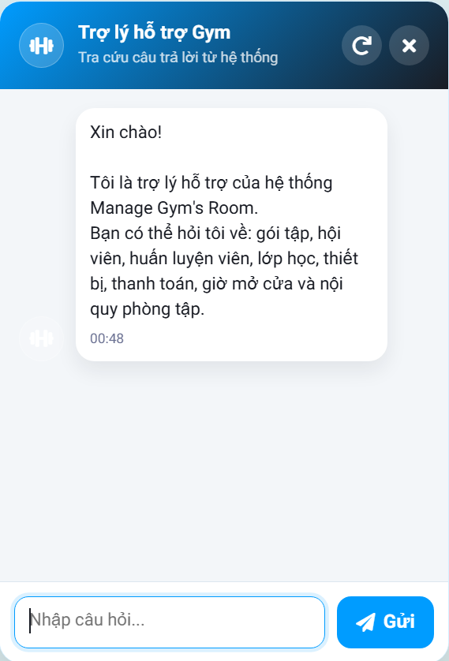
Description
This screen allows Guests and Members to ask gym-related questions and receive automatic responses from the Gym Center Management System. The chatbot searches the FAQ database for matching questions or keywords and returns predefined answers. If no matching FAQ is found, the system displays a predefined message informing the user that the question is outside the supported scope.
Roles/Actors: Guest, Member
Functions
- Open and close the chatbot window.
- Display the welcome message.
- Enter gym-related questions.
- Search the FAQ database for matching questions or keywords.
- Display predefined answers.
- Display an out-of-scope response when no matching FAQ is found.
- Clear the current conversation.
- Display the conversation history during the current session.
Field Description
Field Name | Description
Chatbot Header | Displays the chatbot title and a brief description of its purpose.
Reset Conversation Button | Clears the current conversation and restarts the chatbot with the default welcome message.
Close Button | Closes the chatbot window without affecting the current user session.
Conversation Area | Displays all messages exchanged between the user and the chatbot during the current session.
Welcome Message | Displays the default greeting and introduces the topics supported by the chatbot.
User Question | Displays the question entered by the user.
Chatbot Response | Displays the predefined answer retrieved from the FAQ database.
Message Timestamp | Displays the time when each message is sent or received.
Question Input | Allows the user to enter a gym-related question.
Send Button | Submits the entered question for processing and displays the corresponding response.
Unsupported Question Message | Displays a predefined message when no matching FAQ is found: "Sorry, your question is outside our support scope. Please contact us via email or phone for further assistance."

3.12 Blog & Policies

3.12.1 Content & Policies Management Screen
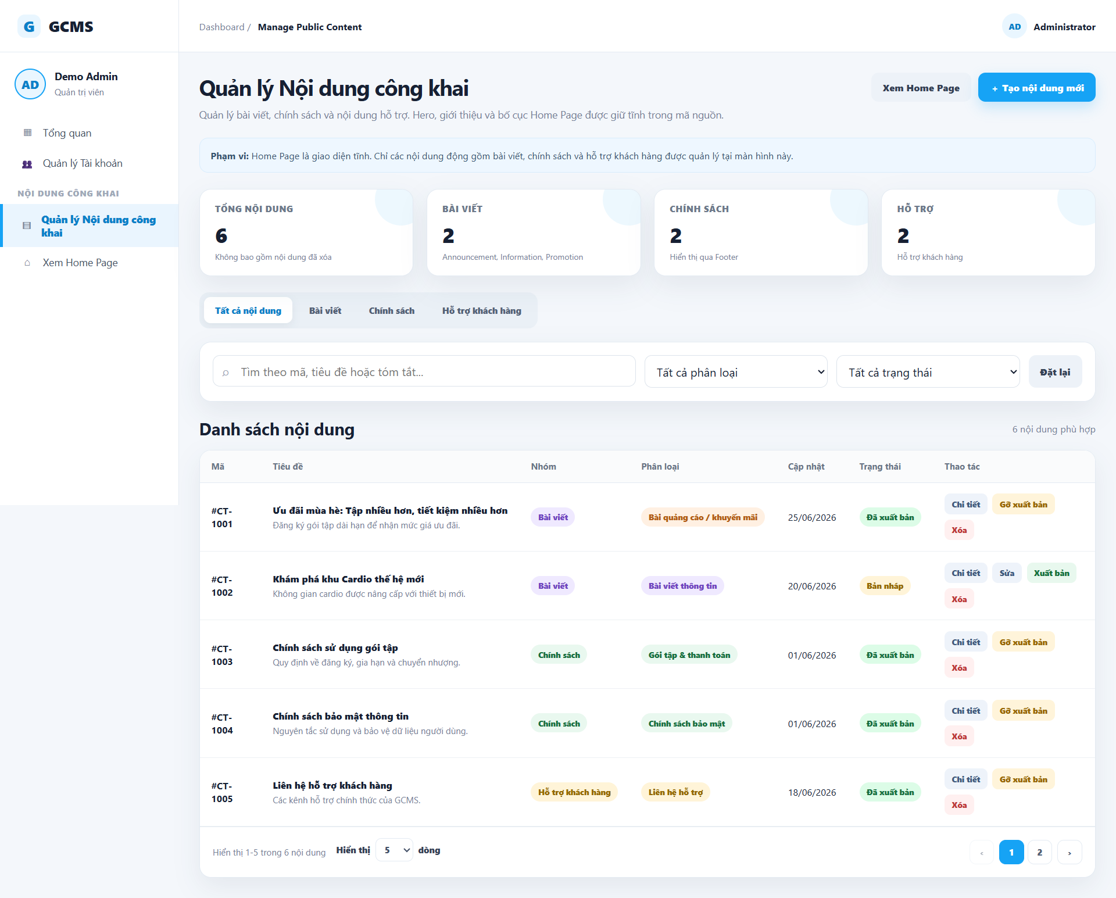
Description
This screen allows administrators to manage blog posts and gym policies, including creating, editing, monitoring published content, and updating policy information for gym members.
Roles/Actors: Admin
Field Description
Field Name | Description
Blog & Policy Statistics | Displays summary statistics such as active policies, published posts, drafts, and member views.
Search Blog Posts | Search bar for finding blog posts quickly.
Category Filter | Filter blog posts by category.
Sort Posts | Sort blog posts by latest or other conditions.
Recent Blog Posts | Displays recently published blog posts with category, title, description, and publish date.
Create New Post | Button to create a new blog post.
Edit Post | Allows admin to edit an existing blog post.
Delete Post | Allows admin to remove a blog post.
Gym Policy List | Displays current gym policies and their status.
View Policy | View detailed policy information.
Edit Policy | Modify existing policy information.
Archive Policy | Save policy into archive storage.
Policy Edit Form | Form for updating policy title, category, status, and content.
File/Image Upload | Upload attachments or images related to policies.
Save Draft | Save policy changes as draft.
Preview Policy | Preview policy content before publishing.
Update Policy | Publish or update the current policy information.

4. Non-Functional Requirements

4.1 External Interfaces

4.1.1 User Interface
- The system shall provide responsive web interfaces for desktop and tablet devices.
- The system shall support role-based dashboards and navigation.
- The system shall display validation messages clearly near related input fields.
- The system shall support modern browsers including Google Chrome, Microsoft Edge, and Mozilla Firefox.

4.1.2 Hardware Interface
- The system shall support barcode scanner or QR scanner devices for member check-in.
- The system shall support receipt printers for invoice printing.
- The system shall support image upload devices for equipment and trainer profile management.

4.1.3 Software Interface
- The system shall connect to a relational database management system.
- The system shall support email services for notifications and password reset.
- The system shall integrate with payment systems if online payment is enabled.

4.2 Quality Attributes

4.2.1 Usability
- The system interface shall be easy to use for non-technical users.
- Average users shall be able to complete the login process within 1 minute.Staff users shall be able to register membership packages within 3 minutes.
- The system shall provide meaningful error messages and confirmation notifications.
- The system shall follow consistent UI design standards across all screens.

4.2.2 Performance
- System response time for standard operations shall not exceed 3 seconds under normal conditions.
- Search operations shall return results within 5 seconds.
- The system shall support at least 500 concurrent users.
- The system shall support at least 10,000 member records.
- Daily backup operations shall not interrupt normal system usage.

4.2.3 Security
- Passwords shall be encrypted before storage.
- The system shall implement role-based access control.
- Sessions shall automatically expire after 30 minutes of inactivity.
- The system shall prevent unauthorized access to restricted functions.
- The system shall maintain audit logs for important operations.
- The system shall restrict the Personal Trainer role to read-only access on the training schedule interface.
- The system shall block all write, modify, or delete API requests regarding the schedule repository when initiated by a Personal Trainer account.
- The system shall exclusively allow authorized Staff and Admin roles to perform structural modifications on any training schedule.

4.2.4 Reliability
- The system shall achieve at least 99% uptime.
- The system shall recover automatically after unexpected failures.
- Backup data shall be created daily.
- The system shall validate all input data before processing.
- The system backend shall execute an automated schedule conflict validation before executing database commitments.
- The system shall reject the database transaction if a newly generated training session overlaps with an existing, active session of the same trainer.
- The system shall invoke and display a conflict error message to the user immediately upon detecting overlapping timestamps.

4.2.5 Maintainability
- Source code shall follow coding standards and naming conventions.
- The system architecture shall support modular development.
- Database structures shall be documented clearly.
- Error logs shall be stored for troubleshooting purposes

4.2.6 Scalability
- The system shall support future expansion for multiple gym branches.
- The database shall support increasing member and transaction records.
- Additional modules shall be integrated without affecting existing functions.

5. Requirement Appendix

5.1 Business Rules
ID | Type | Rule Definition
BR-CONS-01 | Constraint | Only active users can log in to the system.
BR-CONS-02 | Constraint | Each email address must be unique in the system.
BR-CONS-03 | Constraint | Members can only access features assigned to the Member role.
BR-CONS-04 | Constraint | Staff can manage daily operations, including member check-ins, package registration/renewal/transfer, payment recording, PT schedule adjustment, and equipment issue reporting.
BR-CONS-05 | Constraint | Administrators have full access to all management functions.
BR-CONS-06 | Constraint | Membership packages must have valid duration and pricing information.
BR-CONS-07 | Constraint | Expired membership packages cannot be used for check-in.
BR-ACT-08 | Action Enabler | Personal Trainer recruitment, including CV submission, interview, professional evaluation, and approval, is handled outside the system. A Personal Trainer profile and account can only be created by Staff/Admin after offline approval.
BR-CONS-09 | Constraint | Equipment with Broken status must be excluded from available equipment lists until repaired.
BR-CONS-10 | Constraint | Payment records cannot be deleted after confirmation.
BR-CONS-11 | Constraint | Members can register for active Personal Trainer service plans, but detailed training sessions must be arranged by Staff/Admin.
BR-COMP-12 | Computation | Package expiration dates are calculated automatically based on duration.
BR-CONS-13 | Constraint | System notifications must be visible only to authorized users.
BR-CONS-14 | Constraint | Equipment maintenance history must be retained for auditing purposes.
BR-CONS-15 | Constraint | Trainers can only view schedules assigned to themselves.
BR-ACT-16 | Action Enabler | A newly submitted PT service registration must be created with Pending status. Staff/Admin can process payment if required, activate the registration, and arrange training sessions for the selected trainer and member.
BR-CONS-18 | Constraint | A membership package can only be transferred if the current package is active and has remaining duration.
BR-CONS-19 | Constraint | Package transfer must record both the current member and the target member for audit purposes.
BR-CONS-20 | Constraint | Verified Personal Trainer information, including full name, phone number, specialization, career start date, certificate file, PT service price, trainer status, and linked account status, must be created or updated only by Staff/Admin. Uploaded PT certificate files must use supported formats such as PDF, JPG, JPEG, or PNG. Personal Trainers cannot directly update verified professional information.
BR-CONS-21 | Constraint | Personal Trainers can only update limited public profile information such as avatar, display name, and bio/description.
BR-ACT-22 | Action Enabler | When Staff/Admin creates a Personal Trainer account, the system must generate a temporary password, store only the hashed password, require the PT to change the password at first login, and must not display any hard-coded default password in the user interface.
BR-CONS-27 | Constraint | Personal Trainer schedules and session attendance results are managed by Staff/Admin. Personal Trainers can only view their assigned schedules and work history.
BR-CONS-28 | Constraint | Only Active and non-deleted Personal Trainers are displayed on the public Personal Trainer list.
BR-CONS-29 | Constraint | The PT service registration must store TotalAmount at the time of registration. Later PT service price changes must not affect old registrations or revenue reports.
BR-CONS-30 | Constraint | Each equipment record must have a unique Equipment Code.
BR-CONS-31 | Constraint | Each equipment record must have a valid equipment status.
BR-CONS-32 | Constraint | Only Active and non-deleted equipment records are displayed in the standard equipment list.
BR-CONS-33 | Constraint | Equipment removed from active operation shall not be included in current equipment statistics and reports.
BR-CONS-34 | Constraint | Each equipment issue must be associated with an existing equipment record.
BR-CONS-35 | Constraint | Equipment issues must have a valid issue status.
BR-ACT-36 | Action Enabler | A newly reported equipment issue must be created with Pending status.
BR-CONS-37 | Constraint | Equipment with unresolved issues should not be considered fully available for operation.
BR-ACT-38 | Action Enabler | When an equipment issue is marked as In Progress, the related equipment should be considered under maintenance.
BR-ACT-39 | Action Enabler | When an equipment issue is marked as Resolved, the related equipment may be returned to Available status according to operational requirements.
BR-CONS-40 | Constraint | Each phone number must be unique in the system for User accounts.
BR-CONS-41 | Constraint | The system uses predefined fixed time slots to manage PT training sessions. PT sessions and proposed reschedule/make-up slots must use these fixed slots and must not overlap with existing non-cancelled schedules of the involved Personal Trainer or Member.
BR-ACT-42 | Action Enabler | The system must automatically calculate and generate the exact number of training session records corresponding to the selected PT service plan (12 sessions for the 1-Month plan, and 36 sessions for the 3-Month plan) upon schedule confirmation by Staff/Admin.
BR-ACT-44 | Action Enabler | When the PT's status in the PT_Profiles table is changed to "Inactive," the system must automatically update the corresponding status in the Users table to "Locked" to prevent the PT from logging into the system.
BR-CONS-45 | Constraint | Personal Trainer experience years must be calculated from Career Start Date and must be within the range [1, 25] at the time of creation or update. Experience years are not stored as the primary editable value.
BR-CONS-46 | Constraint | Personal Trainer service price must be greater than 1,000 VND and must be a multiple of 1,000 VND.
BR-CONS-47 | Constraint | Attendance/status updates are allowed only for eligible sessions. Future sessions and Cancelled sessions cannot be marked as Attended or Absent.
BR-CONS-48 | Constraint | Only Admin can cancel PT sessions. Cancellation is allowed only for future Upcoming sessions. This rule applies to both single-session cancellation and mass cancellation by selected date.
BR-ACT-49 | Action Enabler | For escalated reschedule or make-up requests, Staff/Admin can only approve or reject the proposed slot submitted by Member/PT. Staff/Admin must not manually select a different date or time slot in the current scope.
BR-CONS-50 | Constraint | A make-up request for a Cancelled PT session must include a valid proposed future date and must not use a mass-cancelled date. If approved, the system creates a new Upcoming session and keeps the original Cancelled session unchanged. If rejected, the cancelled session is not consumed, and Member/PT may submit another make-up request with a different valid slot.
BR-COMP-51 | Computation | PT package progress is calculated by CompletedSessions / PurchasedSessions. Cancelled sessions are excluded from progress, while completed make-up sessions are counted after completion.
BR-COMP-52 | Constraint | Admin and Staff can manage blogs and policies.
BR-COMP-53 | Constraint | Staff-created or staff-updated content must always be saved as Draft.
BR-COMP-54 | Constraint | Only Admin can publish, hide, or delete blogs and policies.
BR-COMP-55 | Constraint | Public users can only view Published and non-deleted blogs and policies.
BR-COMP-56 | Constraint | Policy content must not have a thumbnail.
BR-CONS-57 | Constraint | Each Personal Trainer package type name must be unique in the system to prevent configuration conflicts.
BR-CONS-58 | Constraint | Personal Trainer package configurations, specifically Duration (Months) must be in range 1 - 120 and Number of Sessions, must be in range 1 - 500.
BR-CONS-59 | Constraint | Deleting a Personal Trainer package type must be executed as a soft delete (IsDeleted = 1). Existing member registrations (Pending, Active, Completed, or Cancelled) with ‘Paid’ status utilizing the deleted package type must remain entirely unaffected to preserve historical and financial data integrity.
BR-CONS-60 | Constraint | Check-in and check-out actions for Staff and Personal Trainers can only be performed for the current date.
BR-CONS-61 | Constraint | Staff and PT check-in must occur strictly within the attendance time window defined for the selected shift.
BR-CONS-62 | Constraint | A Staff or Personal Trainer cannot be checked in more than once for the same shift on the same day.

5.2 System Messages
# | Message code | Message Type | Context | Content
1 | MSG01 | Inline Message | No search results found | No search results found
2 | MSG02 | Validation Message | Required field is empty | The * field is required.
3 | MSG03 | Toast Message | Login successfully | Login successfully.
4 | MSG04 | Inline Message | Invalid login credentials | Incorrect email or password.
5 | MSG05 | Toast Message | Register account successfully | Register account successfully.
6 | MSG06 | Toast Message | Update profile successfully | Update profile successfully.
7 | MSG07 | Toast Message | Change password successfully | Password changed successfully.
8 | MSG08 | Toast Message | Add member successfully | Add member successfully.
9 | MSG09 | Toast Message | Update member successfully | Update member successfully.
10 | MSG10 | Toast Message | Payment recorded successfully | Payment recorded successfully.
11 | MSG11 | Validation Message | Exceed maximum field length | Exceed maximum length of {max_length}.
12 | MSG12 | Toast Message | PT service registration submitted successfully | PT service registration submitted successfully.
13 | MSG13 | Toast Message | Equipment added successfully | Equipment added successfully.
14 | MSG14 | Toast Message | Equipment issue reported | Equipment issue reported successfully.
15 | MSG15 | Toast Message | Notification sent successfully | Notification sent successfully.
16 | MSG16 | Toast Message | Create Personal Trainer account successfully | Personal Trainer account created successfully.
17 | MSG17 | Validation Message | Duplicate trainer email | This email is already used by another account.
18 | MSG18 | Validation Message | Invalid certificate file | Certificate file must be PDF, JPG, JPEG, or PNG.
19 | MSG19 | Validation Message | Schedule conflict detected | Schedule conflict detected. The selected time slot overlaps with an existing session.
20 | MSG20 | Toast Message | Schedule generated successfully | Training schedule generated successfully.
21 | MSG-21 | Validation Message | Create reschedule/make-up request without permission | Only Member or Personal Trainer can submit a reschedule or make-up request.
22 | MSG-22 | Validation Message | Invalid or missing training session | Invalid training session ID or training session not found.
23 | MSG-23 | Validation Message | Proposed date is empty | Please select a proposed date.
24 | MSG-24 | Validation Message | Proposed date is in the past | The proposed date cannot be in the past.
25 | MSG-25 | Validation Message | Missing request reason | Please enter a reason for the schedule change.
26 | MSG-26 | Validation Message | Invalid session status for request creation | Reschedule or make-up requests can only be created for Upcoming or Cancelled sessions.
27 | MSG-27 | Validation Message | PT information not found | Personal Trainer information for this session could not be found.
28 | MSG-28 | Validation Message | Member information not found | Member information for this session could not be found.
29 | MSG-29 | Authorization Message | Requester is not related to the session | You are not related to this training session.
30 | MSG-30 | Validation Message | Existing pending request | This session already has a pending reschedule or make-up request.
31 | MSG-31 | Validation Message | Proposed slot is outside fixed slots | The proposed time slot must belong to the system fixed slots.
32 | MSG-32 | Validation Message | Proposed slot equals original schedule | The new time slot must be different from the original schedule.
33 | MSG-33 | Validation Message | Proposed slot/date has been mass-cancelled | This time slot has been mass-cancelled by Admin. Please select another date or time slot.
34 | MSG-34 | Validation Message | Proposed slot conflicts with both PT and Member schedules | The proposed time slot conflicts with both the Personal Trainer and Member schedules.
35 | MSG-35 | Validation Message | Proposed slot conflicts with PT schedule | The proposed time slot conflicts with the Personal Trainer schedule.
36 | MSG-36 | Validation Message | Proposed slot conflicts with Member schedule | The proposed time slot conflicts with the Member schedule.
37 | MSG-37 | Toast Message | Request submitted successfully | Reschedule or make-up request submitted successfully.
38 | MSG-38 | Validation Message | Request does not exist | Reschedule request does not exist.
39 | MSG-39 | Validation Message | Request already processed | This request has already been processed.
40 | MSG-40 | Validation Message | Actor account not found | The acting user account does not exist.
41 | MSG-41 | Authorization Message | User has no permission to respond | You do not have permission to respond to this request.
42 | MSG-42 | Validation Message | Related session not found | Related training session could not be found.
43 | MSG-43 | Validation Message | Cannot approve due to mass-cancelled slot | Cannot approve because the proposed time slot has been mass-cancelled by Admin.
44 | MSG-44 | Validation Message | Proposed slot becomes unavailable before approval | The proposed time slot now conflicts with the PT and/or Member schedule.
45 | MSG-45 | Validation Message | Missing rejection reason | Please enter a rejection reason.
46 | MSG-46 | Validation Message | Missing support request reason | Please enter a support request reason.
47 | MSG-47 | Validation Message | Invalid request action | Invalid action.
48 | MSG-48 | Toast Message | Reschedule request approved | Reschedule request approved successfully.
49 | MSG-49 | Toast Message | Reschedule request rejected | Reschedule request rejected successfully.
50 | MSG-50 | Toast Message | Request escalated to Staff/Admin | Support request sent to Staff/Admin successfully.
51 | MSG-51 | Validation Message | Substitute session not found | Teaching session does not exist.
52 | MSG-52 | Validation Message | Substitute assignment for non-upcoming session | Substitute PT can only be assigned for Upcoming sessions.
53 | MSG-53 | Validation Message | Substitute PT is same as current PT | Substitute PT must be different from the current PT.
54 | MSG-54 | Validation Message | Substitute PT inactive or not found | Substitute PT is inactive or does not exist.
55 | MSG-55 | Validation Message | Substitute PT schedule conflict | Substitute PT has a schedule conflict at this time slot.
56 | MSG-56 | Error Message | System error while assigning substitute PT | System error occurred while assigning substitute PT.
57 | MSG-57 | Toast Message | Substitute PT assigned successfully | Substitute PT assigned successfully.
58 | MSG-58 | System Notification | Notification title for substitute PT | New Substitute Teaching Session Assigned
59 | MSG-59 | System Notification | Notification content for substitute PT | You have been assigned to teach as a substitute for [Original PT Name] on [Date] from [Start Time] to [End Time] for member [Member Name]. Reason: [Substitute Reason].
60 | MSG-60 | System Notification | Notification title for original PT | Teaching Session Transfer Notification
61 | MSG-61 | System Notification | Notification content for original PT | Your teaching session with member [Member Name] on [Date] from [Start Time] to [End Time] has been transferred to [Substitute PT Name]. Reason: [Substitute Reason].
62 | MSG-62 | Validation Message | Invalid attendance update request | Invalid request.
63 | MSG-63 | Validation Message | Invalid attendance status | Invalid attendance status. Only Attended, Absent, or Pending is accepted.
64 | MSG-64 | Validation Message | Attendance session not found | Teaching session does not exist.
65 | MSG-65 | Validation Message | Attendance for future session | Cannot record attendance for a future teaching session.
66 | MSG-66 | Validation Message | Attendance for cancelled session | Cannot record attendance for a cancelled teaching session.
67 | MSG-67 | Validation Message | PT registration not active | Cannot record attendance because the member’s PT registration is locked or ended.
68 | MSG-68 | Error Message | System error while updating attendance | System error occurred while updating attendance.
69 | MSG-69 | Toast Message | Attendance updated successfully | Training session result updated successfully.
70 | MSG-70 | Validation Message | Missing mass cancellation date | Please select a cancellation date.
71 | MSG-71 | Validation Message | Missing mass cancellation reason | Please enter the mass cancellation reason.
72 | MSG-72 | Error Message | Mass cancellation failed | Mass cancellation failed due to a system error.
73 | MSG-73 | Error Message | Mass cancellation exception | Processing error: [Error Detail].
74 | MSG-74 | Toast Message | Mass cancellation successful | Successfully cancelled [Number] PT sessions for [Slot Name / All Slots] on [Date].
75 | MSG-75 | Toast Message | No eligible sessions for mass cancellation | No Upcoming PT sessions found for [Slot Name / All Slots] on [Date].
76 | MSG-76 | Toast Message | Add, create new PT package successfully | “Successfully added a new PT package!”
77 | MSG-77 | Toast Message | Update PT package successfully | "PT package information updated successfully!"
78 | MSG-78 | Toast Message | Delete PT package successfully | “PT package successfully deleted!”
79 | MSG-79 | Validation Message | Invalid or empty PT package name (1-100 chars) | Please enter a valid PT package name (1-100 characters).
80 | MSG-80 | Validation Message | Invalid package duration (<=0 or >120) | Duration must be greater than 0 months (Maximum 120 months).
81 | MSG-81 | Validation Message | Invalid session count (<=0 or >500) | Number of sessions must be between 1 and 500.
82 | MSG-82 | Validation Message | Package status not selected | Please select the package status.
83 | MSG-83 | Error Message | Missing required package fields submitted | Please fill in all required fields.
84 | MSG-84 | Validation Message | Empty package name submitted | Package name cannot be empty.
85 | MSG-85 | Validation Message | Invalid package duration submitted | Package duration (months) must be greater than 0.
86 | MSG-86 | Validation Message | Invalid session count submitted | Number of sessions must be greater than 0.
87 | MSG-87 | Validation Message | Duplicate package name during creation | This package name already exists in the system.
88 | MSG-88 | Validation Message | Duplicate package name during update | This package name is already in use by another package.
89 | MSG-89 | Error Message | Target package not found or deleted | The package does not exist in the system.

5.3 Assumptions and Dependencies
- The system requires a stable internet connection for normal operation.
- Users must have valid accounts assigned by the system.
- Email notification services must be configured correctly.
- The organization is responsible for maintaining hardware devices.
- Personal Trainer schedules depend on Staff/Admin processing PT service registrations and arranging training sessions after registration approval/payment handling.

5.4 Other Requirements

5.4.1 Audit Logs
- The system shall record important activities such as login, payment, package registration, and equipment updates.

5.4.2 Backup and Recovery
- The system shall perform automatic daily backups.
- Backup files shall be retained for at least 30 days.

5.4.3 Localization
- The system shall support English language interfaces.
- Future support for Vietnamese language shall be possible.

5.4.4 Compliance
- The system shall comply with organizational data privacy and security policies.
- Financial information shall be protected and accessible only to authorized users.

5.5 Glossary and Acronyms Table
Term | Full name | Definition
A | Added | Used in the "Record of Changes" section.
BR | Business Rule | Rules that define or constrain some aspect of the business.
CRUD | Create, Read, Update, Delete | The four basic functions of persistent storage.
CSV | Comma-Separated Values | File format used for exporting reports.
D | Deleted | Used in the "Record of Changes" section.
GMCS | Gym Center Management System | The software application designed to manage gym operations.
M | Modified | Used in the "Record of Changes" section.
PDF | Portable Document Format | A file format used to present and exchange documents reliably, used for exporting reports.
PT | Personal Trainer | A fitness professional who delivers one-on-one training sessions.
QR | Quick Response | A type of matrix barcode used with scanning devices (e.g., QR scanner).
SMS | Short Message Service | A text messaging service component of most telephone, Internet, and mobile device systems, used as a notification channel.
SRS | Software Requirement Specification | A document that describes what the software will do and how it will be expected to perform.
UC | Use Case | A specific situation in which a product or service could potentially be used.
UI | User Interface | The space where interactions between humans and machines occur.

